Year 1 Spring term 2021

This document could be used by all schools to support teachers in planning for blended learning during the spring term 2021. It is based on the Hampshire Scheme of Learning (HSL), which is available to schools subscribing to Moodle Plus (https://maths.hias.hants.gov.uk). It does not include all national curriculum statements. Teachers will need to adapt these plans based on prior planning and assessment.
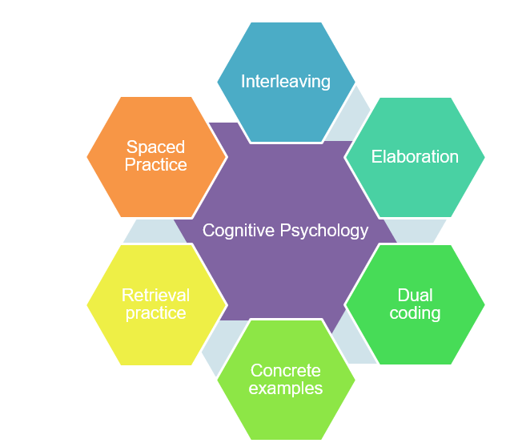
The sequence of domains outlined have been suggested to support a smooth transition to blended learning. The careful sequencing of domains encourages pupils to make links across domains and supports teachers’ use of effective strategies supporting recall of learning, particularly spaced practice and retrieval practice, identified through cognitive psychology research (Weinstein, Sumeracki and Caviglioli, 2019). It is important that children are prompted to access their memories of prior teaching and learned knowledge during periods of remote teaching.
The number of lessons provides a suggested structure, based on hourly lessons.

It will be important for teachers to plan a sequence of a few key tasks and linked skills practise as a ‘learning journey’ for each unit of work. Pupils will need support to understand the problem and have examples of how to record their solutions. Further examples of similar problems to the key task, using variation techniques, will support pupils to develop confidence and independence with each task.

The Hampshire Maths Team will provide a ‘problem of the week’ example to support this approach linked to the plan below. Teachers will need to adapt these examples to meet the needs of the range of leaners in their class.

This document also shows where ‘Ready -to- Progress’ criteria (RTPs) from the DFE Teaching Mathematics: Guidance for Key Stage 1 and 2 (June 2020)* document could be used to support review, practice, and consolidation. The National Centre for the Teaching of mathematics (NCETM) has produced resource materials to support the RTPs. Each RTP has linked resources, including power point slides, which could be used to support modelling of key mathematical concepts

*(DfE Mathematics Guidance: Key stage 1 and 2, June 2020, https://www.ncetm.org.uk/in-the-classroom/teaching-maths-through-the-pandemic/support-with-2020-dfe-guidance/

The NCETM supporting resource materials can be found at:

https://www.ncetm.org.uk/classroom-resources/exemplification-of-ready-to-progress-criteria/

Points to consider when using RTP resources:

They should be used flexibly, guided by pupils' response, repeating activities where pupils lack confidence. Materials from Year 1 may support addressing gaps and misconceptions for whole class, small groups or 1:1 focused intervention. The ready-to-progress criteria are intended as goals for the end of the year.

Video lessons

The NCETM, White Rose Maths and Oak Academy have key stage 1 and 2 video lessons with linked resources such as power points and follow up tasks that can support remote education.
The NCETM maths videos can be found at https://www.ncetm.org.uk/in-the-classroom/teaching-maths-through-the-pandemic/primary-video-lessons/
The Oak Academy maths videos can be found at https://teachers.thenational.academy/subjects/maths
White Rose Maths videos can be found here: https://whiterosemaths.com/homelearning/

Spring 1
Find everyday opportunities to develop children’s understanding of time (hours and half-hours).
Lessons | Domains | Objectives (HSL Unit 1.5) | DfE RTPs
15 | Addition and subtraction | - Derive the partitions for 8,9 and 10  - Use partitions of 5,6,7,8,9 and 10 to derive associated subtraction facts.  - Use partitioning and part-whole diagrams to read, write and interpret mathematical statements to 20 ~ focus on teen numbers and the language of ‘ten and some more’ (teen numbers)  - Use tens frames to develop understanding and the recall of the set of calculations showing ‘ten plus some ones’  - Solve one-step problems that involve addition, using concrete objects and pictorial representations and the language of ‘ten and some more’ (teen numbers) | 1NPV-1  1NPV-2  1NF-1
5 | Measurement: Time (2) and mass (3) | - Tell the time to the hour and half past the hour. Begin to draw the hands on a clock-face.  - Know how many minutes there are in an hour and half an hour  - Solve practical problems involving mass or weight using the language of heavy/light; heavier than/ lighter than. Pictorial recording.
Video Resources
Oak Academy
Unit 1: Numbers to 10 https://teachers.thenational.academy/units/numbers-to-10-526c
Unit 4: Numbers to 20: https://teachers.thenational.academy/programmes/y1-maths
Unit 6: Time https://teachers.thenational.academy/units/time-77d2
Unit 11: Measures (1) length and mass https://teachers.thenational.academy/units/measures-1-length-and-mass-0f65
White Rose Maths
https://whiterosemaths.com/homelearning/year-1/

Lessons | Domains | Objectives (HSL Unit 1.6) | DfE RTPs
5 | Fractions and geometry | - Recognise and name common 2D shapes including squares and circles, rectangles and triangles  - Recognise and name a half as one of two equal parts of a shape  - Recognise, find and name a quarter as one of four equal parts of a shape | IG-1
10 | Multiplication and division | - Count reliably in 2s and 10s.  - Link counting in 10s to grouping objects and to the pattern of numbers on a number-line.  - Solve one-step problems involving multiplication, focussing on groups of 2 and 10, using concrete objects, pictorial representations and arrays with the support of the teacher.  - Rehearse together the language of ‘How many groups of 2 (10) are there?’ ~ ‘There are 3 groups of 2’  - Share objects equally by counting how many in each group and record pictorially.
Video Resources
Oak Academy
Unit 10 Fractions: https://teachers.thenational.academy/units/fractions-da2b
Unit 18: Multiplication and money (2s and 10s) https://teachers.thenational.academy/units/multiplication-and-money-26b5

Spring 2

Lessons | Domains | Objectives (HSL Unit 1.7) | DfE RTPs
5 | NPV | - Count to at least 100 forwards, beginning with 0 or 1, or from any given number  - Count in 2s to 20, modelling on a number-line  - Count in 10s to 100, modelling on a number-line  - Read numbers from 0 to 100. Write numbers from 1 to 20  - Order numbers up to 100 starting from any number crossing the tens boundaries.  - Count back from any given number up to 50.  - Given a number, identify one more and one less  - Add 10 to a number using concrete resources and a number-line | 1NPV-1  1NPV-2  1NF-1
10 | Subtraction and addition | - Revise and use partitions of all numbers up to 10, recalling and deriving associated subtraction facts to solve problems.  - Use partitioning and part-whole diagrams to read, write and interpret mathematical statements to 10 when solving problems.  - Develop children’s fluency with using known or derived number facts , moving on from counting in ones (on fingers).  - Solve one-step problems that involve addition and subtraction to 20, using concrete objects and pictorial representations.  - Deepen understanding of the relationship between the concrete and ordinal for numbers up to 20. E.g. ’11 is ten and one’ (using concrete objects) and also ’11 is one more than 10’ (position on a number-line).
Video Resources
Oak Academy
Unit 4: Numbers to 20: https://teachers.thenational.academy/programmes/y1-maths
Unit 8: Numbers to 50 https://teachers.thenational.academy/units/numbers-to-50-fe7e
Unit 12: Numbers from 50-100 https://teachers.thenational.academy/units/numbers-50-to-100-and-beyond-d3e8
Unit 2 Addition and subtraction within 10 https://teachers.thenational.academy/units/addition-and-subtraction-within-10-77cd
Unit 9: Addition and subtraction within 20 https://teachers.thenational.academy/units/addition-and-subtraction-within-20-79fd
White Rose Maths
https://whiterosemaths.com/homelearning/year-1/

Lessons | Domains | Objectives (HSL 1.8) | DfE RTPs
10 | Addition and subtraction/ money | - Recognise and know the value of different denominations of coins and notes.  - Count to at least 100 forwards, beginning with 0 or 1, or from any given number. Make links with counting in pennies  - Count in 2ps to 20p, modelling on a number-line  - Count in 10ps to 100p, modelling on a number-line. Develop understanding that 100p = £1  - Read numbers from 0 to 100. Write numbers from 1 to 20  - Order amounts of any money up to 100p using 1p and 10p coins. Link to a number-line marked with pence.  - Count back in pennies from any amount up to 50p  - Given a total, identify one penny more and one penny less. Use coins to model the amount and record on a number-line to explore patterns  - Add and subtract 10p to and from an amount of money using 10p and 1p coins and a number-line. | 1NF-1  1NF-2  1AS-1  1AS-2
Video Resources
Oak Academy
Unit 18: Multiplication and money (2s and 10s) https://teachers.thenational.academy/units/multiplication-and-money-26b5

Lessons | Domains | Objectives (HSL 1.9) | DfE RTPs
10 | Addition and subtraction / measurement (mass) | - Solve practical problems involving mass or weight using comparative language such as heavy/light; heavier than/ lighter than. Pictorial recording.  - Measure and begin to record mass and weight using non-standard units to compare the mass of two or three objects.  - Combine the mass of two objects (measured using non-standard units such as ‘cubes’) to find the total and the difference between the number of cubes.  - Read, write and interpret mathematical statements involving addition (+) , subtraction (-) and equals (=) signs.  - Solve simple one-step word problems in the context of mass that involve addition and subtraction to 20, using concrete objects and pictorial representations. | 1NPV-1  1NPV-2  1NF-1  1AS-2
Video Resources
Oak Academy
Unit 11: Measures (1) length and mass https://teachers.thenational.academy/units/measures-1-length-and-mass-0f65
White Rose Maths
https://whiterosemaths.com/homelearning/year-1/

