Y3/4 | KS2 Multiplication/Division Qs  (Generate similar examples) | Knowledge/ strategy  Mental strategies need to develop through discussion, using modelling the mathematics using concrete resources combined with recording (eg number lines, part whole diagrams such as bar models). Pupils need to decide when formal methods an appropriate choice. |  | Pupils who need further teaching to address gaps in understanding  Date:
 | 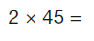 | - Any TU x2  - Read as ‘double 45’ or two times 45/ 45 multiplied by 2  - Know doubles of any TU number | Mental
 | 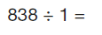 | - Any number ÷ by 1  - Conceptual understanding | Mental
 | 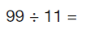 | - Any division fact related to tables fact  - Recall tables fact  - Know linked tables fact to check | Mental
 | 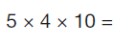 | - Any multiplying of 3 numbers including 10/100  - Know and recall tables fact plus PV understanding | Mental
 | 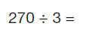 | - Any related fact (x 10/ 100) linked to tables  - Know and use 27÷ 3 related fact  - Check with multiplication | Mental
 | 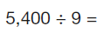 | - Any related fact (x 10/ 100) linked to tables  - Know and use 54÷ 9 related fact  - Check with multiplication | Mental
 | 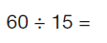 | - Any TU÷TU  - Read as ‘how many groups of 15 in 60’  - Recall and use related multiplication fact  - Double double 15 | Mental
 | 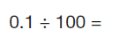 | - Any similar PV calculation | Mental
 | 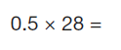 | - Read / interpret 0.5=half; ‘half times 28; 28 lots of a half | Mental  jotting
 | 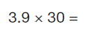 | - Any U.t x multiple of 10  - Find simple PV calculation: (3.9x10 ) x3 | Mental  jotting
 | 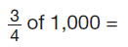 | - ¾ of any 2/3/4 digit multiple of 10  - Find half , halve again to find quarter, x 3 | Mental  jotting
 | 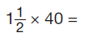 | - Any mxed number x multiple of 10  - Multiply whole numbers, then multiply by half  - Know and use related tables fact 1x4 | Mental  jotting
 | 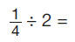 | - Any unit fraction ÷2  - Use mental imagery of fraction wall/ bar model | Mental
 | 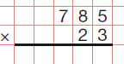 | - Any HTU x TU (Long Division)  - Use rounding to check reasonable answer eg 800x 20; 80 x 20 x100 | Formal  method
 | 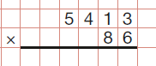 | - Any TH HTU x TU (Long Division)  - Use rounding to check reasonable answer eg 5000 x90; 500 x9 x100 | Formal method
 | 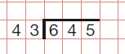 | - Any HTU ÷TU  - Use rounding and multiplication to check: 43 x ?=645; 43 x10= 430; 43x 15 =645 | Formal method
 | 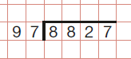 | - Any TH H T U ÷TU (Long Division)  - Use rounding and multiplication to check: 97 x?= 8827;  97 x10=970; 97 x100= 9700; | Formal method
 | 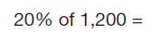 | - Any % of 3 or 4 digit number  - Find 10% (use PV) then double | Mental  jotting
 | 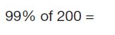 | - Find 1% and subtract from 200 | Mental  jotting
 | 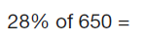 | - Any % of 3 or 4 digit number  - Find 10% (use PV) 5%, 1% and combine to find 28% | Mental  jotting
 | 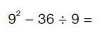 | - Order of operations  - Know and understand squared  - Know and recall tables fact | Mental  jotting

