2018 KS2 Multiplication/Division Qs  (Generate similar examples) | Knowledge/ strategy  Mental strategies need to develop through discussion, modelling the mathematics using concrete resources combined with recording (eg number lines, part whole diagrams such as bar models). |  | Pupils who need further teaching to address gaps in understanding  Date:
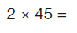 | - Any TU x2  - Read as ‘double 45’ or two times 45/ 45 multiplied by 2  - Know doubles of any TU number | Mental
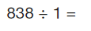 | - Any number ÷ by 1  - Conceptual understanding | Mental
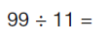 | - Any division fact related to tables fact  - Recall tables fact  - Know linked tables fact to check | Mental
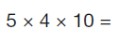 | - Any multiplying of 3 numbers including 10/100  - Know and recall tables fact plus PV understanding | Mental
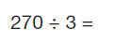 | - Any related fact (x 10/ 100) linked to tables  - Know and use 27÷ 3 related fact  - Check with multiplication | Mental
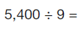 | - Any related fact (x 10/ 100) linked to tables  - Know and use 54÷ 9 related fact  - Check with multiplication | Mental
Additional Examples
25÷1= | - Any TU÷1  - Conceptual understanding | Mental
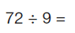 | - Any tables/ division facts  - Number fact recall / inverse check | Mental
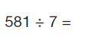 | - Any 3 digit ÷U  - Notice 581= 560+21 (multiples of 7)  - Short division, check using facts | Mental
5÷10 | - Any U÷10  - Using understanding of PV/ links with 5/10  - Using bar model / number line imagery | Mental
0.4 ÷10 | - Any decimal to 1 dp ÷10  - Using understanding of PV | Mental
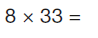 | - Any TU x U  - 2 part calculation: (30x8) +(3x8) ; use of PV  - check using facts &PV | Mental  Jottings
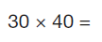 | - Any multiple of 10 x multiple of 10  - Use related number facts &PV: 3x40 , 30x40, | Mental  Jottings
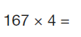 | - Any HTU x U  - Vertical layout expanded  - Check with facts eg 100x4; 60x4;7x4 | Formal
0.9x2 | - Any decimal to 1 dp x U  - Link with fractions/ equivalent decimals, eg 9/10 x 2= 18/10= 1.8  - Calculate as 9x2 then divide by 10 | Mental

