KS2 Add/ Subtraction Qs  (Generate similar examples)  2018 | Knowledge/ strategy  Mental strategies need to develop through discussion, using modelling the mathematics using concrete resources combined with recording (eg number lines, part whole diagrams such as bar models). Pupils need to decide when formal methods an appropriate choice. | Pupils who need further teaching to address gaps in understanding  Date:
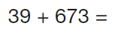 | - Any near multiple of 10 +HTU  - Add 40 and adjust
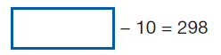 | - Read calculation ‘something -10 =298;  - Use part/whole understanding. Bar model to support  - Know 298+10  - Use PV understanding
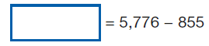 | - Equals sign at the beginning
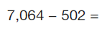 | - Any 4 digit – 3 digit number  - Formal method
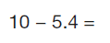 | - Any whole number - decimal (tenths)  - Use number line imagery  - Know 10-5 = 5; 5-0.4= 4.6
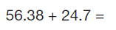 | - Any TU.t h + TU.t  - Use formal, check with rounding (56+25)  - Check use of PV when setting out (zero as a place holder)
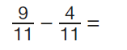 | - Any subtraction of fractions with same denominator  - Link to U+U number bond facts
Additional examples
3+ 0.5 | - Any whole number + tenths decimal  - Using PV understanding, saying ‘5 tenths’ and ‘0 point 5’  - Using number line imagery/ PV arrow cards
4 – 0.5 | - Any whole number – tenths decimal  - Using PV understanding, saying ‘5 tenths’ and ‘0 point 5’  - Using number line imagery
9- 3.4  6+2.7 | - Any whole number +/ – tenths decimal  - Knowing/ checking reasonable answer  - Using number line imagery
2/6 + 3/ 6=  4/6 + 3/6 = | - Any addition of fractions with same denominator (to one and more than one whole)  - Link to U+U bonds as known fact  - (Bar model imagery/ fraction walls)
5/8 -2/8 = | - Any subtraction of fractions with same denominator  - (Bar model imagery/ fraction walls)
2/8+ 1/8 +4/8= | - Adding any 3 fractions same denominator  - (bar model imagery/ fraction walls)
2 ½ + ½ | - Mixed number addition same denominator  - Recognise ½ +1/2 = one whole

