Y3/4 | KS2 Add/ Subtraction Qs  (Generate similar examples) | Knowledge/ strategy  Mental strategies need to develop through discussion, using modelling the mathematics using concrete resources combined with recording (eg number lines, part whole diagrams such as bar models). Pupils need to decide when formal methods an appropriate choice. |  | Pupils who need further teaching to address gaps in understanding  Date:
 | 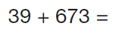 | - Any near multiple of 10 +HTU  - Add 40 and adjust
 | 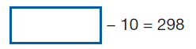 | - Read calculation ‘something -10 =298;  - Use part/whole understanding. Bar model to support  - Know 298+10  - Use PV understanding
 | 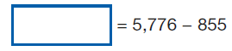 | - Equals sign at the beginning  - Bar model to support
 | 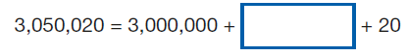 |  | Use PV understanding
 | 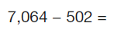 | - Any 4 digit – 3 digit number  - Formal method
 | 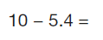 | - Any whole number - decimal (tenths)  - Use number line imagery  - Know 10-5 = 5; 5-0.4= 4.6
 | 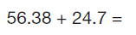 | - Any TU.t h + TU.t  - Use formal, check with rounding (56+25)  - Check use of PV when setting out (zero as a place holder)
- Any whole number subtract decimal to 3dp
- Use formal, check with rounding (6-6)
- Check use of PV when setting out (zero as a place holder)
 | 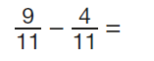 | - Any subtraction of fractions with same denominator  - Link to U+U number bond facts
 | 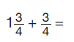 | - Mixed number +fraction same denominator  - Separate whole number from fractions  - Two steps, recombine fractions and whole number eg 1+ 6/4=
 | 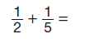 | - Addition of unit fractions with different denominators  - Equivalence imagery (bar model/ fraction wall)
 | 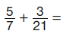 | - Addition of fractions different denominators
 | 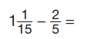 | - Mixed number - fraction different denominator  - Convert mixed number to top heavy fraction then both to same denominator  - Equivalence imagery (bar model/ fraction wall  - Multi- steps, change fraction to simplest form
 | 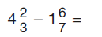 | - Mixed number subtract mixed number different denominators  - Convert both to top heavy fractions  - Find LCD, subtract  - Change to mixed number answer
 | 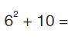 | - Understand squared number

