KS1 Multiplication and Division Qs  (Generate similar examples) | Knowledge/ strategy  Mental strategies need to develop as a consequence of pupils talking about and using concrete resources combined with recording (using number lines, arrays and part whole diagrams eg bar models) | Pupils who need further teaching to address gaps in understanding  Date
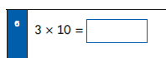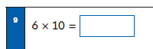 | - Any U x 10 from 10 x tables  - Understand this can be read as ‘3 times (multiplied by) 10’ and ’10 times (multiplied by) 3’ etc
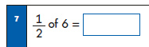 | - Can ‘read ‘fractions as numbers  - Know half of all even units numbers
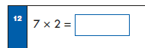 | - Any U x 2  - Can interpret tables fact as ‘counting in 2s’ or ‘double 7’
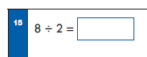 | - Can ‘read’ as ‘half of 8’, ‘8 divided into groups of 2’  - Recall and use with understanding 2x 4=8 to check
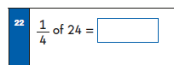 | - Able to ‘read’ one quarter written as a number.  - Able to find one quarter of a number by finding half and halving again  - Recall and use part whole diagrams eg bar models for halves and quarters.  - Understand and use one half = two quarters
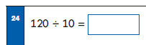 | - Any multiple of 10 divided by 10  - Read and interpret as ‘120 divided into groups of 10’  - Count in 10s beyond 100
Examples as above using multiples of 5
Find 1/3 of a number | - Able to read ‘one third’  - Able to use bar model diagrams to show equal parts
Find 2/4 of a number

