KS1 Add/ Subtraction Qs  (Generate similar examples) | Knowledge/ strategy  Mental strategies need to develop through discussion, using concrete resources combined with recording (eg number lines, part whole diagrams such as bar models) | Pupils who need further teaching to address gaps in understanding  Date
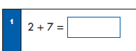 | - Any U+U preferably as known fact  - Could link to ‘missing box’ presentation and bar models/ part- whole
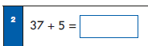 | - Any TU +U, bridging through 10  - Using number bonds to partition second number eg 3+2= 5
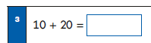 | - Any multiple of 10 + multiple of 10 (link to Q10)  - Model with structured resources  - Link to U+ U facts eg 1+2
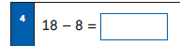 | - Using teens number PV knowledge  - Model with PV arrow cards, dienes, 2 part diagrams
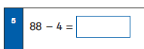 | - No crossing of 10s boundary  - Count back 4  - Know 4 is half of 8 to check
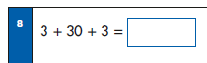 | - Understand can do in any order, explain choice  - Spot double 3= 6
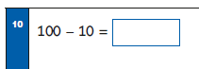 | - Any multiple of 10 - multiple of 10 (Model with structured resources)  - Know multiples of 10 facts to 100  - Link to number bonds of 10
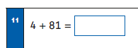 | - Understand and use commutativity to calculate as 81+4  - Know and use 4+1=5 as a fact
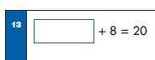 | - Able to ‘read’ this calculation as ‘something’ plus 8=20 or 20= 8 plus something. Bar model or part-part whole diagrams to support  - Know and use number bond of 20
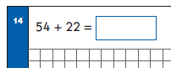 | - Any TU +TU  - Add multiples of 10 to a number then adding units eg 54+20+2  - (Bridge through 10 with units if necessary)
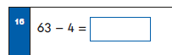 | - Any TU -U where units number bridges through 10 eg 63-3-1
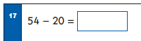 | - Any TU – multiples of 10  - Model with dienes
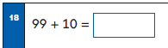 | - Bridging through 100 boundary
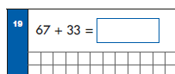 | - Any TU +TU  - Counting on in multiples of 10 then ones eg 67+30=97  - Knowing and using number bond of 10 for units
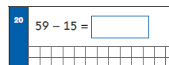 | - Any TU-TU, no crossing 10 boundary eg 59-10=49; 49-5= 44  - Using number bonds for 9 (5+4)
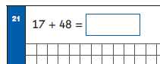 | - Any TU +TU  - Understand and use commutativity to calculate 48+17  - Adding teens number as + 10 + units  - Using number bonds (7=2+5) to bridge through 10 eg 48+10=58; 58+ 2=60; 60+5 =65
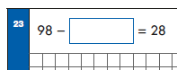 | - Able to ‘read’ this calculation as 98- ‘something’ = 28 or 28+ ‘something’ = 98  - Recall and understand part whole diagrams eg bar models  - Recognise only need to add or subtract 10s
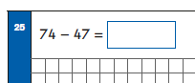 | - Any TU-TU  - Count back in multiples of ten (40) then partition 7 to bridge through 10 eg 74-40=34; 34-4-3= 27  - Check by considering the fact 74-50 =24 so must be 3 more

