Bar Modelling
Topic Area: Ratio
- Resources and the origin of them:
Previously, I have only used Bar modelling within the topic of Percentages, and also to a lesser degree, with Fractions, so wanted to give myself the challenge of tackling a new topic in a different way. I chose Ratio as this is a topic my year 9 group were about to tackle, and also, my current year 11 group are finding it difficult visualising ratio in order to tackle questions. I thought that giving the tool of Bar Modelling early on, could help certain pupils find an approach to answer more complicated Ratio questions.
I researched various websites and also some online tutorials that introduced the Singapore method with Bar modelling. www.thesingaporemaths.com gave me some worked examples, as did www.greatmathsteachingideas.com and various youtube blogs such as www.youtube.com/watch?v=XaHftZe-zck&nohtml5=False gave an online questions that I could adapt and use in my own powerpoint.
My plan was to introduce the bar model to my high set year 9 group so that they could use it as a tool to try to tackle the most complicated ratio questions. I did emphasise that bar modelling was not the only method available for them to use. Some pupils, who appreciate visual representations of problems would prefer to use bar modelling to help them tackle questions while other pupils may prefer other methods.
- Methodology
Using models adapted from examples in the above websites, I designed a powerpoint that I hoped would introduce the concept of bar modelling at a very easy level. I insisted that even if the class could work out the answer, at this early stage, they were to draw a bar model to represent the question. By doing this, I could ensure that the actual understanding of the concept was represented on whiteboards before I gave the class questions to try in their books.
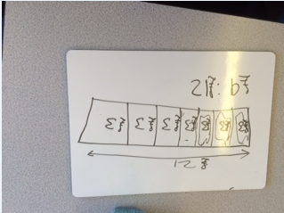
Having introduced the visual aid, I was pleased that the class were able to share ratio into given quantities and were happy to draw out bars.
We were also able to successfully use ratio to find a quantity when the other was known.
After some more practice, I then pushed the class by resourcing some tricky ratio questions and trying to apply the bar model to these. Again, I insisted on attempting to find a bar model to represent the problem. Only after we had found the answer using a bar model, did I then encourage the class to try to think of other ways to tackle the problem.
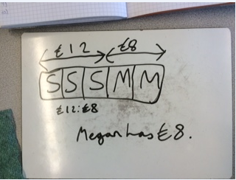
My intention was then to give them various ratio questions and to encourage them to use bar modelling at least to help them to find a route into a ratio question, even if they didn’t use bar modelling for the whole question.

- Outcomes
Pupils were very responsive to using bar modelling for the simpler ratio questions and I was happy that they really understood the concept of a ratio and sharing it out. However, with the most complicated questions, pupils still struggled to fully grasp the total method. However, I do feel that with perseverance, both on their part, but also on my part, and with more examples, this would become easier. I need to practice finding the best representation myself and portraying it well in a bar model. I feel that I will definitely use the resources again with another group, but will tweak my powerpoint to find more examples of a similar type so that pupils can have more confidence with the trickiest questions (see slides 13-25 of powerpoint).
As I said earlier, I did emphasise with the class that this was a tool to use if they wanted to so also showed pupils ways of tackling questions without using bar models.
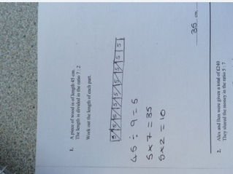
Having tackled the trickiest questions, I then gave the pupils questions from the ‘kesh’ selection of exam questions to practice. I didn’t insist on the bar model method, but many pupils chose to use this visual representation to help them.
One problem I did have was that some pupils really wanted to use the bar model method for ratio with large numbers – so were taking time drawing many bar segments (eg ratio given of 15:19). I encouraged them to try to visualise what they were doing and why.
- Next Steps
I will be keen to trial this method with lower ability classes – obviously focussing on the simpler questions, sharing an amount into ratio and using ratio to find quantity. However, I am also going to persevere with the more complicated questions with other top sets. I will continue to emphasise the ‘tool’ aspect of this method and encourage pupils to think about other methods also (see slides 27-29 of powerpoint)

