Bar Modelling
Topic Area: Number
Fractions
- Resources and the origin of them
Before presenting the bar modelling method to my low ability year 10 pupils, I spent some time reading blogs about how it was best utilised. From this, I devised a sequence of lessons to teach fractions to my pupils. Although they have been taught this topic several times during their mathematical education, it is a topic that they find extremely difficult. I used a variety of resources, some I created myself and others were sourced from online websites.

My objective was for this to be a pictorial representation with scaffolded questioning, in order for my pupils to access the topic and eventually construct visual representations of more complex problems.

Literature Review
http://www.thedailyriff.com/WordProblems.pdf
http://www.hmhco.com/~/media/sites/home/education/global/pdf/white-papers/mathematics/elementary/math-in-focus/mif_model_drawing_lr.pdf?la=en
http://194.81.189.19/ojs/index.php/step/article/viewFile/243/368

- Methodology
The set of lessons started with very basic equivalent fractions using the bars. The worksheet was taken from http://www.mathworksheets4kids.com. Pupils then investigated this further by cutting and sticking strips of paper cut into equivalent pieces.
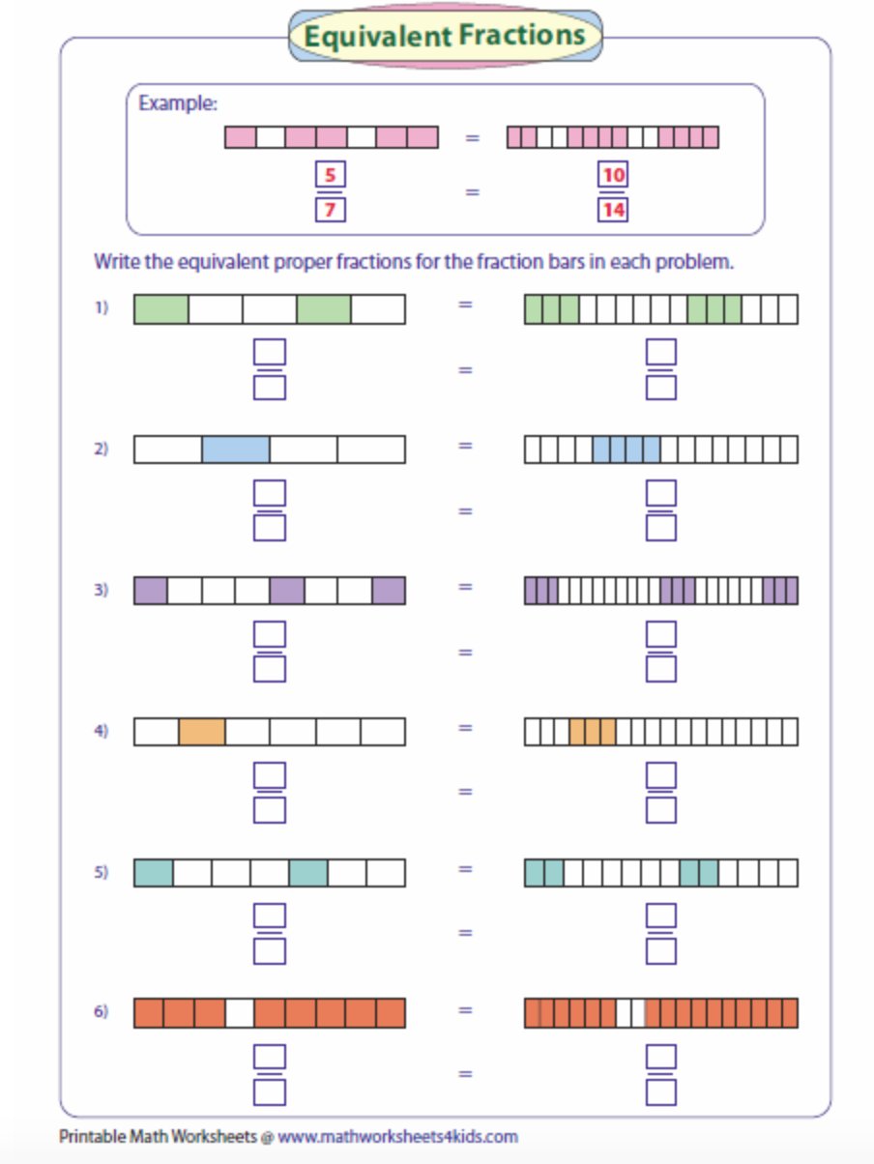
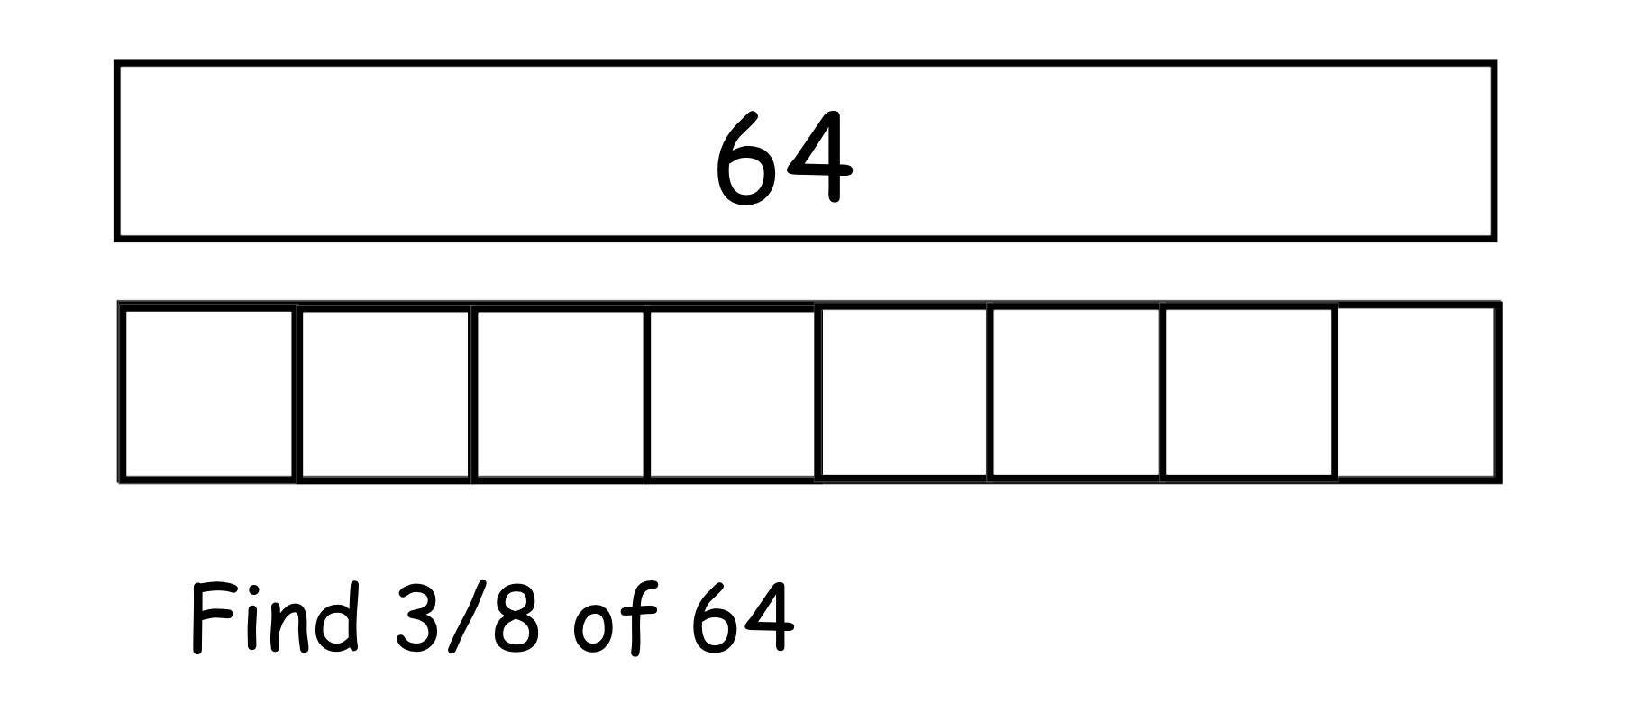
The following lesson, pupils were given mini white boards and we used the bar modelling approach to find fractions of an amount. By lesson three we started to use the bars to model more complex wordy problems. We began initially by drawing them as a group, eventually moving to working independently.
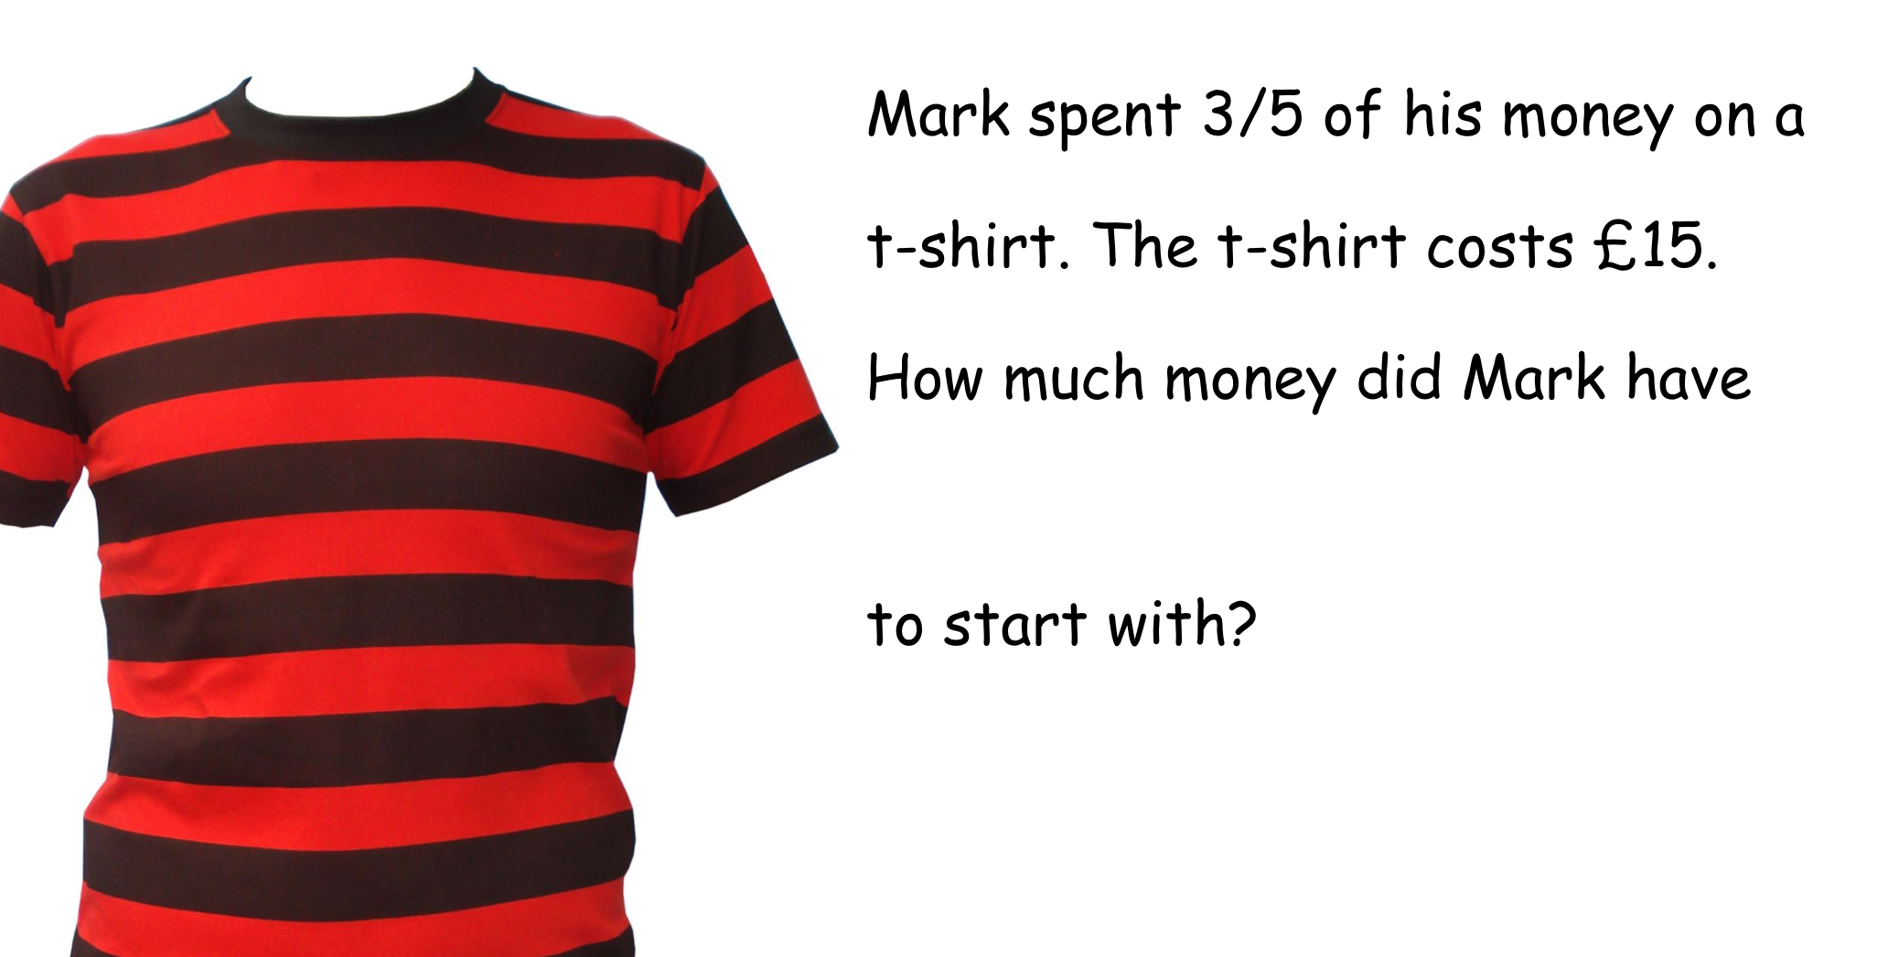

- Outcomes
I trialled this with a low ability Year 10 class, when introducing the method I explained to the class that this would be a new approach to problem solving and would help them to finally crack fractions. The bar method was a new approach for all of them, which made them all feel as though they were all at the same point .

The pupils were very quick to pick up the idea about equivalent fractions and seemed to enjoy making equivalent fractions using strips of paper. As the idea of the bar method became familiar we moved away from pieces of paper and began using mini white boards. The reason behind this was to reduce the time we spent cutting paper, but additionally a mini white board allowed them the flexibility to wipe out mistakes easily without it being a permanent feature in their books.

One of the biggest challenges I faced as a teacher was the hesitancy from the boys. They openly referred to it as a “baby method” and as a practitioner I had to be overtly positive about how well they were now doing while applying this method. Despite their reservations it proved to be successful as pupils were engaging with a topic they were previously struggling to access. The visual representation made conversations about why things were happening much easier for them to grasp.

- Next Steps
Having trialled this approach with a KS4 foundation class, I am interested in trying this with a KS3 low ability group. I hope by introducing it at an earlier stage in their education, they are more willing to accept it as a method. This will reinforce their number work and lead into supporting them with abstract concepts by visualising everything in an algebraic approach.

