Bar Modelling
Topic Area: Number
Numeracy techniques
- Resources and the origin of them
I have used bar modelling sporadically in the past, I have used it mainly for fraction work and the pupils are open to it. Using it for numeracy, at a very low level, without insulting the intelligence of my classes was difficult.
I used resources that are already made to help introduce the bar modelling technique http://www.thesingaporemaths.com/ This website is great for step by step instructions on how to use the bars to solve word problems, exercises and their answers. It is based for KS2 pupils but was a nice way in for my year 7’s. I also used a worksheet from http://thepensivesloth.com/tag/tape-diagrams/ to illustrate how sums may be shown. He has some good ideas on how to use the bar model- he calls them tape diagrams.
Lastly, to see if my pupils had benefitted from the bar modelling introduction I used AQA’s problem solving file from http://filestore.aqa.org.uk/subjects/AQA-9306-W-PSQ.PDF. I selected a few of these problems for my class to attempt with models. I use these problems regularly with all abilities are not based on tryng to be functional or necessarily difficult but on the pupils being able to understand the skills and maths that is needed to be able to answer the problem.

My plan was to arm my low level year 7’s with strategies, skills and tools to tackle numeracy problems using diagrams and bar models.

- Methodology
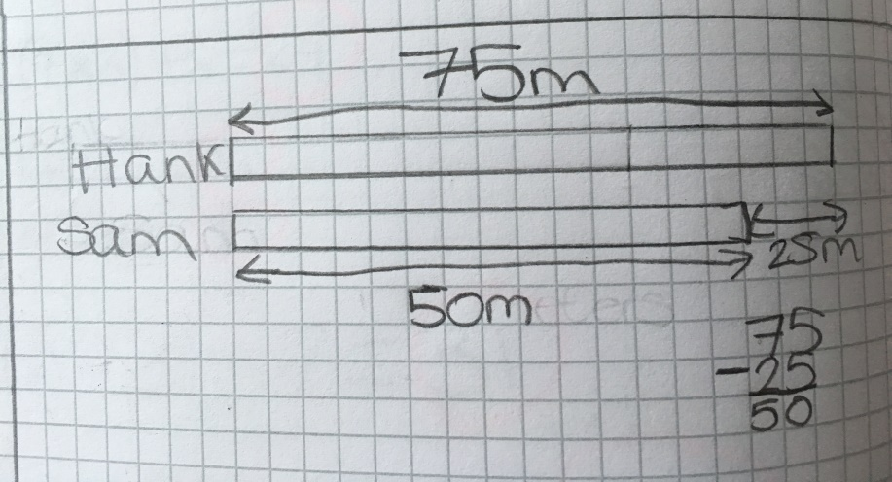
We started our journey of bar models on mini whiteboards. This is a split class that I only see once a week on a Friday afternoon, mini whiteboards keep them interested and dispel the ‘fear’ of getting it wrong even if we don’t have much written down in their books after a lesson. We used year 4 level1 , 2 and 3 from http://www.thesingaporemaths.com/ to show examples and get pupils practicing the bar model. These only included adding and subtracting problems to be illustrated using the bar model, we needed to start small. It took a lot of persuasion. They did not believe that this was of any use to them and they did not need to use a bar model as they could work them out. This changed when I was giving them problems they could not solve independently. They got used to differences and sums/ totals of expressions and how to build their bar model to find an answer. The class worked in groups or pairs to help them with this new approach to problem solving.

They did some basic problems from the website working together to develop the diagram that went with it- even if they could answer the question without it. We would then use the animations on the website to check their work or cement their ideas. Some pupils still not wanting to write in their books until they knew it was correct. In hindsight we should have spent more time on this, including looking at multiplying and dividing using bar modelling but time constraint and delivering the curriculum gets in the way.

My plan was to see if this way in was useful for my class by asking them to do further tasks that would/could require bar models- either in an obvious way or not.

- Outcomes
Pupils became a lot more open to the idea of bar modelling for number work after we had revisited it numerous times, I think they were very set on their own methods and even if they didn’t have a method they were very happy with trial and improvement until they find the right answer.

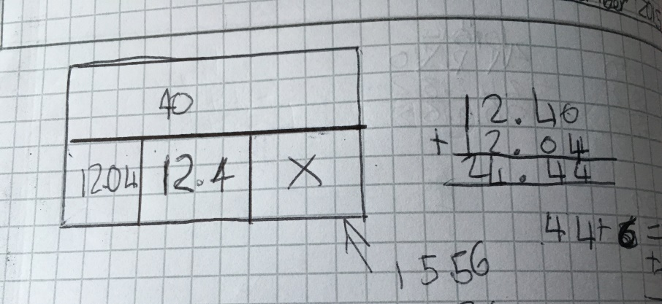
After a bit of time, I thought I would test the water with bars again and gave them the pirate joke with bar models, they loved it. They were very keen and could apply their knowledge and understanding of bars modelling to find the unknown values and find the answer to the riddle. They were confident with adding the lower bars and finding the difference with the upper bar if necessary. Myself, the class and the TA were pleased with the approach and mind-set toward bar modelling and it had been a success, but it was obvious that this task needed them to use these skills. The bars were drawn for them and they just had to use them to find the missing amounts.

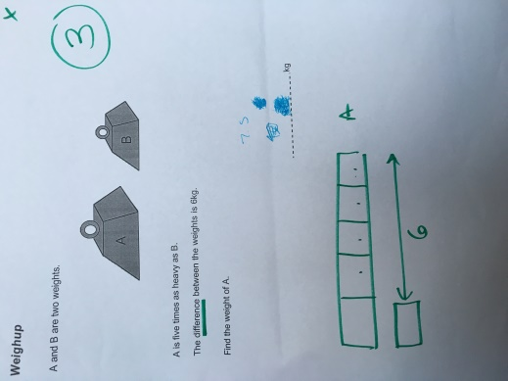
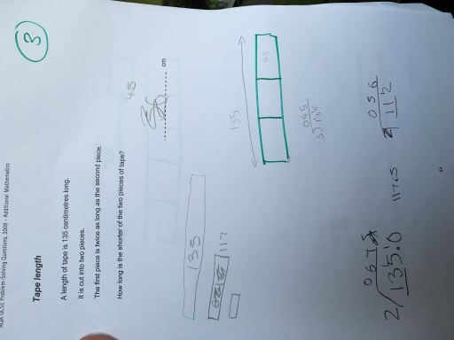
The real test came when I wanted the class to solve some more challenging problems without hinting at the bar modelling as an approach. From the AQA problem solving pack I used ‘Coin double’, ‘Five times’, ‘Bunch of pens’, ‘Apple crumble’, ‘Tape length’, ‘Toto’, ‘Weighup’ and ‘Skywalker’ as a relay race. I put them into pairs, they came to get a question, gave it a go, brought it back to me, if they got it correct I gave them 5 points, if they got it wrong I sent them back to try again, they would get 3 points on a future visit if they got it right. Well this was the plan, there were lots of wrong answers! No groups were deciding to model their problem using a model or diagram of any kind so I adapted my plan. If they bought me a attempt at an answer which was wrong I would draw them a basic bar model diagram to help support their workings. They tried hard and the number of correct answers after they had a basic model rocketed. It was good to see their confidence grow and their ability to use the diagram I drew. It is clear from this that we still need to work on how to draw a bar model to represent a problem or situation but their ability to use and draw information from them has grown.

I taught my low ability year 7’s using year 4 problems and I hope that in future years pupils have the skills to use techniques they have learnt at primary school with bar modelling up to secondary school to apply to new topics and subjects to help them progress. It was difficult to embed this when they already have an abstract way of thinking about these problems (or think they do). If it was regularly used from an early age then, hopefully, pupils will be more receptive to solving problems and be comfortable using any method they have to hand.

- Next Steps
I plan to use the bar model more and more with other classes for fractions and percentages as well as delving into algebra with them. I will aim to develop resources for our scheme of work for these topics for year 7 and ratio and proportion in year 8.

