Bar Modelling
Topic Area: Algebra
Solving Simultaneous Equations
- Resources and the origin of them
Having used the bar method with number work (fractions, percentages and ratio) and seeing how well some students responded to it, I wanted to extend the bar method to algebra. I had found and used Thinking Blocks (available at http://www.mathplayground.com/thinkingblocks.html ) with number topics, but was unable to find useful bar method resources to help with simultaneous equations.

I intended that students used the visual bar method as a way of accessing simultaneous equations, and then could move on to other more efficient methods once understanding of the processes involved had been established.

- Methodology
The idea was to create a visual way of introducing or reinforcing the elimination method of solving simultaneous equations, and to deepen understanding of why and how to eliminate terms. The Powerpoint demonstrated using two bars, one for each equation, then matching them to identify similarities and enable elimination.
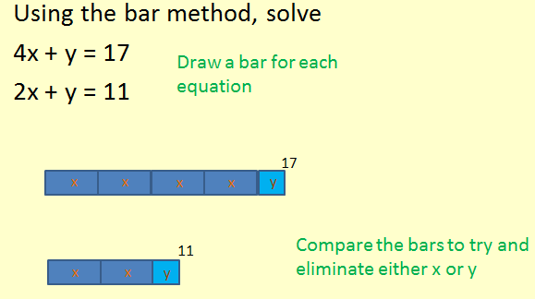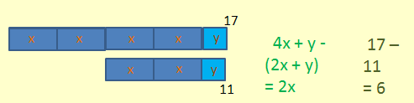

I used one example with a subtraction, indicating this by putting the block underneath the rest of the bar.
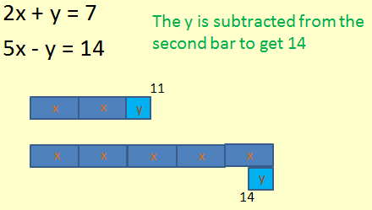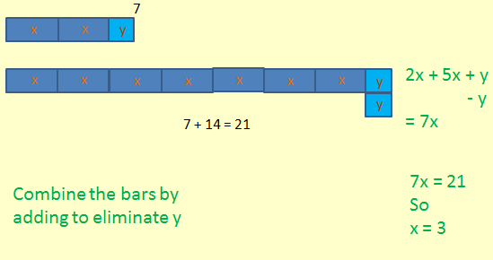

Following these examples, students were then given GCSE exam questions on simultaneous equations to answer.

- Outcomes
This was used with Year 11 students previously working at C/D grades, who had various levels of prior knowledge of simultaneous equations. Most had little or no prior knowledge of using the bar method. More confident students were able to move quickly to solving simultaneous equations without drawing the bars.
Weaker students in general were happy to draw the bars and used these to base their working on.
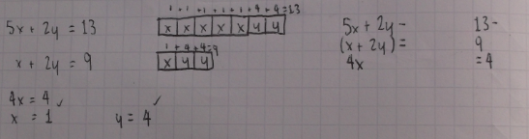
In the example above the student worked out the value of x, and then wrote the numbers above the bars to calculate y.

In evaluating the bar method as a way of deepening understanding of using elimination to solve simultaneous equations there are two main considerations. Firstly it would be beneficial if students were familiar with using the bar method. In this case, they had used it maybe once before for ratio, so its use had not been firmly established as a ‘go-to’ method.
Secondly, using the bar method as an introduction to more efficient algebraic (written) methods gave several pupils the confidence to tackle simultaneous equations, where they had otherwise baulked at answering such questions. As previously noted, some students having seen the method did not feel the need to use it as they could see what was happening and understood what to do.

Overall I felt that all students benefited from seeing the bar method, and it helped to re-inforce their understanding of how and why to use elimination to solve simultaneous equations. These conclusions have been based solely on my observations with two Year 11 classes, and on comments made by students who said that they could more clearly see what to do.

- Next Steps
I have used a couple of ways of teaching simultaneous equations using pictorial representations (for example comparing items of food on a menu to work out individual prices). The bar method is a more efficient way of doing this, and I would like to investigate how these two methods could be linked.

I also think I need to develop further ideas for subtraction and negative numbers.

