Bar Modelling

Topic Area: Algebra
Solving Equations
- Resources and the origin of them
This set of lessons was designed by Roberta follow on from the creating and rearranging lessons that I had designed. They move from simple set up with the bar method through to unknowns on one or both sides. I added a lesson in the middle where brackets had to be expanded before solving as we had recently covered expanding bracket. I used the lessons with a high ability year 7 class directly after the creating and rearranging lessons.

- Methodology
I used the lessons from Roberta as a 3 lesson set, one lesson with unknown on one side, one with brackets and the final with unknown on both sides.

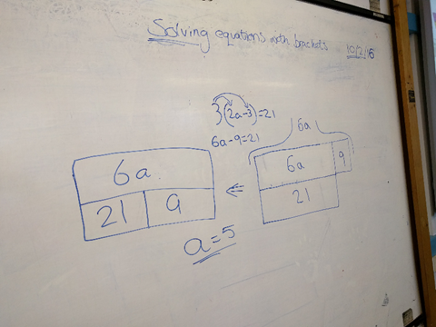
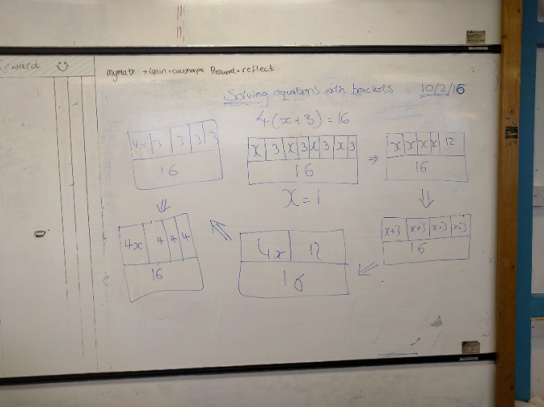
- Outcomes
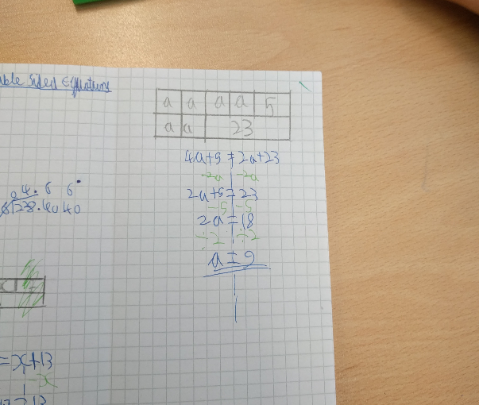
Having completed the creating and rearranging lessons, students were very happy forming the bars for the equations. From the beginning a few students had identified a way of representing the subtraction sums with a ‘hat’ which is something I had worried about a little knowing it came up in the next lesson, but the students came to it on their own. Almost all the class took to this method and it really helped the lower end of the group to visualise the equations. There were a few that initially wanted to just write down answers but encouraged by the idea they were a test group, and this method would help them when there are unknowns on both sides they did use the method successfully.

As we moved into equations where brackets were involved the students came up with lots of ways of representing the situation, this meant that more students were able to access the work than might have been the case otherwise. It was interesting to see how students of different levels approaced this, some expanded the bracket before drawing bars and others took it down to a basic level.

When we moved onto solving with unknowns on both sides I feel the bar method really came into its own. Being able to line up terms in an equation meant that students could cancel them out in order to solve, from this they were able to develop a balancing method, going from pictorial to abstract.. This worked beautifully for when all elements of the sum are addition, however, with subtraction things got a bit tricky.

Most students were happy to move onto the balancing method for this, where others persavered with bars to varying levels of success. This is definitley something to look at in the development of teaching this lesson. The image show shows an incorrect example of how students represented an equation compared to the correct version in the lesson sildes.

Generally I feel students got further with solving equations at this early stage in Yr 7 that I would normally have expected, espeically the lower ability in the class. A lot of students commented on enjoying this set of lessons and that they found solving equations much easier this way.
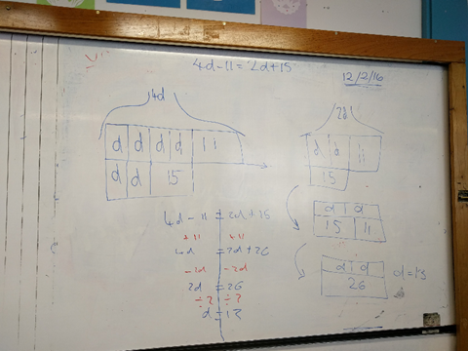

- Next Steps
I plan to revisit this topic with my Year 7s and spend longer investigation how to represent working with subtraction sums. I am also aiming to use the lessons on solving simultaneous equations using the bar method.

