Bar Modelling
Topic Area: Algebra
Solving Equations
- Resources and the origin of them

I had previously only really used the bar model with ratio, so using it with algebra was a new concept for me. Through research via the TES and other websites I found a collection of resources which I then built upon to create a pathway through from solving one step equations up to solving with unknowns on both sides. The resources were designed to offer a scaffold towards balancing, rather than a replacement for it.

Particularly useful were the three worksheets by ‘ianmckenzie’ on TES found here: https://www.tes.com/teaching-resource/solving-linear-equations-using-the-bar-method-11000712. Following the ideas in the worksheets I went on to create a PowerPoint which would support the teaching of the method.

- Methodology
I taught the topic to bottom set year 9, who had a very varying understanding of algebra and equations. I started by introducing the bar method with rearranging, making use of the lessons created by Amy Tate. The group had already met bar modelling with ratio in the previous unit of work, so were familiar with the structure to some extent already.

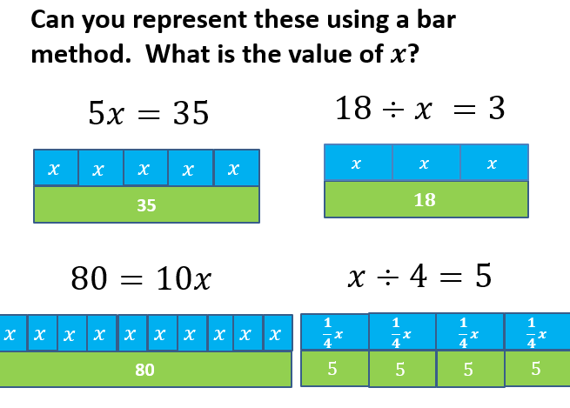
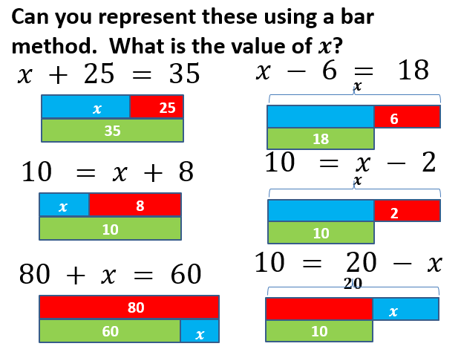
I started with one step equations. The greatest issue that had to initially be overcome was how to represent an equation where subtraction was involved. I settled in the end for a bracket which showed that the unknown was the whole bar. The idea was it could then easily be seen that the constants added together would make up the unknown.
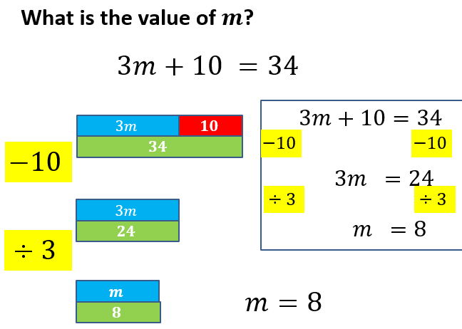
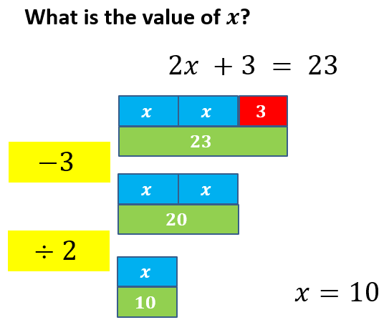
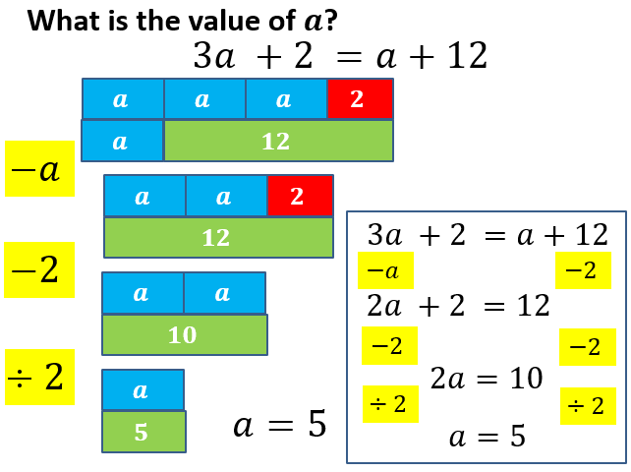
The slides then went onto 2 step equations. The yellow boxes on the left were shown to help show the links to the balancing method. It was also important to highlight that the size of the box of the unknown did not matter. With the help of animations on the PowerPoint the next section then went onto showing the links between the bar modelling method and balancing. This was then followed by a set of questions for them to attempt.

The slides finally progressed onto equations with unknowns on both sides, which was tackled in a similar method to the 2 step equations. I have not yet had the chance to trial this part with a group.

- Outcomes
I trialled this with a bottom set year 9 group who were very varied in both ability (stretching from an old NC KS3 level 2 to 5a) and their understanding of algebra. They had all been exposed to equations of some sort in the past and this did create issues, because some pupils were unwilling to try using the bar method, however all pupils did end up using it at least to some extent during the topic.

With the low level pupils, I focused on getting them to draw the picture of the equation rather than worrying too much about them solving to find the unknown. Typically, however, once they had managed to represent the equation they found the solving part fairly straightforward, and it was weaknesses in other parts of their mathematics (times tables for example) which provided the barriers to learning. I was very much focusing on helping the pupils understand what the unknown meant in the case of a pictorial representation, helping them to have a more pictorial base on which to build their understanding of equations and I do believe this worked.

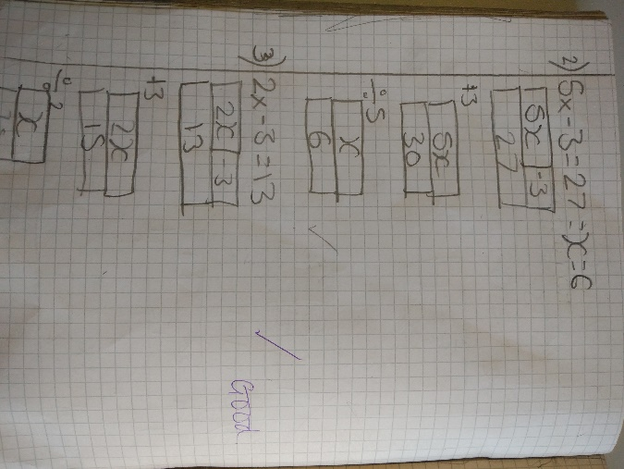
The middle ability typically embraced the bar modelling method fairly willingly, ho wever there were issues when something was being subtracted from the unknown, and I feel that the pupils in many cases learnt what the picture looked like for a subtract question, rather than understanding why it worked. It did, however provide a good support to the pupils solving two step equations and the balancing method. Interestingly it also linked nicely into equations with brackets – which was not something that I had actually considered representing with a bar model, but it formed a natural progression and helped develop understanding.
Differing approaches to dealing with subtraction strategies.
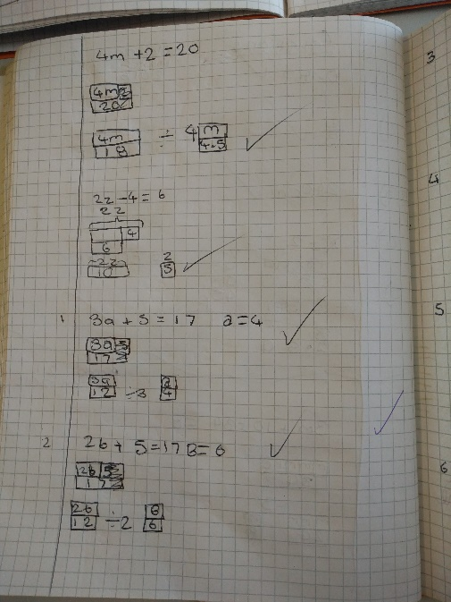
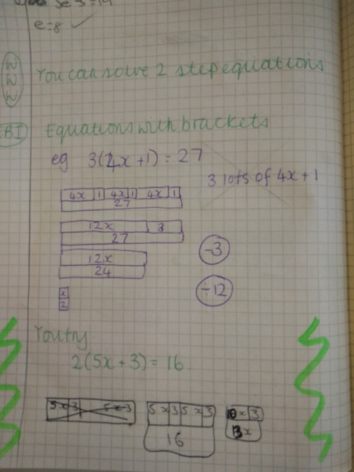
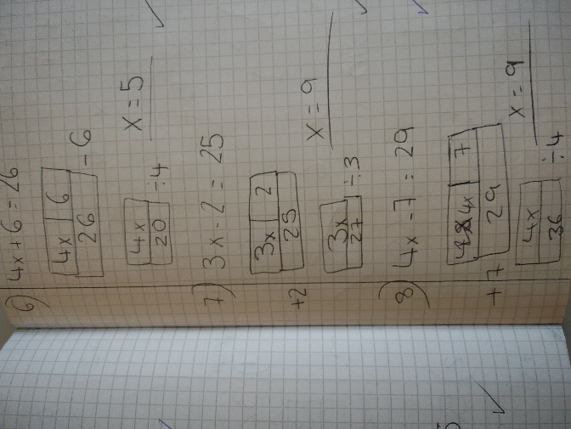

Broadening the application to solving with brackets.

The high ability pupils did struggle to see the need for the bar model, as in many cases they could just problem solve their way to the answer by doing the inverse (particularly the case for 2 step equations), but without representing it in any formal manner. It did however really help to develop the pupils understanding with equations with brackets and then unknowns on both sides – even if they then progressed quickly onto the balancing method as they found drawing the pictures too cumbersome.
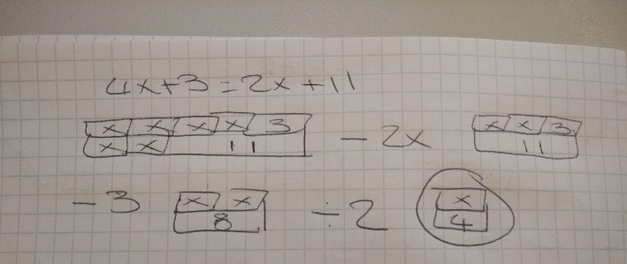
Unknowns on both sides

Overall I feel that the bar method did really help to develop the pupils understanding of how to solve equations by giving them a pictorial representation. It would be particularly useful when teaching a group meeting equations for the first time, rather than a group which had such varied past experiences of them. The method also did struggle where subtraction and negatives were involved, but my abilities to develop this were possibly hampered by the group that I trialled the method with.

- Next Steps
I would like to go on and try this method with a different group, especially to see how the method helps to develop the balancing method. There are also possibilities with expanding brackets which I did not realise existed and I would like to extend into that part of solving equations also. I do also feel that there are still some issues with subtraction that could benefit from some extra work to help make it clearer to weaker pupils.

