Bar Modelling
Topic Area: Algebra
Creating/Rearranging
- Resources and the origin of them
Having not used the bar method before I created a set of lessons to create visual representations of formulae using the bar method and also writing formulae when given the bars. This lead on nicely to rearranging formulae , students writing down as many different formulae as they could from the bars and then honing this skill when asked to make a specific variable the subject.

My intention was for this to be a journey for the students thought the lesson set with the idea of a subject being introduced part way through.

- Methodology
The set of lessons started with very basic creation of sums using the bars. Students used a ‘cut and stick’ approach to this, first measuring strips of paper and then laying out to prove equality and writing the statements using these for subtraction and addition.

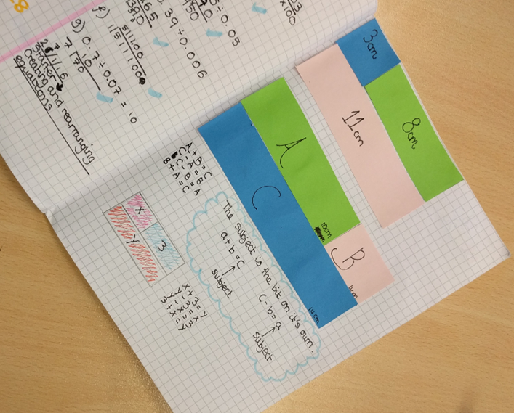
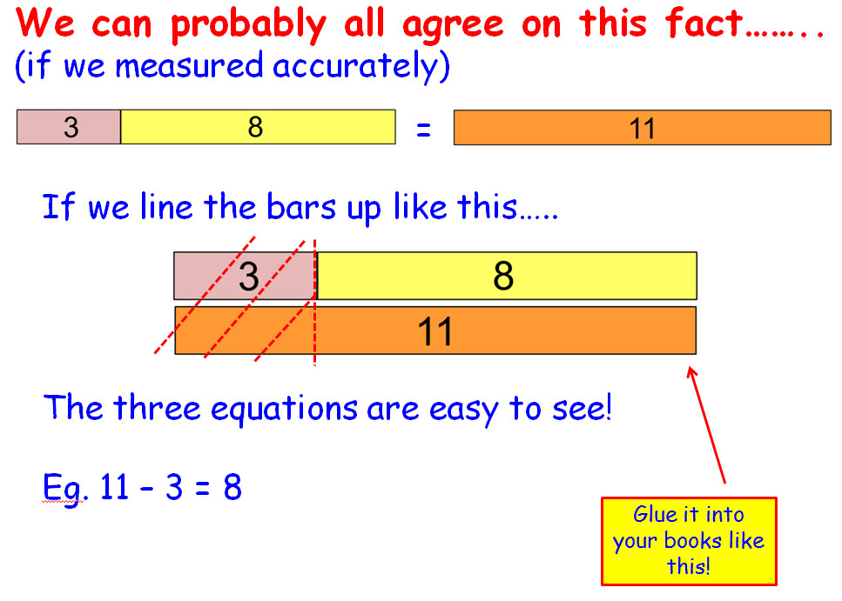
Following this, students were given a choice of continuing work cutting bars and gluing or moving onto drawing bars in their books as we started creating algebraic formulae and equations with the bars.

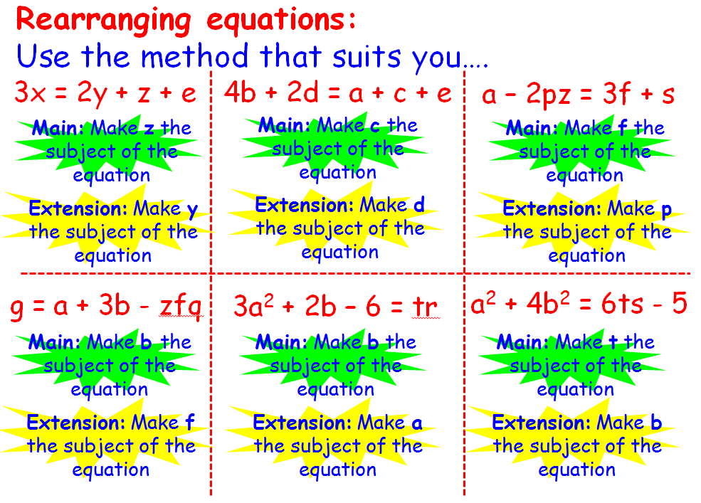
Once they were fairly happy creating various levels of formulae with their bars we moved onto writing formulae when given the bars. This approach automatically meant we were getting different formulae depending on how you approached the bars. It led onto discussions about the equivalence of different formulae and students rising to the challenge of writing as many formulae as they could for one set of bars. It was only at this point that I introduced the idea of a subject.

Further work was now to be given an equation, draw the bars for it and then students were given two subjects to rearrange to, one main task and one extension. Progress points in the lesson looked at the balancing method alongside the bars, some students preferring to use this method and most using for final stages on complex rearranging.

- Outcomes
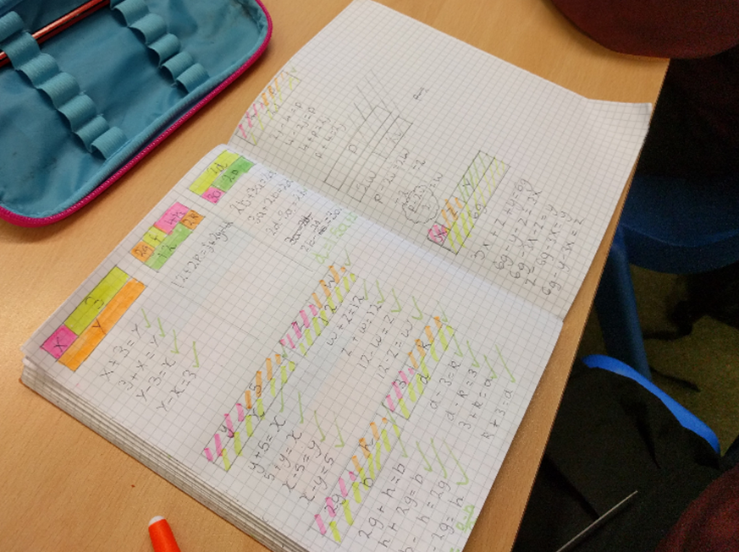
I trialled this initially with a high ability Year 7 class, when introducing the method I was hoping that some students may have seen this at primary school but it was new to all and this, I feel, made it more enjoyable for all of us. We flew through the introduction and simple formulae; they could see the value and were very keen to be trialling a new technique. (I discussed at the beginning that this was a new approach and they were going to help me try it out, also that I wanted them to watch out for what did and didn’t work and constantly searching for how we could improve the methods for our learning.)

Students were very quickly able to write multiple formulae from the bars they were given and in the second lesson became confident being given a formula and then creating the bars in order to be able to rearrange with ease. As the idea of the subject was naturally discussed students had become comfortable with the idea before being asked to make a particular element the subject. I have never seen students so easily rearrange to a subject as I have done with this method. Even the lowest ability student in the class was able to access quite complex formulae, in fact he lead the way and was helping others!

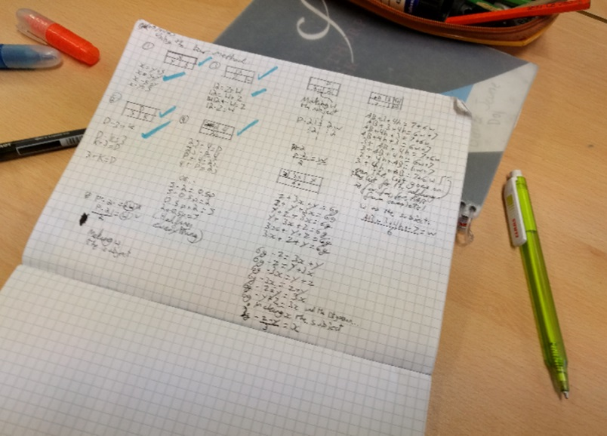
One thing that was a challenge was the number of different formulae they came up with! There were so many variations that it led to some lovely conversations about equivalence of formulae and how functions can be written in various ways.

I really enjoyed teaching this way with my Year 7s, and in fact have also taught this to my lower ability Year 8 students and although it took longer to get going they also much preferred the technique. Members of my department are now using this across all year groups to largely positive feedback, one even used it in an observation with SLT and they thought the method was brilliant with its visual aspect. I have had LSAs come and ask me about it to use with individuals and for intervention too.

- Next Steps
I have also used the bar method for rearranging, using the resources provided by my group members on the LMT, and my next aim is simultaneous equations. I am also going to try to introduce the bar method, especially with the younger years, to support number work. There is lots to try…….

