Y6 Block A Term 1 (15 lessons) | Learning Objectives :  By the end of this sequence of lessons all pupils will be able to….. | Mastery
Problem solving and reasoning  - Solve one and two-step problems involving whole numbers, simple fractions and decimals, money and measures, including time and temperature, perimeter and applying multiplicative scaling  - Identify and describe patterns, properties and relationships to establish invariants, apply in unfamiliar situations to make deductions; investigate a given statement and test with examples; collect data to create graphs and support an argument  Number and Place Value  - read, write, order and compare numbers to at least 1 000 000 and determine the value of each digit  - count forwards or backwards in steps of powers of 10 for any given number up to 1 000 000  - round any number up to 1 000 000 to the nearest 10, 100, 1000, 10 000 and 100 000  - solve number problems and practical problems that involve all of the above  - read, write, order and compare numbers up to 10 000 000 and determine the value of each digit  - round any whole number to a required degree of accuracy  - use negative numbers in context, and calculate intervals across zero  - solve number and practical problems that involve all of the above. | Year 6 | Contextual and investigative maths
 | Addition and subtraction  - perform mental calculations, including with mixed operations and large numbers  - solve addition and subtraction multi-step problems in contexts, deciding which operations and methods to use and why  Measures  - use, read, write and convert between standard units, converting measurements of length, mass, volume and time from a smaller unit of measure to a larger unit, and vice versa, using decimal notation to three decimal places  - convert between miles and kilometres  - Solve problems involving the calculation and conversion of units of measure, using decimal notation up to three decimal places  Geometry: properties of shape  - compare and classify geometric shapes based on their properties and sizes and find unknown angles in any triangles, quadrilaterals, and regular polygons  - recognise angles where they meet at a point, are on a straight line, or are vertically opposite, and find missing angles | Spot the mistake:  -80, -40, 10, 50  What is wrong with this sequence of numbers?  What’s missing?  The same amount is added each time:  1 □ □ □ 7  5 □ □ □ □ 16.25  True or False?  When I count backwards in 50s from 10 I will say  -200.  True or False?  The temperature is -3. It gets 2 degrees warmer. The new temperature is -5? Explain your answer.  Create it  Create seven digit numbers where the digit sum is six and the tens of thousands digit is two.  e.g. 4020000  What is the largest/smallest number?  Possibilities  Two numbers each with two decimal places round to 23.1 to one decimal place. The total of the numbers is 46.2. What could the numbers be?  Balance it  Make this calculation balance. What could the numbers be? Can you come up with other examples?  6.32 + □ = 8 - □  Missing symbols  Write the missing signs  ( + - ) in this number sentence:  6 12.3 = 61.9 11.9  What else do you know?  If you know this:  86.7 + 13.3 = 100  what other facts do you know?  What do you notice?  Give an example of a six digit number which rounds to the same number when rounded to the nearest 10000 and 100000  NRICH: Round the Four Dice  Convince me  Three four digit numbers total 12435.  What could they be?  Convince me  Explain the story of the graph  (using negative numbers in context)  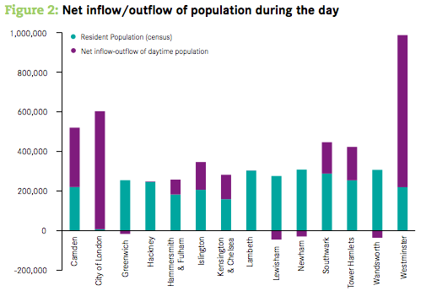  Ordering  Put these amounts in order starting with the largest.  100 cm³  1000000 mm³  1 m³  Explain your thinking  Write more statements  Chen, Megan and Sam have parcels. Megan’s parcel weighs 1.28kg, Chen’s parcel is 1450g and Sam’s parcel is half the weight of Megan’s parcel. Write down some other statements about the parcels. How much heavier is Megan’s parcel than Chen’s parcel?  What else do you know?  If I know 1 mile = 1.6 km, what else do I know?  If I know 1 km = 0.62 miles, what else do I know?  Time  A film lasting 200 minutes finished at 17:45. At what time did it start?  What if there were 3 minutes of adverts every 15 minutes, how many minutes would the film last and what time did it start?  Possibilities  One angle of an isosceles triangle is 38⁰.  What could the other angles of the triangle be?  Are there any other possibilities? Explain your reasoning.  One angle of a scalene triangle is 56⁰. What could the other angles of the triangle be? Are there any other possibilities? Explain your reasoning.  What else do you know?  This is an equilateral triangle inside a square. What do you know about the angles in this shape? How do you know?  NRICH: Where Are They?  NRICH: Quadrilaterals  What else do you know?  What size are the other angles?  34⁰

Y6 Block B Term 1 (15 lessons) | Learning Objectives :  By the end of this sequence of lessons all pupils will be able to….. | Mastery
Problem solving and reasoning  - Solve one and two-step problems involving whole numbers, simple fractions and decimals, money and measures, including time and temperature, perimeter and applying multiplicative scaling  - Identify and describe patterns, properties and relationships to establish invariants, apply in unfamiliar situations to make deductions; investigate a given statement and test with examples; collect data to create graphs and support an argument  Number and Place Value  - read, write, order and compare numbers to at least 1 000 000 (10,000,000) and determine the value of each digit  - count forwards or backwards in steps of powers of 10 for any given number up to  1 000 000  - round any number up to 1 000 000 to the nearest 10, 100, 1000, 10 000 and 100 000  - solve number problems and practical problems that involve all of the above  - interpret negative numbers in context, count forwards and backwards with positive and negative whole numbers through zero  - round any whole number to a required degree of accuracy  - use negative numbers in context, and calculate intervals across zero  - solve number and practical problems that involve all of the above. | Year 6 | Contextual and investigative maths
 | Multiplication and division  - identify common factors, common multiples and prime numbers  - multiply multi-digit numbers up to 4 digits by a two-digit whole number using the formal written method of long multiplication  - solve problems involving multiplication and division  Algebra (do within multiplication and division)  - Generate and describe linear number sequences  - Express missing number problems algebraically  Fractions, decimals and percentages  - compare and order fractions, including fractions >1  - identify the value of each digit to three decimal places and multiply and divide numbers by 10, 100 and 1000 where the answers are up to three decimal places  - recall an use equivalences between simple fractions, decimals and percentages, including in different contexts | Missing numbers  2.4 ÷ 0.3 = □ x 1.25  Which number could be written in the box?  Use a fact  12 x 1.1 = 13.2  Use this fact to work out  15.4 ÷ 1.1 =  27.5 ÷ 1.1 =  Prove It  What goes in the missing box?  18□4 ÷ 12 = 157  38□5 ÷ 18 = 212.5  33□2 ÷ 8 = 421.5  38 x □.7 = 178.6  7  9  42  2268  Build it  Two rectangles multiply together to make the rectangle above. Solve it…  Always, sometimes, never  Is it always, sometimes or never true that multiples of 7 are 1 more or 1 less than prime numbers?  Investigations involving Factors and Multples:  NRICH: Mystery Matrix  (completing a times table grid – knowledge of factors and multiples)  NRICH: Factor Lines  NRICH: Factor-multiple Chains  NRICH: The Moons of Vuvv  NRICH: Round and Round the Circle  (looking for patterns)  Different totals  □□□□ x □□ =  Use the digits 1 3 5 and 8. What is the biggest total you can make? What is the smallest total you can make? What is the closest you can get to 50,000?  What do you notice?  One thousandth of my money is 31p. How much do I have?  Order  Put these decimals in order starting with the smallest:  19.91 1.991 119.19 91.19 1.019 1.919  Order  0.26 2/10 5/20 0.24 2/5 23%  Explain your steps for working this out.  15/8 7/4 3/2 1 ¾  Explain your steps for working this out.  Give an example of …  Give an example of a fraction that is greater than 1.1 and less than 1.5.  Write another example that no one will think of. Explain how you know it is correct.  Give an example of a decimal that is greater than 3/8 but smaller than 4/6. Explain how you know.  Write another example.  Give an example of a percentage that is in between 2/5 and 0.6  n and p stand for two numbers.  n is a multiple of 5  p is a multiple of 6  n = 2  p 3  Find the numbers that n and p stand for.  NRICH: Plenty of Pens  (algebra)  Spot the mistake  Spot the mistake in this sequence (the numbers increase by the same amount each time):  1 ¼ 3 ¾ 4 ½ 7 9 ½ 11 ¾ 14 ¼  Can you correct the sequence?  Can you find?  Can you find the smallest number that can be added to or subtracted from 87.6 to make it exactly divisible by 8/7/18?  Algebra – investigating possibilities  p and q each stand for whole numbers.  p x q = 2400  What could the numbers be?  If q was 10 times p, what totals could you make?  What patterns do you notice?  If y stands for a number complete the table below  What is the largest value of y if the greatest number in the table was 163?  Prove it  Is it true that 2 days is the same as 180,000 seconds?  How many seconds would there be in 3 days? 4 days?  (multiplication and division in context of time).
  y | 3y | 3y + 1
  25
   |  | 28
Y6 Block C Term 1 (15 lessons) | Learning Objectives :  By the end of this sequence of lessons all pupils will be able to….. | Mastery
Problem solving and reasoning  - Solve one and two-step problems involving whole numbers, simple fractions and decimals, money and measures, including time and temperature, perimeter and applying multiplicative scaling  - Identify and describe patterns, properties and relationships to establish invariants, apply in unfamiliar situations to make deductions; investigate a given statement and test with examples; collect data to create graphs and support an argument  Number and Place Value  - read, write, order and compare numbers to at least 1 000 000 and determine the value of each digit  - count forwards or backwards in steps of powers of 10 for any given number up to 1 000 000  - round any number up to 1 000 000 to the nearest 10, 100, 1000, 10 000 and 100 000  - solve number problems and practical problems that involve all of the above  - read, write, order and compare numbers up to 10 000 000 and determine the value of each digit  - round any whole number to a required degree of accuracy  - use negative numbers in context, and calculate intervals across zero  - solve number and practical problems that involve all of the above. | Year 6 | Contextual and investigative maths
 | Addition and subtraction  - perform mental calculations, including with mixed operations and large numbers  - solve problems involving addition and subtraction  - solve addition and subtraction multi-step problems in contexts, deciding which operations and methods to use and why  Algebra (do within addition and subtraction)  - Find pairs of numbers that satisfy an equation with two unknowns  Statistics  - interpret and construct pie charts and line graphs and use these to solve problems  - calculate and interpret the mean as an average  Measures  - use, read, write and convert between standard units, converting measurements of length, mass, volume and time from a smaller unit of measure to a larger unit, and vice versa, using decimal notation to three decimal places  - convert between miles and kilometres  - Solve problems involving the calculation and conversion of units of measure, using decimal notation up to three decimal places  Geometry: position and direction  - describe positions on the full coordinate grid (all four quadrants)  - draw and translate simple shapes on the co-ordinate plane, and reflect them in the axes | See Block A  Measurement conversion  What was the peak travel distance in miles on the Bakerloo line?  What is the difference in miles between travel on the Piccadilly line and the Metropolitan line?  Build it - Use of inverse – addition and subtraction  36  18  216  Conversion between units of metric measures.  0.04l  0.62l  115ml  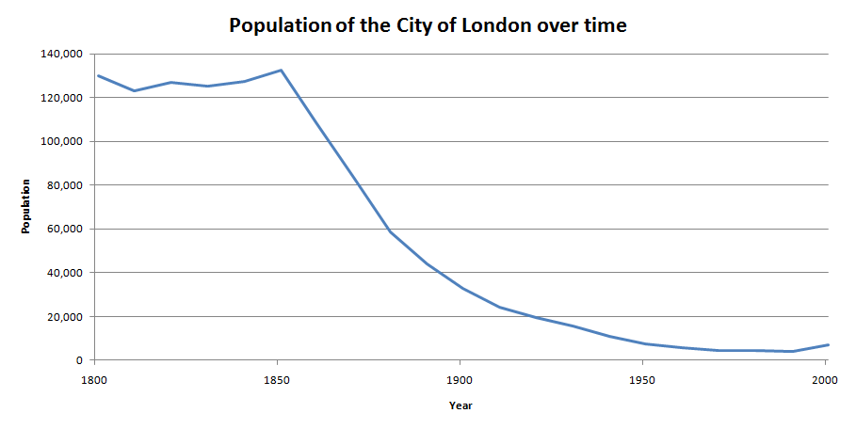  Explain the story of the graph  What was the difference in the population between 1800 and 1900?  What is the largest and smallest 50 year difference?  If the population of London increased by 10% every 50 years from 2000, how many years would it take to reach the highest population on the graph?  Pie Chart Angles  Alfie did a survey to find which soup was most popular.  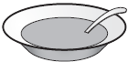  The choices were:  - tomato  - chicken  - mushroom  A quarter of the children chose chicken soup.  Four times as many children chose tomato soup as chose mushroom soup.  Alfie makes a pie chart to show this information.  What angle should he use for the children who chose tomato soup?  NRICH: Match the Matches  (interpreting charts and graphs to decide the football team)  What’s missing?  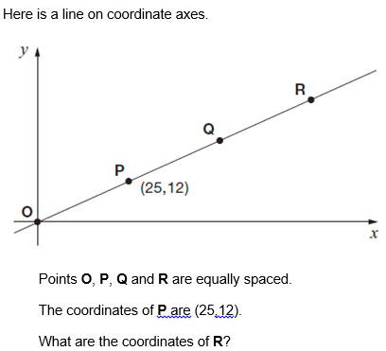  Convince me:  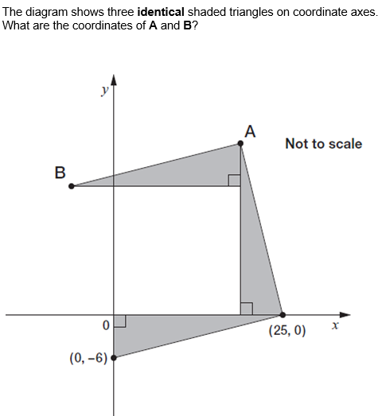  NRICH: Eight Hidden Squares  (finding 8 hidden squares on a coordinate grid – would need to be extended)  There’s also one called 10 hidden squares – very similar.  What if…?  The mean of three numbers is 8. Two of the numbers are the same. What could the three numbers be?  What if the mean is 7?  What if there were four numbers and the mean was 8?  Three apples have a mean mass of 100g. The largest apple is removed. The mean mass of the remaining two apples is 70g. What is the mass of the largest apple?  Possibilities  The difference between two numbers is 2. When each number is rounded to the nearest hundred, the difference between them is 100. What could the two numbers be?  Fact Family  If 1 km = 0.62 miles, how many miles in 5 km? 7? 9?  If 1 mile = 1.6 km, how many km in 5 miles? 8? 12?  Problem Solving  A shop makes 100 sandwiches.  All the sandwiches are either cheese or tuna.  Some of the sandwiches also have salad with the cheese or tuna.  30 sandwiches have cheese with salad.  15 sandwiches have tuna without salad.  75 sandwiches have salad.  How many sandwiches have cheese without salad?  Sarah had a bag of cherries.  She ate 5 cherries, then gave half of what she had left to Liam.  Liam ate 5 of his cherries, then gave half of what he had left to Amy.  Amy got 2 cherries.  How many cherries did Sarah have in her bag at the start?  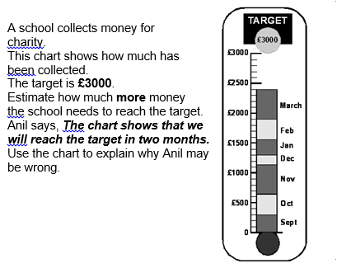
Y6 Block D Term 1 (15 lessons) | Learning Objectives :  By the end of this sequence of lessons all pupils will be able to….. | Mastery
Problem solving and reasoning  - Solve one and two-step problems involving whole numbers, simple fractions and decimals, money and measures, including time and temperature, perimeter and applying multiplicative scaling  - Identify and describe patterns, properties and relationships to establish invariants, apply in unfamiliar situations to make deductions; investigate a given statement and test with examples; collect data to create graphs and support an argument  Number and Place Value  - read, write, order and compare numbers to at least 1 000 000 and determine the value of each digit  - count forwards or backwards in steps of powers of 10 for any given number up to 1 000 000  - round any number up to 1 000 000 to the nearest 10, 100, 1000, 10 000 and 100 000  - solve number problems and practical problems that involve all of the above  - read Roman numerals to 1000 (M) and recognise years written in Roman numerals  - read, write, order and compare numbers up to 10 000 000 and determine the value of each digit  - round any whole number to a required degree of accuracy  - use negative numbers in context, and calculate intervals across zero  - solve number and practical problems that involve all of the above. | Year 6 | Contextual and investigative maths
 | Multiplication and division  - multiply multi-digit numbers up to 4 digits by a two-digit whole number using the formal written method of long multiplication  - divide numbers up to 4 digits by a two-digit whole number using the formal written method of long division, and interpret remainders as whole number remainders, fractions, or by rounding, as appropriate for the context  - use estimation to check answers to calculations and determine, in the context of a problem, an appropriate degree of accuracy  Fractions, decimals and percentages  - add and subtract fractions with different denominators and mixed numbers, using the concept of equivalent fractions  Ratio and proportion  - solve problems involving unequal sharing and grouping using knowledge of fractions and multiples  - solve problems involving the relative sizes of two quantities where missing values can be found by using integer multiplication and division facts | See Block B for multiplication and division  25 ÷ □ = 3 remainder 4  35 ÷ □ = 4 remainder 3  Build it  Multiply and divide  408  20  97,920  Conversion of fractions- improper/mixed number and addition and subtraction of equivalent fractions.  8/6  1/3  1/2  Complete the table (scaling and conversion of measures)  The Anvil holds 2680 people. At the schools’ performance, children travel on coaches holding 52 people. How many coaches will be needed to fill the Anvil?  There are 265 children from our school attending. Each 15 children needs 1 adult. How many coaches will be needed for our school?  Missing Signs  (3 □ 7) □ 6 = 100 □ 5 □ 17  Target!  Use the numbers 5,4,6,7,25 and 75 once each and any combination of the four operations to make the number 612.  Always sometimes never  Is it always, sometimes or never true that when you square an even number, the result is divisible by 4?  How do you know?  ¼ 1/5 1/10 1/20 1/40  Use three of the cards to complete the sum below:  □ + □ + □ = ½  NRICH: Andy’s Marbles  (fractions left)  Build it  The number in each box is the sum of the two numbers below it:  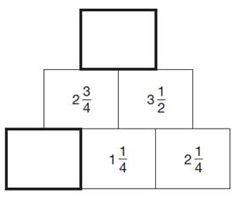  This is Kirsty’s recipe for breakfast cereal:  50g of oats  30g of raisins  40g of nuts.  If she uses 125g of oats, how many grams of raisins does she need? How many grams of nuts does she need?  What if she had 100g of nuts, how many grams of raisins and oats would she need.  NRICH: Orange Drink  (could involve multiplication or fractions through measure)  NRICH: Pumpkin Pie Problem  (measures, ratio, proportion)  NRICH: Jumping  (measures)  How many?  3/5 of a class are girls. There are 6 boys. How many girls are there?  If 3/5 are boys and there are 12 girls, how many boys are there now?  NRICH: Would you Rather?  (finding % of amounts)  See qu3 paper 2 L6 (ratio prop)  NRICH: Four Go  (estimation, approximation, find all possible solutions – reasoning of tactics)  Measurement conversion (4 operations with links to measurement and statistics)  What was the peak travel distance in miles on the Bakerloo line?  What is the difference in miles between travel on the Piccadilly line and the Metropolitan line?  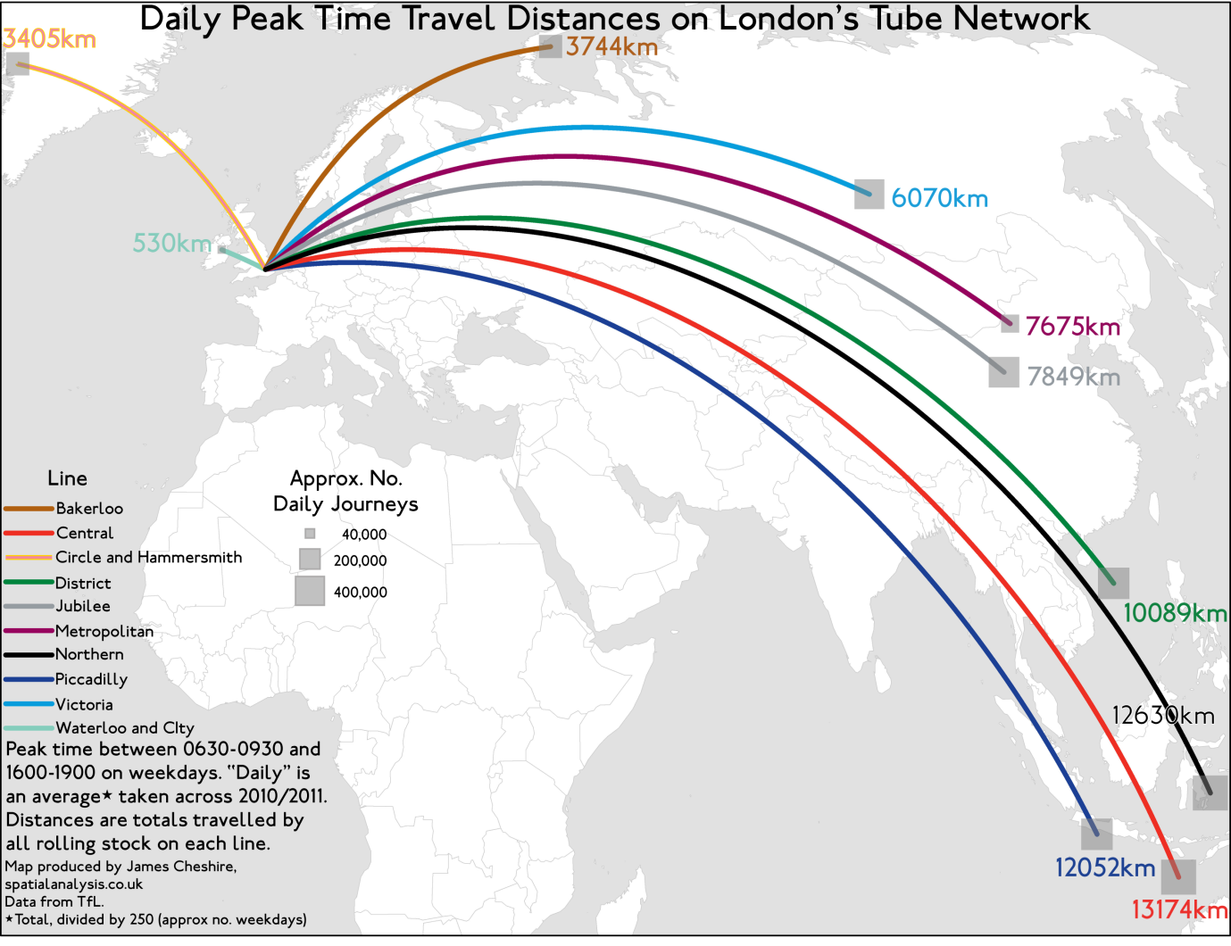
  Recipe | For 3 people | For 9 people | For 8  people
  butter | 330g |  | 880
  flour |  | 450g
  milk |  |  | 1.28L
Y6 Block A Term 2 (15 lessons) | Learning Objectives :  By the end of this sequence of lessons all pupils will be able to….. | Mastery
Problem solving and reasoning  - Solve one and two-step problems involving whole numbers, simple fractions and decimals, money and measures, including time and temperature, perimeter and applying multiplicative scaling  - Identify and describe patterns, properties and relationships to establish invariants, apply in unfamiliar situations to make deductions; investigate a given statement and test with examples; collect data to create graphs and support an argument  Number and Place Value  - read, write, order and compare numbers to at least 1 000 000 and determine the value of each digit  - count forwards or backwards in steps of powers of 10 for any given number up to 1 000 000  - interpret negative numbers in context, count forwards and backwards with positive and negative whole numbers through zero  - round any number up to 1 000 000 to the nearest 10, 100, 1000, 10 000 and 100 000  - solve number problems and practical problems that involve all of the above  - read, write, order and compare numbers up to 10 000 000 and determine the value of each digit  - round any whole number to a required degree of accuracy  - use negative numbers in context, and calculate intervals across zero  - solve number and practical problems that involve all of the above. | Year 6 | Contextual and investigative maths
 | Addition and subtraction,  - perform mental calculations, including with mixed operations and large numbers  - solve addition and subtraction multi-step problems in contexts, deciding which operations and methods to use and why  - use estimation to check answers to calculations and determine, in the context of a problem, an appropriate degree of accuracy  Measures/Shape  - Recognise that shapes with the same areas can have different perimeters and vice versa  - Recognise when it is possible to use formulae for area and volume of shapes (algebra)  - Calculate the area of parallelograms and triangles  - draw 2-D shapes using given dimensions and angles  - illustrate and name parts of circles, including radius, diameter and circumference and know that the diameter is twice the radius  Statistics  - interpret and construct pie charts and line graphs and use these to solve problems  - calculate and interpret the mean as an average (also need to mode, median and range from old curriculum | NRICH: Dicey Perimeter, Dicey Area  (game finding area and perimeter through dice throws)  NRICH: Shape Draw  NRICH: Baravelle   and  each stand for a different number.   = 34   +  =  +  +   What is the value of ?   ÷ 21.7 =37.5  100 – (22.75 + 19.08) =   Investigate  What shapes can you draw with a perimeter of 40cm?  Calculate their area. Draw the shape with the smallest/largest area. How did you do this?  Can you draw a rectliinear shape with the same area and perimeter? What patterns do you notice about the area/perimeter as you increase the area/perimeter?  Graph questions  Comprehension  Can you explain what is happening?  Tell the story using the graph.  What can you conclude from the data/graph?  Application  Which would be the best to present xx data?  When would you use a line graph/bar chart etc?  Find examples of data you would present in x type of graph.  What would happen is I changed the scale/graph type?  Synthesis  Design a way to investigate…  Collect and display data to show…  Evaluation  Which is the best graph for…  Predict what the graph would look like if…  Why would you not use xxx graph for this data?  Compare the data in these graphs- which is the most effective?
Y6 Block B Term 2 (15 lessons) | Learning Objectives :  By the end of this sequence of lessons all pupils will be able to…..
Problem solving and reasoning  - Solve one and two-step problems involving whole numbers, simple fractions and decimals, money and measures, including time and temperature, perimeter and applying multiplicative scaling  - Identify and describe patterns, properties and relationships to establish invariants, apply in unfamiliar situations to make deductions; investigate a given statement and test with examples; collect data to create graphs and support an argument  Number and Place Value  - read, write, order and compare numbers to at least 1 000 000 and determine the value of each digit  - count forwards or backwards in steps of powers of 10 for any given number up to 1 000 000  - interpret negative numbers in context, count forwards and backwards with positive and negative whole numbers through zero  - round any number up to 1 000 000 to the nearest 10, 100, 1000, 10 000 and 100 000  - solve number problems and practical problems that involve all of the above  - read, write, order and compare numbers up to 10 000 000 and determine the value of each digit  - round any whole number to a required degree of accuracy  - use negative numbers in context, and calculate intervals across zero  - solve number and practical problems that involve all of the above. | Year 6
 | Multiplication and division  - divide numbers up to 4 digits by a two-digit whole number using the formal written method of long division, and interpret remainders as whole number remainders, fractions, or by rounding, as appropriate for the context  - divide numbers up to 4 digits by a two-digit number using the formal written method of short division where appropriate, interpreting remainders according to the context.  - solve problems involving multiplication and division  Fractions, decimals and percentages  - use common factors to simplify fractions; use common multiples to express fractions in the same denomination  - multiply simple pairs of proper fractions, writing the answer in its simplest form (e.g. ¼ × ½ = ¹/₈)  - divide proper fractions by whole numbers (e.g. ¹/₃ ÷ 2 = ¹/₆ ).  Ratio and proportion  - solve problems involving the calculation of percentages (e.g. of measures) such as 15% of 360 and the use of percentages for comparison | Two whole numbers are each between 50 and 70. They multiply to make 4095. Write in the missing numbers.   ×  = 4095  Give an example of…  A division problem where the remainder is 2.  A division problem where you round up/down after dividing in context.  Max had a packet of seeds. He shared them between his 3 friends. They all shared them between 4 of their friends. Then they shared them between 2 of their friends. What fraction of the original amount did they all have?  (Hint: Draw a model to scaffold)
Y6 Block C Term 2 (15 lessons) | Learning Objectives :  By the end of this sequence of lessons all pupils will be able to…..
Problem solving and reasoning  - Solve one and two-step problems involving whole numbers, simple fractions and decimals, money and measures, including time and temperature, perimeter and applying multiplicative scaling  - Identify and describe patterns, properties and relationships to establish invariants, apply in unfamiliar situations to make deductions; investigate a given statement and test with examples; collect data to create graphs and support an argument  Number and Place Value  - read, write, order and compare numbers to at least 1 000 000 and determine the value of each digit  - count forwards or backwards in steps of powers of 10 for any given number up to 1 000 000  - round any number up to 1 000 000 to the nearest 10, 100, 1000, 10 000 and 100 000  - solve number problems and practical problems that involve all of the above  - read Roman numerals to 1000 (M) and recognise years written in Roman numerals.  - read, write, order and compare numbers up to 10 000 000 and determine the value of each digit  - round any whole number to a required degree of accuracy  - solve number and practical problems that involve all place value applications.  - use negative numbers in context, and calculate intervals across zero | Year 6
 | Addition and subtraction, multiplication and division  - perform mental calculations, including with mixed operations and large numbers  - solve addition and subtraction multi-step problems in contexts, deciding which operations and methods to use and why  - solve problems involving addition, subtraction, multiplication and division  - use their knowledge of the order of operations to carry out calculations involving the four operations  Algebra  - express missing number problems algebraically  - enumerate all possibilities of combinations of two variables  Geometry: properties of shape (revision)  - recognise, describe and build simple 3-D shapes, including making nets  - compare and classify geometric shapes based on their properties and sizes and find unknown angles in any triangles, quadrilaterals, and regular polygons  - recognise angles where they meet at a point, are on a straight line, or are vertically opposite, and find missing angles.  - Solve problems involving similar shapes where the scale factor is known or can be found (r&p)  Measures (Revision where needed)  - use, read, write and convert between standard units, converting measurements of length, mass, volume and time from a smaller unit of measure to a larger unit, and vice versa, using decimal notation to three decimal places  - convert between miles and kilometres  - calculate, estimate and compare volume of cubes and cuboids using standard units, including centimetre cubed (cm³) and cubic metres (m³) and extending to other units, such as mm³ and km³. | NRICH: Next Size Up  (comparing volumes)  NRICH: Cut Nets  NRICH: Making Cuboids  NRICH: Round a Hexagon  (external angles – will need to be adapted and extended)  Nadia is working with whole numbers. She says, 'If you add a two-digit number to a two-digit number you cannot get a four-digit number.’  Is she correct? Circle Yes or No. Explain why.  Julie says, ‘I added three odd numbers and my answer was 50.’  Explain why Julie cannot be correct.

Y6 Block D Term 2 (15 lessons) | Learning Objectives :  By the end of this sequence of lessons all pupils will be able to…..
Problem solving and reasoning  - Solve one and two-step problems involving whole numbers, simple fractions and decimals, money and measures, including time and temperature, perimeter and applying multiplicative scaling  - Identify and describe patterns, properties and relationships to establish invariants, apply in unfamiliar situations to make deductions; investigate a given statement and test with examples; collect data to create graphs and support an argument  Number and Place Value  - read, write, order and compare numbers to at least 1 000 000 and determine the value of each digit  - count forwards or backwards in steps of powers of 10 for any given number up to 1 000 000  - interpret negative numbers in context, count forwards and backwards with positive and negative whole numbers through zero  - round any number up to 1 000 000 to the nearest 10, 100, 1000, 10 000 and 100 000  - solve number problems and practical problems that involve all of the above  - read, write, order and compare numbers up to 10 000 000 and determine the value of each digit  - solve number and practical problems that involve all place value applications  - use negative numbers in context, and calculate intervals across zero | Year 6
 | Addition and subtraction, multiplication and division (problem solving revision and gap filling)  - multiply multi-digit numbers up to 4 digits by a two-digit whole number using the formal written method of long multiplication  - multiply one-digit numbers with up to two decimal places by whole numbers  - perform mental calculations, including with mixed operations and large numbers  - use their knowledge of the order of operations to carry out calculations involving the four operations  - solve addition and subtraction multi-step problems in contexts, deciding which operations and methods to use and why  - solve problems involving addition, subtraction, multiplication and division  - use estimation to check answers to calculations and determine, in the context of a problem, an appropriate degree of accuracy  Fractions, decimals and percentages  - associate a fraction with division to calculate decimal fraction equivalents (e.g. 0.375) for a simple fraction (e.g. ³/₈)  - multiply simple pairs of proper fractions, writing the answer in its simplest form (e.g. ¼ × ½ = ¹/₈)  - divide proper fractions by whole numbers (e.g. ¹/₃ ÷ 2 = ¹/₆ ).  - use written division methods in cases where the answer has up to two decimal places  - solve problems which require answers to be rounded to specified degrees of accuracy  - recall and use equivalences between simple fractions, decimals and percentages, including in different contexts  Algebra  - generate and describe linear number sequences  - find pairs of numbers that satisfy number sentences involving unknowns  Geometry : position and direction  - describe positions on the full coordinate grid (all four quadrants)  - draw and translate simple shapes on the co-ordinate plane, and reflect them in the axis | My bank balance is - £1029. If I paid in £47 per month. How long would it take for me to pay off my debt? How long until I had enough for a holiday costing £380?  0.571 - what fraction equivalents are there?  Divide fractions by whole numbers.  NRICH- Rectangle tangle.  Odd one out?  2, 5, 8, 11….  6, 9, 12, 15…  7, 10, 13, 16….  34, 37, 40, 43…  -4, -1, 2, 5…  Explain why.  Write other sequences to fit the group.  The rule for this sequence of numbers is ‘add 3 each time’.  1......4......7......10......13......16......…  The sequence continues in the same way. Mary says, ‘No matter how far you go there will never be a multiple of 3 in the sequence.’  Is she correct? Explain how you know.  The numbers in this sequence increase by 7 each time.  1 8 15 22 29 ....  The sequence continues in the same way.  Will the number 777 be in the sequence? Circle Yes or No. Explain how you know.

Y6 Block A Term 3 (15 lessons) | Learning Objectives :  By the end of this sequence of lessons all pupils will be able to…..
Problem solving and reasoning  - Solve one and two-step problems involving whole numbers, simple fractions and decimals, money and measures, including time and temperature, perimeter and applying multiplicative scaling  - Identify and describe patterns, properties and relationships to establish invariants, apply in unfamiliar situations to make deductions; investigate a given statement and test with examples; collect data to create graphs and support an argument  Number and Place Value  Year 5  - read, write, order and compare numbers to at least 1 000 000 and determine the value of each digit  - count forwards or backwards in steps of powers of 10 for any given number up to 1 000 000  - round any number up to 1 000 000 to the nearest 10, 100, 1000, 10 000 and 100 000  - solve number problems and practical problems that involve all of the above  Year 6  - read, write, order and compare numbers up to 10 000 000 and determine the value of each digit  - solve number and practical problems that involve all place value applications.  - use negative numbers in context, and calculate intervals across zero | Year 6
 | Addition and subtraction, multiplication and division  - divide numbers up to 4 digits by a two-digit whole number using the efficient written method of long division, and interpret remainders as whole number remainders, fractions, or by rounding, as appropriate for the context  - perform mental calculations, including with mixed operations and large numbers  - identify common factors, common multiples and prime numbers  - solve addition and subtraction multi-step problems in contexts, deciding which operations and methods to use and why  - solve problems involving addition, subtraction, multiplication and division  - use estimation to check answers to calculations and determine, in the context of a problem, levels of accuracy.  Fractions, decimals and percentages  - multiply simple pairs of proper fractions, writing the answer in its simplest form (e.g. ¼ × ½ = ¹/₈)  - divide proper fractions by whole numbers (e.g. ¹/₃ ÷ 2 = ¹/₆ ).  - solve problems which require answers to be rounded to specified degrees of accuracy  - use common factors to simplify fractions; use common multiples to express fractions in the same denomination  - compare and order fractions, including fractions >1  - add and subtract fractions with different denominators and mixed numbers, using the concept of equivalent fractions  - identify the value of each digit to three decimal places and multiply and divide numbers by 10, 100 and 1000 where the answers are up to three decimal places  - multiply one-digit numbers with up to two decimal places by whole numbers  Measures  - calculate the area of parallelograms and triangles  - calculate, estimate and compare volume of cubes and cuboids using standard units, including centimetre cubed (cm³) and cubic metres (m³) and extending to other units, such as mm³ and km³.  - solve problems involving converting between units of time (revision / starter)  Algebra  - use simple formulae  - generate and describe linear number sequences  - express missing number problems algebraically  - find pairs of numbers that satisfy number sentences involving two unknowns  - enumerate all possibilities of combinations of two variables | Write the three prime numbers which multiply to make 231.   ×  ×  = 231  Give an example of…  Fractions that multiply together to make 1/24  … of a fraction less than 0.2  All possibilities…  What could this be…?  □ ÷ □ = 1/6  Calculate the area…  3cm 2cm  4 cm 60º  60º  8cm  Volume and Algebra  If I had a 3 x 3 x 3 cm cube and wanted to cut it into individual cm³ again. What is the minimum number of cuts I will need to make?  (n² - 3) Explain why this is correct. How does it work?  What if…? I then did the same with a 4 x 4 x 4 cm cube? Can you predict how many will be needed for…? Express as a formulae.  What if…?  I had a cuboid with the following dimensions  12cm  4cm  What would the volume be? What if I was to increase the length by 2cm each time? What patterns can you see?  I have a cube. One of its faces has an area of 25cm² What is the volume? What if I increased the size of one side of the face by 1cm each time? What do you notice about the volume?

Y6 Block B Term 3 (15 lessons) | Learning Objectives :  By the end of this sequence of lessons all pupils will be able to…..
Problem solving and reasoning  - Solve one and two-step problems involving whole numbers, simple fractions and decimals, money and measures, including time and temperature, perimeter and applying multiplicative scaling  - Identify and describe patterns, properties and relationships to establish invariants, apply in unfamiliar situations to make deductions; investigate a given statement and test with examples; collect data to create graphs and support an argument  Number and Place Value  - read, write, order and compare numbers to at least 1 000 000 and determine the value of each digit  - count forwards or backwards in steps of powers of 10 for any given number up to 1 000 000  - interpret negative numbers in context, count forwards and backwards with positive and negative whole numbers through zero  - solve number problems and practical problems that involve all of the above | Year 6
Revision programme

Ensure children are fluent in number and able to calculate efficiently.

Include short practice sessions on key skills such as counting, rounding, estimating and calculating mentally (with jottings!), scaling up and down (x/÷ by 10, 100, 1000 ), patterning to see rules for sequences or generate old for new (if I know this, what else do I know), partitioning in different ways.

Give children opportunities to practice accurate measuring of length, angle etc. including use of a protractor.

Offer both contextual problems and pure number and shape puzzles to encourage children to reason and problem solve using heuristics~ being systematic, checking, making lists, starting from a simple problem or calculation (usually with zero or one) and building up by patterning, drawing diagrams and making informal jottings and so on.

Make sure children are asking the right questions when faced with a mathematical problem:
- What is the same and what is different?
- If I know this, what else do I know?
- How many different ways could I show this?

Model revision strategies for the children such as making A5 reminder cards of key facts and practising different ways of showing the same answer.

For 2016 SATs, there is no probability and no mental maths test.

Y6 Block C Term 3 (15 lessons) | Learning Objectives :  By the end of this sequence of lessons all pupils will be able to…..
Problem solving and reasoning  - Solve one and two-step problems involving whole numbers, simple fractions and decimals, money and measures, including time and temperature, perimeter and applying multiplicative scaling  - Identify and describe patterns, properties and relationships to establish invariants, apply in unfamiliar situations to make deductions; investigate a given statement and test with examples; collect data to create graphs and support an argument  Number and Place Value  - read, write, order and compare numbers to at least 1 000 000 and determine the value of each digit  - count forwards or backwards in steps of powers of 10 for any given number up to 1 000 000  - round any number up to 1 000 000 to the nearest 10, 100, 1000, 10 000 and 100 000  - solve number problems and practical problems that involve all of the above | Year 6
Revision programme

Ensure children are fluent in number and able to calculate efficiently.

Include short practice sessions on key skills such as counting, rounding, estimating and calculating mentally (with jottings!), scaling up and down (x/÷ by 10, 100, 1000 ), patterning to see rules for sequences or generate old for new (if I know this, what else do I know), partitioning in different ways.

Give children opportunities to practice accurate measuring of length, angle etc. including use of a protractor.

Offer both contextual problems and pure number and shape puzzles to encourage children to reason and problem solve using heuristics~ being systematic, checking, making lists, starting from a simple problem or calculation (usually with zero or one) and building up by patterning, drawing diagrams and making informal jottings and so on.

Make sure children are asking the right questions when faced with a mathematical problem:
- What is the same and what is different?
- If I know this, what else do I know?
- How many different ways could I show this?

Model revision strategies for the children such as making A5 reminder cards of key facts and practising different ways of showing the same answer.

For 2015 SATs, remember to include all three averages plus range and probability

For 2016 SATs, there is no probability and no mental maths test.

Practice papers: Don’t overdo this!

Include a range of questions at the same level and sometimes about the same area of maths.
These could be five minute sessions or whole lessons with collaboration between learners.

Do not waste time testing what children do not know by giving them lots of practice papers under test conditions.

Try using AfL and then targeting the types of questions each child needs with correctly modelled answers to support the child.

Y6 Block D Term 3 (15 lessons) | Learning Objectives :  By the end of this sequence of lessons all pupils will be able to…..
Problem solving and reasoning  - Solve one and two-step problems involving whole numbers, simple fractions and decimals, money and measures, including time and temperature, perimeter and applying multiplicative scaling  - Identify and describe patterns, properties and relationships to establish invariants, apply in unfamiliar situations to make deductions; investigate a given statement and test with examples; collect data to create graphs and support an argument  Number and Place Value  - read, write, order and compare numbers to at least 1 000 000 and determine the value of each digit  - count forwards or backwards in steps of powers of 10 for any given number up to  1 000 000  - solve number problems and practical problems that involve all of the above | Year 6
Contact your main Secondary feeder.
Work with them to construct a couple of units of work for Y6 that will prepare them for the first few weeks of Year 7.
Ask your secondary school which areas of maths they will be covering first.

Plan an extended project that encourages pupils to use and apply their mathematical knowledge in a problem solving and reasoning environment.
- A design project (a space station, an elephant carrier)
- Planning an event (school fete stall, fund raiser, trip to the theatre)
- Creating plans and scaled drawings, building the model (of a dinosaur, a famous building)
- Plan, design and make a resource or game (Top Trumps, boards games, strategy games such as Nim)

