Date : 19th May 2026
Time: 1315- 1600 (approx. finish)
Venue: VOCO Winchester Hotel & Spa, an IHG Hotel
Morn hill caravan club site, Telegraph Way, Winchester SO21 1HZ
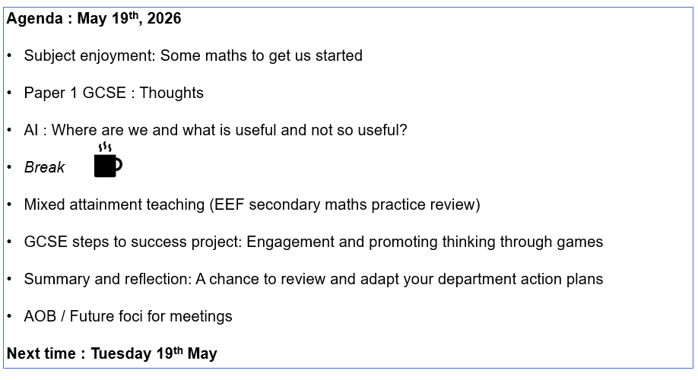

Pre-meeting items and tasks
Please come prepared to discuss
- The use of AI in your department and in classrooms
- Paper 1 : particularly Grade 3 to Grade 4 students reactions
- Your views on mixed attainment classes v setting
(Blog : Maths pupils 'make slower progress in mixed ability classes' )

Please review
- EEF secondary maths practice review (executive summary and end conclusion is fine !)

Please bring
- Copies of paper 1, or a content list, to share if possible.

Contact me with AOB at least one week before the meeting.
Contact
Jo Lees: jo.lees@hants.gov.uk

