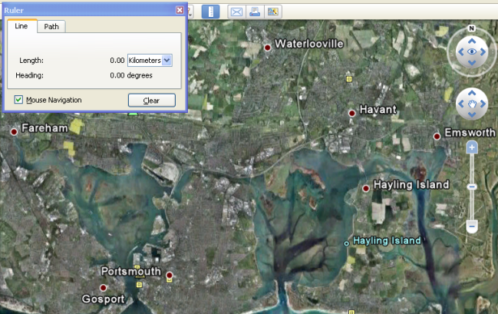An Introduction to Bearings Using
Google Earth 5 Software*
(Shape, Space and Measure: Bearings)
Activity: The activity involves pupils working
independently through a series of tasks to
introduce them to, and develop their knowledge
of, the concept of bearings in their local area.

This will improve your students understanding of mathematics because they will work through each question and task to gain knowledge at a pace which suits them individually. Pupils will use their own local area so that they can mentally check the viability of their answers.

Outcomes: Pupils will gain an understanding not only of forward bearings, but also back-bearings and the relationship between them. This is often a problem for many (and even C Grade) pupils. Many pupils will not have seen their local area from the sky, and it has been noted by staff that once the program has been loaded, a good 10 minutes should be allowed for pupils to study the area of their house, local shops, as well as their school.

Follow-up/extension: Once pupils understand the principles of bearings then they can investigate the subject in a number of different tasks.
Specific Instructions:
- Ask your Network Manager to install Google Earth 5, most networks will only have version 4.
- The program will install “bits” onto the operating computer the first time it is loaded, this takes time!
- Log yourself onto the computer and click to open the Google Earth logo.
- Discourage pupils from using the top two right hand controls.
- Zoom in on Portsmouth, Fareham, Emsworth, Hayling, Havant and Waterlooville.
- Click on the Ruler button (on the bar above the map) and look at the Heading value.
- Answer each of the questions on the Task 1 Sheet as fully as possible.
- Follow the instructions of Task 2 and find the hidden place. Then design a “Treasure Map” of your own.

Prior knowledge: The tasks are ordered so that no prior knowledge is required.

Key questions: What are the bearings and how are they useful?
What is the connection between Bearings and Back Bearings?

* Google Earth Version 4 does not have the same access to “Headings” as the Americans call Bearings! However Headings are not all “three-figure” and hence this needs to be emphasised by the teacher.
USING GOOGLE EARTH 5 TO TEACH BEARINGS
(Google being American uses Headings, almost the same as our Bearings)
TASK 1: A real beginning!

Log yourself on to the network and click to open the Google Earth 5 logo.
Using the Zoom slide (the lower control on the Right of the Map window), zoom in on Portsmouth, Fareham, Emsworth, Hayling, Havant and Waterlooville.
Left Click the Ruler button (just above the Map), so that you can see the Heading value.
Left Click on the top blue Google Earth bar.
It will cause you problems to use the top two controls on the top right of the Map window.
Left Click in the centre of the map and move your mouse to begin answering these.

- What is the highest number that it is possible to get? Where does this number occur?
- What happens if you try to go above this number? Why does this happen?
- Which is the direction of turn, clockwise or anticlockwise?
- Think of a compass (North, South, East and West), what is the heading of each?
- What is the heading from Fareham to Havant?
- What is the heading from Fareham to Waterlooville?
- What is the heading from Fareham to Portsmouth?
- Is the heading from Fareham to Hayling the same as the heading from Hayling to Fareham?
- Is the heading from Havant to Portsmouth the same as the heading from Portsmouth to Havant?
- Is the heading from Emsworth to Waterloo the same as the heading from Waterloo to Emsworth?
- Explain your answers to Questions 12 to 14?
- Can you explain the connection between your answers in Questions 12 to 14?
- What do you consider the three most important things that you have learnt about bearings from this lesson?

Move the map across so that Emsworth is in the centre of the map by using the hand symbol and dragging the map.
Left Click on Emsworth and move 3 kilometres on a bearing of 155 degrees; this should take you to the North of a small airfield.
- The number of this runway is 19; although there are only three runways, two of which are not in use. Can you explain this?
- Try using the Ruler to run a Bearing line from North to South.
- Move to Heatrhrow, 30 kilometres East of London. Find the Heading of the two main runways (Left and Right). Both runways can be used in either direction. What are the headings of each of these?
- Find other airports; Southampton, Manchester, Glasgow, Paris, etc. Find the headings of these runways to support your findings?
USING GOOGLE EARTH 5 TO TEACH BEARINGS (2)
(Google being American uses Headings, almost the same as our Bearings)
TASK 2: A Development!

Log yourself onto the network and Click to open the Google Earth logo.
You will need to you use the ‘Zoom’ slide (the lower control on the top right of the Map window).
It will cause you problems if you use the top two controls (on the top right of the Map window).
Look at the lower section of the left side bar, at Layers, open ‘Primary Database’, if it’s not open.
Turn on, or tick ‘Places of Interest’
‘Panoramio’
‘Borders and Labels’.

Now follow these instructions.
- Go to Wellington Airport
Hide side bar
- At each stage start at the centre of the runway and measure using the ruler.
- travel 2230km on a bearing of 284⁰
- 2740km bearing of 350.65⁰
- 1408km bearing of 091⁰
- 209km bearing of 187.63⁰
- 5340m bearing of 306.27⁰
- Zoom in and click on label…. What did you discover?
- What is the name and latitude and longitude of this place?
Design your own ‘Treasure Map’ directions in the same way, using at least 8 instructions.

You have now earned the right to play with the top two controls in the top right corner of the Map window.
First ensure that ‘3D Buildings’ is ticked in the ‘Layers’ section on the left hand part of the screen.
Then move to the middle of London, focus on a building that you recognise, and then ‘play’ to see what they do.

