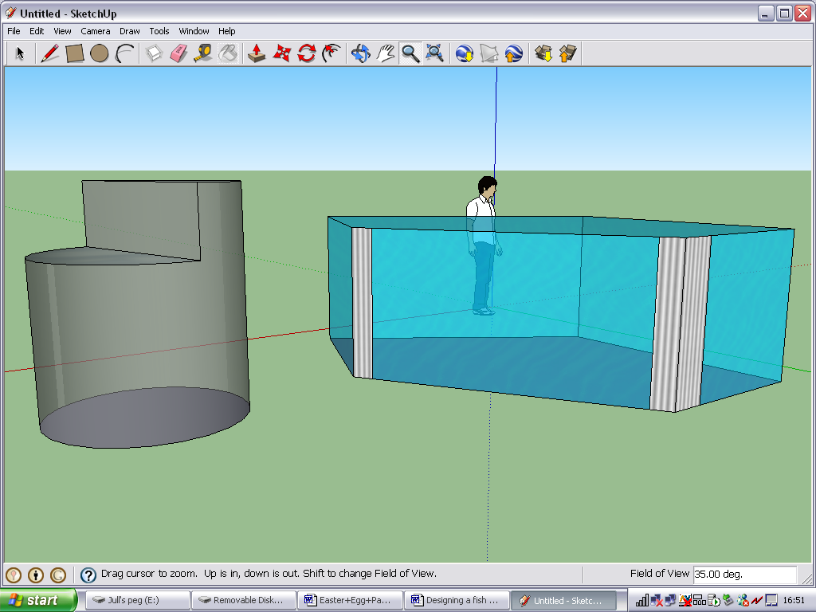Using Google Sketchup to design a Fish tank
(Or other similar 3-dimensional shapes).
Activity: Applying functional Maths and ICT to design an appropriate size fish tank to meet the needs of the user, considerate of the necessary volume and surface area required.
This will improve your students understanding of mathematics because the software package allows a blank canvas in 3 dimensions thereby not limiting your students’ ability in 3D to their ability of constructions. While constructions is a vital area of Mathematics, sometimes we want to use 3D shapes for work in other areas, such as volume and surface area, and in traditional isometric drawing or building of nets, students will be limited by their ability to construct and therefore this may hinder the use and understanding of the 3D shape. By creating their fish tank in Google Sketchup not only will it save vital time in the construction of the model, but it will allow for proportion work to test the validity of the shape; it will allow for work on plans and elevations as the software uses a 360º orbiting tool; it will allow for accurate measurement of dimensions, including in metric and imperial measures, and it will allow students to create multiple shapes in a short time, for example, to compare the dimensions of cuboids with equal volume.
Outcomes: Pupils will be able to create multiple 3D shapes in a short space of time which have not been constrained by their ability with constructions. They will also have been able to draw other areas of Mathematics into the lesson, such as those mentioned above, and will develop links between areas of maths that would otherwise have been hard to do. Above all else, they will develop their spatial awareness and have confidence to use a software package that can benefit many areas of the geometry curriculum – 3D Pythagoras, 3D coordinates, etc.
Follow-up/extension: this specific task had a follow up of creating the nets to consolidate their understanding, and they also went to design technology to build their tanks on a scaled version. Students were also asked to consider how they could create tanks with equivalent volume or surface area but were more complex in their design, including non-prisms. Familiarity with the software then lends itself to other areas of Maths for future use.
Specific Instructions:
- The lesson plans and user guides walk all students (and teachers) through the use of the software, and the development of the concept.
Prior knowledge: An understanding of how to calculate volume and surface area is necessary, but can be taught within the unit. The wide ranging scope of the activity, with such vast opportunities for differentiation means that they can, but it is not necessary to, use plans and elevations units conversions, both metric and imperial, and use the effect of a changing dimension on the overall volume (proportion). .
Key questions: What is volume and how do we calculate it? Do we need to consider the total surface area, or the surface area of the water? If we know the volume, how do we work inversely to find the dimensions? How can we tell if it is a realistic size?

Where and why did the learning start?
A chance discussion by students in class one day delivered the question – is it fair or not to keep pet fish? We discussed the different types of tank, from a standard bowl to the exuberant tall cylindrical shapes in the lobbies of high flying company receptions and decided there must be parameters to ensure the health of the fish. The module developed into 4/5 lessons which originally had the aim of developing the students functionality of shape, and it seemed that the use of this piece of software would enhance the understanding of the 3D models, make the activity enjoyable, not limit students work by their ability to construct, but also allow students to create many more virtual models that could be tested for validity than could be achieved on isometric paper.
Lesson 1: Internet research – what are the guidelines for the keeping of fish? Does volume have to be in proportion to the amount/size of fish kept? How about water surface area? What type of fish do you want to keep? What size fish tank would they need?

Lesson 2: Functional Maths – the research delivered approximate rules in imperial measurements, so this lesson involved metric conversions, calculating the total length of fish they would be keeping, and the subsequent volume and water surface area needed. Excel was used for formulae, and to derive dimensions.

Lesson 3: Using Google Sketchup – This was a stand alone lesson to allow the students to become familiar with all the functions of the software, and to experience some of the advanced feature, such as importing models and images from the warehouse.

Lesson 4: Creating the tank – Students followed a user guide, but largely worked independently to create at least one tank that met the required volume and surface area. Differentiation came through students creating multiple tanks with equivalent volumes, non-prisms, but also in their approach to the calculations.

Lesson 5: Self and peer assessment – students had to review the effectiveness of their tank, consider the maths and ICT they had used, and then share their models with others. Any mathematically correct tanks were forwarded for work in Design Technology for scale model construction.

For the purpose of this familiarisation and introduction to the software activity the remit you will be given is to construct a fish tank that has a volume of approximately 110 litres, and a water surface area of 1800cm²

