Year 5 Spring term 2021

This document could be used by all schools to support teachers in planning for blended learning during the spring term 2021. It is based on the Hampshire Scheme of Learning (HSL), which is available to schools subscribing to Moodle Plus (https://maths.hias.hants.gov.uk). It does not include all national curriculum statements. Some additional maths team objectives included as suggestions. Teachers will need to adapt these plans based on prior planning and assessment.
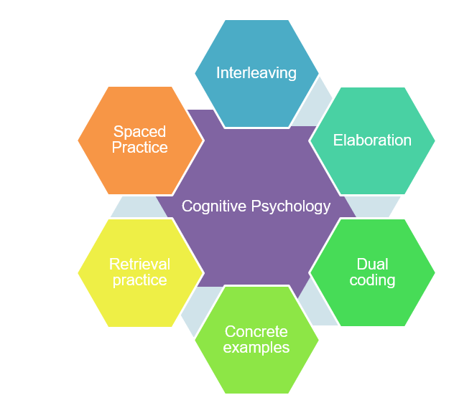
The sequence of domains outlined have been suggested to support a smooth transition to blended learning. The careful sequencing of domains encourages pupils to make links across domains and supports teachers’ use of effective strategies supporting recall of learning, particularly spaced practice and retrieval practice, identified through cognitive psychology research (Weinstein, Sumeracki and Caviglioli, 2019). It is important that children are prompted to access their memories of prior teaching and learned knowledge during periods of remote teaching.
The number of lessons provides a suggested structure, based on hourly lessons.

It will be important for teachers to plan a sequence of a few key tasks and linked skills practise as a ‘learning journey’ for each unit of work. Pupils will need support to understand the problem and have examples of how to record their solutions. Further examples of similar problems to the key task, using variation techniques, will support pupils to develop confidence and independence with each task.

The Hampshire Maths Team will provide a ‘problem of the week’ example to support this approach linked to the plan below. Teachers will need to adapt these examples to meet the needs of the range of leaners in their class.

This document also shows where ‘Ready -to- Progress’ criteria (RTPs) from the DFE Teaching Mathematics: Guidance for Key Stage 1 and 2 (June 2020)* document could be used to support review, practice, and consolidation. The National Centre for the Teaching of mathematics (NCETM) has produced resource materials to support the RTPs. Each RTP has linked resources, including power point slides, which could be used to support modelling of key mathematical concepts

*(DfE Mathematics Guidance: Key stage 1 and 2, June 2020, https://www.ncetm.org.uk/in-the-classroom/teaching-maths-through-the-pandemic/support-with-2020-dfe-guidance/

The NCETM supporting resource materials can be found at:

https://www.ncetm.org.uk/classroom-resources/exemplification-of-ready-to-progress-criteria/

Points to consider when using RTP resources:

They should be used flexibly, guided by pupils' response, repeating activities where pupils lack confidence. Materials from Year 5 may support addressing gaps and misconceptions for whole class, small groups or 1:1 focused intervention. The ready-to-progress criteria are intended as goals for the end of the year.

Video lessons

The NCETM, White Rose Maths and Oak Academy have key stage 1 and 2 video lessons with linked resources such as power points and follow up tasks that can support remote education.
The NCETM maths videos can be found at https://www.ncetm.org.uk/in-the-classroom/teaching-maths-through-the-pandemic/primary-video-lessons/
The Oak Academy maths videos can be found at https://teachers.thenational.academy/subjects/maths
White Rose Maths videos can be found here: https://whiterosemaths.com/homelearning/
Spring 1
Find everyday opportunities to develop children’s understanding of time.
Lessons | Content Domain | Objectives (HSL Unit 5.6) | DfE RTPs
10 | Fractions (percentages) | - Know that 1/10 = 0.1 and 1/100 = 0.01  - Recognise the percent symbol (%) and understand that percent relates to the number of parts per 100, write percentages as a fraction with the denominator 100 and as a decimal fraction  - Solve problems which require knowing percentage and decimal equivalents of ½, ¼, 1/5, 2/5, 4/5  - Identify, name and write equivalent fractions of a given fraction, represented visually, including tenths and hundredths.  - Read and write decimal numbers as fractions (e.g. 0.71 = 71/100)  - Recognise and use thousandths and relate them to tenths, hundredths and decimal equivalents  - Round decimals with two decimal places to the nearest whole number and to one decimal place. | 4F-1  4F-2  4F-3  5F-1  5F-2
5 | Geometry  (angle) | - Know angles are measured in degrees: estimate and compare acute, obtuse and reflex angles  - Draw given angles, and measure them in degrees (⁰)  - Use the properties of rectangles to deduce related facts and find missing lengths and angles | 5G-1
Video Resources
Oak Academy
Unit 6: Fractions and decimals https://teachers.thenational.academy/units/fractions-and-decimals-be3a
Unit 8: fractions, decimals and %: https://teachers.thenational.academy/units/fractions-decimals-and-percentages-8726
Unit 7: Angles https://teachers.thenational.academy/units/angles-31a2

NCETM
UKS 2 Fractions: Finding equivalent fractions and simplifying fractions https://www.ncetm.org.uk/classroom-resources/vl-upper-key-stage-2-fractions-video-lessons/

Lessons | Domains | Objectives (HSL Unit 5.7) | DfE RTPs
10 | Subtraction and Addition (whole numbers) | - Add and subtract whole numbers with more than 4 digits. Represent solutions appropriately using informal and formal written methods.  - Add and subtract mentally with increasingly large numbers e.g. 12,462 – 2300 = 10,612  - Use rounding to check answers to calculations and determine, in the context of a problem, levels of accuracy  - Solve addition and subtraction multi-step problems in contexts, deciding which operations and methods to use and why.
5 | Subtraction and Addition (fractions) | - Add and subtract fractions with the same denominator beyond one and multiples of the same number. Use diagrams such as bar models to show part-part-whole relationships  - Solve problems involving number up to three decimal places.  - Use addition and subtraction to solve problems involving measure using decimal and fraction notation. E.g. ¾ m + 50 cm = 1.25 m (or 1 ¼ m) | 4F-3
Video Resources
Oak Academy
Unit 1: Reasoning with Large whole numbers https://teachers.thenational.academy/units/reasoning-with-large-whole-numbers-2bf7
Unit 2: Problem solving with integer addition and subtraction https://teachers.thenational.academy/units/problem-solving-with-integer-addition-and-subtraction-2a10
White Rose Maths
https://whiterosemaths.com/homelearning/year-5/

Lessons | Domains | Objectives (HSL Unit 5.8) | DfE RTPs
5 | Statistics (line graphs including temperature graphs and negative numbers) | - Interpret negative numbers in context, count forwards and backwards with positive and negative numbers through zero (link number-line to a thermometer)  - Solve comparison, sum and difference problems using information presented in a line graph  - Complete, read and interpret information in tables.
Video Resources
Oak Academy
Unit 3: Line graphs and timetables https://teachers.thenational.academy/units/line-graphs-and-timetables-d842
White Rose Maths
https://whiterosemaths.com/homelearning/year-5/

Spring 2
Lessons | Domains | Objectives (HSL 5.9) | DfE RTPs
10 | Measurement (volume and capacity/  reading scales / imperial conversions) | - Understand and use equivalences between metric units and common imperial units such as inches, pounds and pints.  - Estimate volume (e.g. using 1cm3 blocks to build cubes and cuboids) and capacity (e.g. using water)  - Identify 3-D shapes, including cubes and other cuboids, from 2-D representations  - Construct 3-D models of cubes and cuboids from nets and estimate their volume, using 1cm3 blocks to build cubes and cuboids to support understanding of volume.  - Multiply three numbers together, understanding that this can be done in any order and link this to the volume of cubes and cuboids.  - Solve problems involving capacity, including reading a range of scales. | 4NPV-4  5NPV-4  5NPV-5
5 | Fractions | - Multiply proper fractions and mixed numbers by whole numbers, supported by materials and diagrams.  - Solve problems which require knowing percentage and decimal equivalents, including those with a denominator of a multiple of 10 of 25.  - Read, write, order and compare numbers with up to three decimal places  - Solve problems involving number up to three decimal places | 4NPV-4  5NPV-4  5NPV-5
Video Resources
Oak Academy
Unit 6; Fractions and decimals https://teachers.thenational.academy/units/fractions-and-decimals-be3a
Unit 10: Converting units of measure https://teachers.thenational.academy/units/converting-units-of-measure-1475

Lessons | Domains | Objectives (HSL 5.10) | DfE RTPs
10 | Subtraction and addition / NPV (focus on mental strategies) | - Add and subtract mentally with increasingly large numbers. Develop independence and fluency with identifying calculations that can be done mentally. Strategies include ‘nearly numbers’, near-doubles’, place value, key facts and derived facts, part-whole reasoning and so on.  - Add and subtract whole numbers with more than 4 digits. Represent solutions appropriately using informal and formal written methods.  - Use rounding to check answers to calculations and determine, in the context of a problem, levels of accuracy  - Solve addition and subtraction multi-step problems in contexts, deciding which operations and methods to use and why.  - Add and subtract fractions with the same denominator beyond one and multiples of the same number. Use diagrams such as bar models to show part-part-whole relationships  - Solve problems involving number up to three decimal places.  - Solve problems involving measure.
Video Resources
Oak Academy
Unit 11: Calculating with whole numbers and decimals: https://teachers.thenational.academy/units/calculating-with-whole-numbers-and-decimals-4fe5
NCETM
Using equivalence and the compensation property to calculate https://www.ncetm.org.uk/classroom-resources/vl-upper-key-stage-2-number-addition-and-subtraction-video-lessons/
White Rose Maths
https://whiterosemaths.com/homelearning/year-5/

Lessons | Domains | Objectives (HSL 5.11) | DfE RTPs
10 | Multiplication and division (tables and related facts) | - Multiply numbers up to 4-digits by a one- or two- digit number, drawing upon known facts  - Divide numbers up to 4-digits by a one- digit number, introducing short division and interpreting remainders appropriately for the context  - Multiply and divide whole numbers and those involving decimals by 10, 100 and 1000.  - Solve problems involving multiplication and division, including using their knowledge of factors and multiples  - Solve problems involving multiplication and division, including scaling by simple fractions. | 4NF-3  4MD-2  5NF-1  5NF-2
Video Resources
Oak Academy
Unit 4: Multiplication and division: https://teachers.thenational.academy/units/multiplication-and-division-6f51
White Rose Maths: https://whiterosemaths.com/homelearning/year-5/

