Year 3 Spring term 2021

This document could be used by all schools to support teachers in planning for blended learning during the spring term 2021. It is based on the Hampshire Scheme of Learning (HSL), which is available to schools subscribing to Moodle Plus (https://maths.hias.hants.gov.uk). It does not include all national curriculum statements (bold). Some additional maths team objectives included as suggestions. Teachers will need to adapt these plans based on prior planning and assessment.
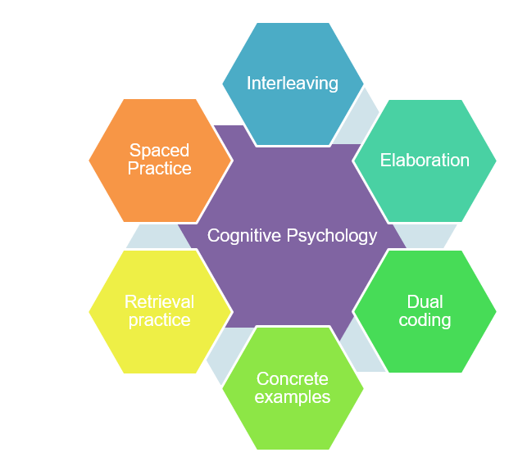
The sequence of domains outlined have been suggested to support a smooth transition to blended learning. The careful sequencing of domains encourages pupils to make links across domains and supports teachers’ use of effective strategies supporting recall of learning, particularly spaced practice and retrieval practice, identified through cognitive psychology research (Weinstein, Sumeracki and Caviglioli, 2019). It is important that children are prompted to access their memories of prior teaching and learned knowledge during periods of remote teaching.
The number of lessons provides a suggested structure, based on hourly lessons.

It will be important for teachers to plan a sequence of a few key tasks and linked skills practise as a ‘learning journey’ for each unit of work. Pupils will need support to understand the problem and have examples of how to record their solutions. Further examples of similar problems to the key task, using variation techniques, will support pupils to develop confidence and independence with each task.

The Hampshire Maths Team will provide a ‘problem of the week’ example to support this approach linked to the plan below. Teachers will need to adapt these examples to meet the needs of the range of leaners in their class.

This document also shows where ‘Ready -to- Progress’ criteria (RTPs) from the DFE Teaching Mathematics: Guidance for Key Stage 1 and 2 (June 2020)* document could be used to support review, practice, and consolidation. The National Centre for the Teaching of mathematics (NCETM) has produced resource materials to support the RTPs. Each RTP has linked resources, including power point slides, which could be used to support modelling of key mathematical concepts

*(DfE Mathematics Guidance: Key stage 1 and 2, June 2020, https://www.ncetm.org.uk/in-the-classroom/teaching-maths-through-the-pandemic/support-with-2020-dfe-guidance/

The NCETM supporting resource materials can be found at:

https://www.ncetm.org.uk/classroom-resources/exemplification-of-ready-to-progress-criteria/

Points to consider when using RTP resources:

They should be used flexibly, guided by pupils' response, repeating activities where pupils lack confidence. Materials from Year 1 may support addressing gaps and misconceptions for whole class, small groups or 1:1 focused intervention. The ready-to-progress criteria are intended as goals for the end of the year.

Video lessons

The NCETM, White Rose Maths and Oak Academy have key stage 1 and 2 video lessons with linked resources such as power points and follow up tasks that can support remote education.
The NCETM maths videos can be found at https://www.ncetm.org.uk/in-the-classroom/teaching-maths-through-the-pandemic/primary-video-lessons/
The Oak Academy maths videos can be found at https://teachers.thenational.academy/subjects/maths
White Rose Maths videos can be found here: https://whiterosemaths.com/homelearning/

Spring 1
Measurement: Find every day opportunities to tell the time, including on a clock face with Roman numerals. Practise counting e.g. in multiples of 3,4 and 50 and in 100s from any number.
Lessons | Domains | Objectives (HSL Unit 3.6) | DfE RTPs
10 | Fractions | - Recognise and use unit fractions as numbers (on a number-line)  - Recognise and show, using diagrams, equivalent fractions with small denominators (construct ‘fraction families as bar models eg whole / half/ quarters, eighths; whole/ thirds/ sixths etc)  - Add and subtract fractions with the same denominator within one whole eg 5/7 +1/7= 6/7 (represent/ interpret using bar models and number lines)  - Compare and order unit fractions  - Solve problems that involve all of the above
5 | Geometry | - Recognise angles as a property of shape  - Recognise that two right-angles make a half-turn  - Recognise that three right-angles make three-quarters of a turn and four, a complete turn  - Identify whether angles are greater than or less than a right angle | 2G-1  3G-1
Video Resources
Oak Academy
Unit 9: Fractions https://teachers.thenational.academy/units/fractions-ed51
Unit 10: Angles and shape https://teachers.thenational.academy/units/angles-and-shape-2e85

NCETM
Lower KS2 fractions 1: Preparing for fractions- part whole https://www.ncetm.org.uk/classroom-resources/vl-lower-key-stage-2-fractions-1-video-lessons/
Lower KS2 Fractions: Comparing, identifying and representing https://www.ncetm.org.uk/classroom-resources/vl-lower-key-stage-2-fractions-2-video-lessons/

Lessons | Domains | Objectives (HSL Unit 3.7) | DfE RTPs
15 | Subtraction and addition | - Add and subtract numbers mentally including a 3-digit number and ones, 3-digit number and tens, 3-digit number and hundreds.  - Add and subtract numbers with up to three digits  - Estimate the answer to a calculation and use inverse operations to check answers  - Compare and order numbers up to 1000  - Read and write numbers up to 1000 in numerals and in words  - Solve number problems and practical problems involving these ideas, including in the context of measurement. | 2NPV-1  2NF-1  2AS-2  2AS-3  3NPV-2  3NF-1  3AS-3
Video Resources
Oak Academy

Unit 2: Place Value: https://teachers.thenational.academy/units/place-value-00b7
Unit 4: Addition and subtraction https://teachers.thenational.academy/units/addition-and-subtraction-48c0
White Rose maths
https://whiterosemaths.com/homelearning/year-3/

Lessons | Domains | Objectives (HSL Unit 3.8) | DfE RTPs
5 | Measurement (time) | - Tell and write the time from an analogue clock using 12 hour and 24 hour clocks  - Estimate and read time with increasing accuracy to the nearest minute  - Record and compare time in terms of seconds, minutes, hours and O’Clock.  - Know 1 hour= 60 minutes; ½ hour = 30 minutes; ¼ hour = 15 minutes; ¾ hour = 45 minutes; 60 seconds= 1 minute
Video Resources
Oak Academy
Unit 8 Time: https://teachers.thenational.academy/units/time-a1c3

Spring 2

Lessons | Domains | Objectives (HSL 3.9) | DfE RTPs
10 | Multiplication and division | - Y2: Recall and use multiplication and division facts for the 2,5 and 10 multiplication tables.  - Represent multiplication and division facts as arrays using a grid (rather than dots) and a number-line  - Count in multiples of 3 ,4 and 8 from zero.  - Derive, recall and use multiplication and division facts for 3 , 4 and 8 multiplication tables  - Write and calculate mathematical statements for multiplication and division using the multiplication tables that they know, using mental strategies  - Solve problems including missing number problems involving multiplication and division, recording solutions with a range of representations to include number-lines, bar-models and arrays. | 2MD-1  2MD-2  3NF-2  3F-1  3F-2
5 | Fractions | - Recognise , find and write fractions of a discrete set of objects: unit fractions and non-unit fractions with small denominators  - Recognise and use fractions as numbers; unit fractions and non-unit fractions with small denominators (number-line)
Videos
Oak Academy
Unit 6: Multiplication and division https://teachers.thenational.academy/units/multiplication-and-division-70b8
Unit 7: Multiplication and division -deriving facts https://teachers.thenational.academy/units/deriving-multiplication-and-division-facts-1216
Unit 14 Fractions parts and wholes https://teachers.thenational.academy/units/fractions-parts-and-wholes-ef35
White Rose maths
https://whiterosemaths.com/homelearning/year-3/

Lessons | Domains | Objectives (HSL 3.10) | DfE RTPs
15 | Subtraction and addition / statistics (10) | - Compare and order numbers up to 1000  - Read and write numbers up to 1000 in numerals and words  - Identify, represent and estimate numbers using different representations particularly including number lines  - Solve problems including missing number problems, using number facts, place value and more complex addition and subtraction  - Interpret and present data using bar charts, pictograms and tables  - Solve one-step questions such as “How many more?” and “How many fewer?” using information presented in scaled bar charts, pictograms and tables. | 3AS-1  3AS-3
 | Measurement (5) (volume/ capacity scales) | - Count up and down in tenths, recognising that tenths arise from dividing an object in ten equal parts.  - Measure, compare, add and subtract volume/capacity (l / ml)
Video Resources
Oak Academy
Unit 4: Addition and subtraction https://teachers.thenational.academy/units/addition-and-subtraction-48c0
Unit 11: Measures https://teachers.thenational.academy/units/measures-86db
White Rose maths
https://whiterosemaths.com/homelearning/year-3/

