Year 4 Spring term 2021

This document could be used by all schools to support teachers in planning for blended learning during the spring term 2021. It is based on the Hampshire Scheme of Learning (HSL), which is available to schools subscribing to Moodle Plus (https://maths.hias.hants.gov.uk). It does not include all national curriculum statements. Some additional maths team objectives included as suggestions. Teachers will need to adapt these plans based on prior planning and assessment.
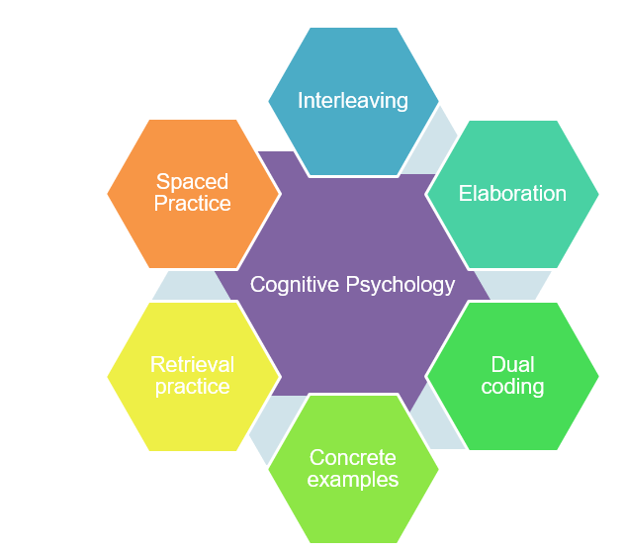
The sequence of domains outlined have been suggested to support a smooth transition to blended learning. The careful sequencing of domains encourages pupils to make links across domains and supports teachers’ use of effective strategies supporting recall of learning, particularly spaced practice and retrieval practice, identified through cognitive psychology research (Weinstein, Sumeracki and Caviglioli, 2019). It is important that children are prompted to access their memories of prior teaching and learned knowledge during periods of remote teaching.
The number of lessons provides a suggested structure, based on hourly lessons.

It will be important for teachers to plan a sequence of a few key tasks and linked skills practise as a ‘learning journey’ for each unit of work. Pupils will need support to understand the problem and have examples of how to record their solutions. Further examples of similar problems to the key task, using variation techniques, will support pupils to develop confidence and independence with each task.

The Hampshire Maths Team will provide a ‘problem of the week’ example to support this approach linked to the plan below. Teachers will need to adapt these examples to meet the needs of the range of leaners in their class.

This document also shows where ‘Ready -to- Progress’ criteria (RTPs) from the DFE Teaching Mathematics: Guidance for Key Stage 1 and 2 (June 2020)* document could be used to support review, practice, and consolidation. The National Centre for the Teaching of mathematics (NCETM) has produced resource materials to support the RTPs. Each RTP has linked resources, including power point slides, which could be used to support modelling of key mathematical concepts

*(DfE Mathematics Guidance: Key stage 1 and 2, June 2020, https://www.ncetm.org.uk/in-the-classroom/teaching-maths-through-the-pandemic/support-with-2020-dfe-guidance/

The NCETM supporting resource materials can be found at:

https://www.ncetm.org.uk/classroom-resources/exemplification-of-ready-to-progress-criteria/

Points to consider when using RTP resources:

They should be used flexibly, guided by pupils' response, repeating activities where pupils lack confidence. Materials from Year 4 may support addressing gaps and misconceptions for whole class, small groups or 1:1 focused intervention. The ready-to-progress criteria are intended as goals for the end of the year.

Video lessons

The NCETM and Oak Academy have key stage 1 and 2 video lessons with linked resources such as power points and follow up tasks that can support remote education. The NCETM, White Rose Maths and Oak Academy have key stage 1 and 2 video lessons with linked resources such as power points and follow up tasks that can support remote education.
The NCETM maths videos can be found at https://www.ncetm.org.uk/in-the-classroom/teaching-maths-through-the-pandemic/primary-video-lessons/
The Oak Academy maths videos can be found at https://teachers.thenational.academy/subjects/maths
White Rose Maths videos can be found here: https://whiterosemaths.com/homelearning/
Spring 1
Find everyday opportunities to develop children’s understanding of time.
lessons | Content Domain | Objectives (HSL Unit 4.6) | DfE RTPs
10 | Fractions | - Recognise and show using diagrams, families of common equivalent fractions.  - Solve problems involving increasingly harder fractions to calculate quantities and fractions to divide quantities, including non-unit fractions where the answer is a whole number.  - Find the effect of dividing a one -or two- digit number by 10 and 100, identifying the value of the digits in the answer as ones, tenths and hundredths.  - Count up and down in hundredths (represent on number lines)  - Recognise that hundredths arise when dividing and object by a hundred and dividing tenths by ten.  - Round decimals with one decimal place to the nearest whole number (represent on number lines)  - Recognise and write decimal equivalents to ¼, ½ and ¾ (represent on number lines and bar models) | 3F-1  3F-2  3F-3
5 | Geometry | - Compare and classify geometric shapes (triangles) based on their properties and sizes.  - Identify acute and obtuse angles  - Identify lines of symmetry in 2-D shapes presented in different orientations  - Describe positions on a 2-D grid as co-ordinates in the first quadrant ((x,y) co-ordinates)  - Describe movements between positions as translations of a given unit to the left / right and up/down. | 3G-1
Video resources:
Oak Academy
Unit 8: Decimals: https://teachers.thenational.academy/units/decimals-8526
Unit 11: 2D shape and symmetry: https://teachers.thenational.academy/units/2-d-shape-and-symmetry-4823
Unit 12: Position and direction https://teachers.thenational.academy/units/position-and-direction-f7d

NCETM
Lower KS2 fractions 1: Preparing for fractions- part whole https://www.ncetm.org.uk/classroom-resources/vl-lower-key-stage-2-fractions-1-video-lessons/
Lower KS2 Fractions: Comparing, identifying and representing https://www.ncetm.org.uk/classroom-resources/vl-lower-key-stage-2-fractions-2-video-lessons/

Lessons | Domains | Objectives (HSL Unit 4.7) | DfE RTPs
15 | Subtraction and Addition | - Recall and use complements to 100 and 1000 to support mental strategies.  - Record and addition and subtraction calculations using a combination of representations e.g bar model, number-line, number sentence.  - Add three numbers, with a sum of up to 1000.  - Estimate and use inverse operations to check answers to a calculation  - Add and subtract numbers with up to four digits using formal written methods building on the use of structured concrete resources to ensure conceptual understanding.  - Solve addition and subtraction two-step problems in context, deciding which operations and methods to use and why. | 3AS-1  3AS-2  3AS-3  4NPV-1  4NPV-2  4NPV-3
Video Resources
Oak Academy
Unit 1: Reasoning with 4-digit numbers https://teachers.thenational.academy/units/reasoning-with-4-digit-numbers-ffd2
White Rose maths
https://whiterosemaths.com/homelearning/year-4/

Lessons | Domains | Objectives (HSL Unit 4.8) | DfE RTPs
5 | Measurement  (Time) | - Read, write and convert time between analogue and digital 12-hour and 24-hour clocks.  - Solve problems involving converting from hours to minutes, minutes to seconds, years to months, weeks to days.  - Represent time intervals on a number-line  - Know 1 hour = 60 minutes; ½ hour = 30 minutes, ¼ hour = 15 minutes, ¾ hour = 45 minutes  - Know I minute = 60 seconds; 365 days in a year (366 in a leap year); 14 days in a fortnight
Video Resources
Oak Academy
Unit 7: Time https://teachers.thenational.academy/units/time-aaeb

Spring 2
Lessons | Domains | Objectives (HSL 4.9) | DfE RTPs
10 | Multiplication and Division | - Y3: Recall and use multiplication and division facts for the 2,3,4,5,8 and 10 multiplication tables.  - Represent multiplication and division facts as arrays using a grid (rather than dots) and on a number-line  - Count in multiples of 6,7 and 9 from zero.  - Derive, recall and use multiplication and division facts for up to 12 x 12  - Use place value, known and derived facts to multiply and divide mentally, including multiplying by 0 and 1, dividing by 1, multiplying together three numbers  - Solve problems including missing number problems involving multiplication and division, recording solutions with a range of representations to include number-lines, bar-models and arrays. | 3NF-2  4NF-1  4NF-2  4MD-1  4MD-2  4MD-3
5 | Fractions | - Solve problems involving increasingly harder fractions to calculate quantities, and fractions to divide quantities, including non-unit fractions where the answer is a whole number  - Find one tenth of an amount by dividing by ten and one hundredth by dividing by one hundred.  - Know one tenth = 0.1  - Count in tenths and record on a number line beyond one. | 4F-1  4F-2
Video Resources
Oak Academy
Unit 3: Multiplication and division https://teachers.thenational.academy/units/multiplication-and-division-6dbb
Unit 5: Securing multiplication facts https://teachers.thenational.academy/units/securing-multiplication-facts-9166
Unit 15: Working with fractions https://teachers.thenational.academy/units/working-with-fractions-8685
NCETM
Lower KS2 Fractions 3: Non-unit fractions; identifying, representing, comparing https://www.ncetm.org.uk/classroom-resources/vl-lower-key-stage-2-fractions-3-video-lessons/
White Rose maths
https://whiterosemaths.com/homelearning/year-4/

Lessons | Domains | Objectives (HSL 4.10) | DfE RTPs
10 | Subtraction and addition / statistics | - Compare and order numbers beyond 1000  - Round any number to the nearest 10,100, 1000  - Identify, represent and estimate numbers using different representations  - Solve number and practical problems that involve an understanding of place value and with increasingly large positive numbers.  - Add and subtract numbers with up to four digits using formal written methods building on the use of structured concrete resources to ensure conceptual understanding.  - Solve comparison, sum and difference problems using information presented in bar charts, pictograms and other graphs, e.g. bar charts for discrete data and time graphs for continuous data | 4NF-3
5 | Measurement (volume/ capacity scales) | - Measure, compare, add and subtract volume/capacity (l / ml)  - Convert between different units of measure (ml/l)  - Solve number and practical problems that involve an understanding of place value and with increasingly large positive numbers.  - Add and subtract numbers with up to four digits using formal written methods building on the use of structured concrete resources to ensure conceptual understanding. | 4NPV-4
Video Resources
Oak Academy
Unit 2: Addition and subtraction https://teachers.thenational.academy/units/addition-and-subtraction-ec16
Unit 4: Interpreting and presenting data https://teachers.thenational.academy/units/interpreting-and-presenting-data-3c56

