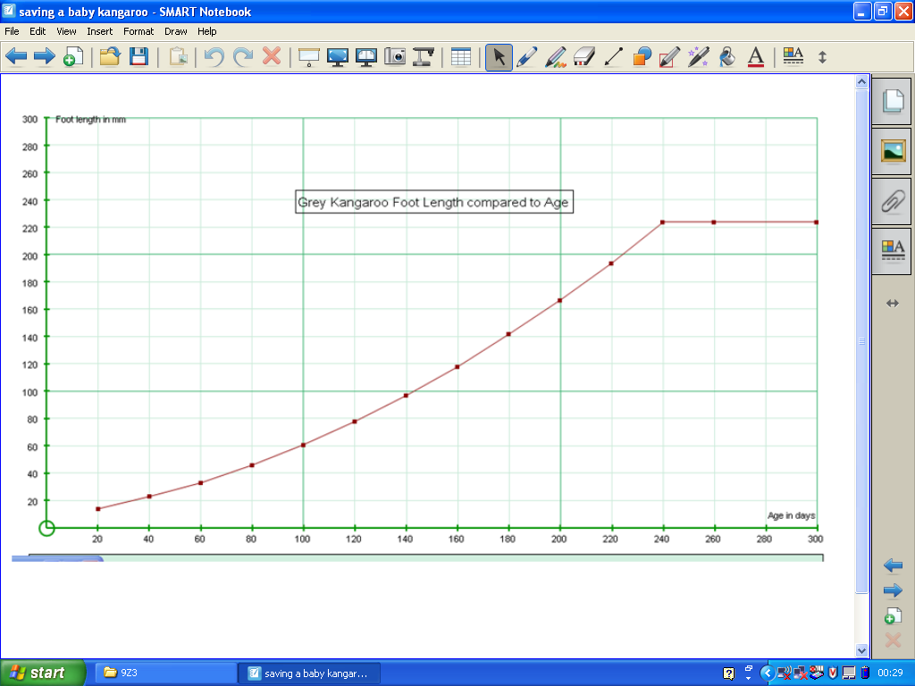Graphing a time series using Autograph or similar software* (Data Handling: presentation)
Activity: Graphing the developmental growth (length and weight) of a range of species of baby kangaroos. This supports the KS3 Bowland project: saving a baby kangaroo
This will improve your students understanding of mathematics because they will be able to produce a set of clearly labelled and correctly scaled graphs of growth against time, which can successfully be used by themselves and others for accurate interpolations. The quality of the graphs will enable the students to identify the species and age of their own baby kangaroo. Students will have to deal with what appears to be missing data (blank cells when, for example, maximum foot length is reached). In order to produce these graphs, students will need to follow a detailed set of ordered instructions.
Outcomes: Students will take pride in the quality of their work, and the importance of clarity will be appreciated when other students actually use these graphs to take accurate readings from. During this activity students work in small groups but everyone is dependent on the full set of graphs being produced correctly, and on time.
Follow-up/extension: The use of the graphing package could be extended to plotting grouped data, histograms or cumulative frequency graphs (with their accompanying box-plots).
Specific Instructions:
- The class is divided into small groups so that each group is responsible for producing a poster which includes three graphs, showing the growth of the tail, foot length and weight of one of the six species of kangaroos.
- The data is provided in a set of growth charts, covering about 200 – 300 days, within the students’ resource area of the Bowland site.
- When all the posters are produced and displayed in the ‘vet’s clinic’, each group is given a baby kangaroo to save. Their first task is to measure their kangaroo’s tail and foot length then to read off the suggested age in days of their baby kangaroo from each species’ graph. They are looking for a consistent age across the three measures, to be able to identify the type of kangaroo and hence it’s approximate age.
- Having determined the species and age of their kangaroo, they have a few other tasks to complete based on the kangaroo’s projected growth and feeding schedule.
- In order to produce the graphs, students need to copy the data from the Bowland site onto an Excel spreadsheet and from there into Autograph. The student’s instruction sheet for this is attached.
Prior knowledge: some familiarity with Excel is desirable as is an ability to cut and paste data.
Key questions: Why is it important to give your graph a title and to label the axes? Does the scale of the axes matter? Why is a line graph better than a bar graph? Why is there no data for some of the charts after a certain date? What will you do about this on your graph?
* This activity could just as easily use Excel or Geometer’s Sketchpad or any other statistical graphing package with minor adjustments to the instruction sheet.
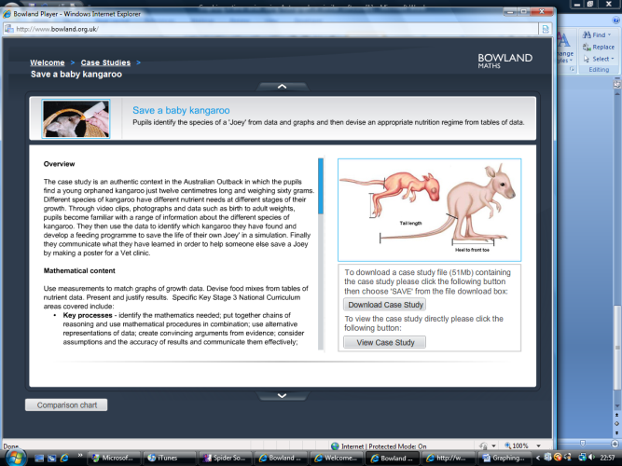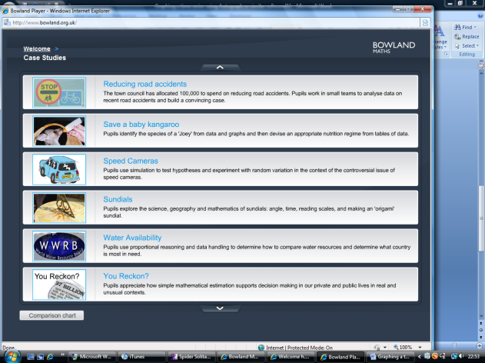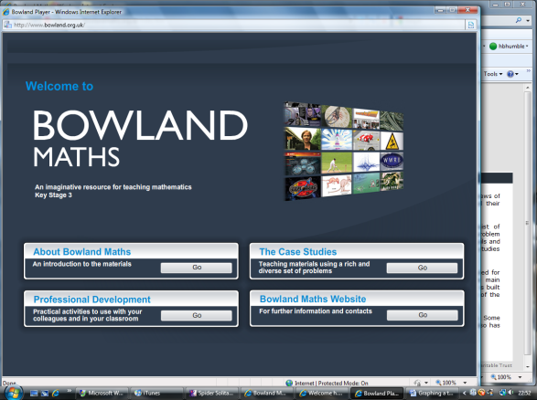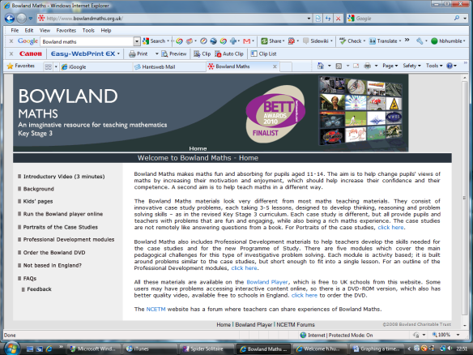Accessing the Activity: Search Bowland Maths on the internet (1) and select “Run the Bowland Player online”. Select The Case Studies (2)
(5)
(3)
(2)
(1)
Use the scroll arrows until you see Save a baby kangaroo (3)Either download or view case study (4)
(4)
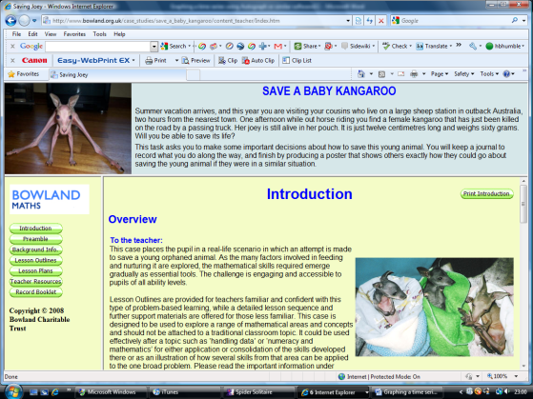Click here to begin if you are a teacher (5) All the resources are on tabs on the left. (6)
(6)

At stage (3) there is the option to view the comparison charts showing curriculum coverage, age and ability, resources, links to KS3 PoS etc (7)
(7)

