Connect4Maths is a strategy to support pupils with knowledge recall and retrieval using cognitive psychology strategies, particularly dual coding, elaboration, space practice and retrieval practice.
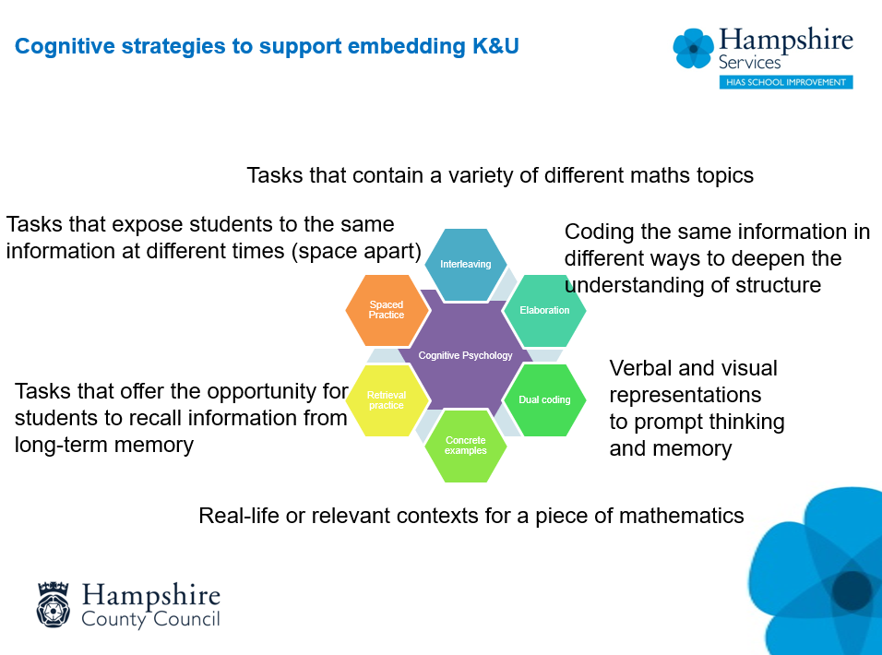

This word document contains a blank, editable template to enable teachers to create bespoke versions for their own pupils.
There are some examples of the HIAS maths team resource, which is available on the Moodle Plus for subscribing schools. This resource is linked to the HIAS scheme of learning units of work, one Connect4Maths set of tasks for each unit.

Connect4Maths Samples:
Full set available on the HIAS Maths Moodle Plus
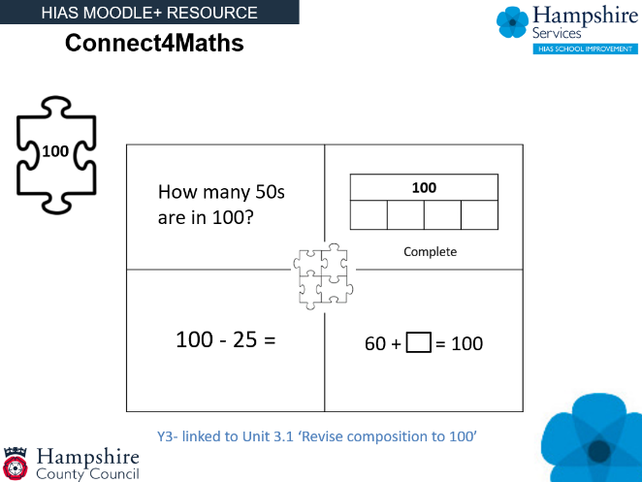
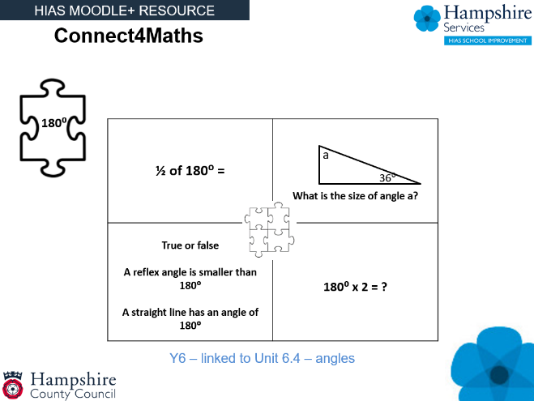

Connect4Maths Blank template

