KS2 Arithmetic P1 2017  Multiplication and division | Knowledge/ strategy | Pupils who need further teaching to address gaps in understanding  Date:
505 ÷ 1 = | Any ÷by 1  Conceptual understanding/ mental
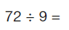 | Any tables/ division facts  Number fact recall / inverse /mental
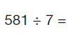 | Any 3 digit ÷U  Notice 581= 560+21 ( multiples of 7)  Short division/ mental, check using facts
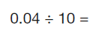 | Any decimal to 2dp  Using understanding of PV / mental
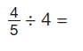 | Dividing simple fractions by U  Conceptual understanding/ mental
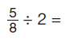 | Dividing simple fractions by U  Noticing need for equivalent fraction  Conceptual understanding/ jotting/ mental
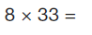 | Any TUxU  2 part calculation: (30x8) +(3x8) ; use of PV  Jottings, formal method ; check using facts &PV
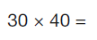 | Any multiple of 10 x multiple of 10  Use related number facts &PV: 3x40 , 30x40, mental
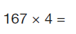 | Any HTUxU  Short multiplication  Check with facts eg 100x4; 60x4;7x4
Any 4 digit x1000
Using PV understanding/ mental
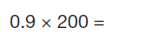 | Any decimal to 1 dp x multiple of 100  Use of related facts &PV: 9x2; 0.9x2, 0.9x200
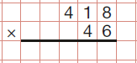 | Formal method with HTUxTU  Check reasonableness of answer: 400x40/ 400x50
Key stage 2 Arithmetic Paper 2017: multiplication and division

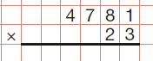 | Formal method with Th HTUxTU  Check reasonableness of answer: 4500x20/ 5000x20
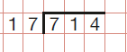 | Formal method with HTU÷TU  Check reasonableness of answer with conceptual understanding of inverse and related facts: 17x ?=714
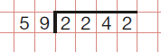 | Formal method with Th HTU÷TU  Check reasonableness of answer with conceptual understanding of inverse and related facts: 59x ?=2242
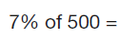 | Use of related facts: 10% of 500; 5% of 500; 1% of 500  Jottings
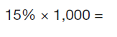 | Use of related facts: 15% of 100= 15; 15% of 1000= 150  Jottings
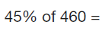 | Use of related facts: 50% of 460; 5% of 460 or 10% of 460 and 5% of 460  Jottings
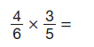 | Conceptual understanding through array  Method
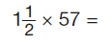 | Any mixed number x TU  Two part calculation  Jotting
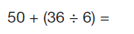 | Order of operations
Key stage 2 Arithmetic Paper 2017: multiplication and division cont/:

