KS1  Addition and Subtraction | Knowledge/ strategy | Pupils who need further teaching to address gaps in understanding  Date:
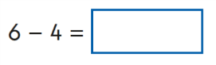 | Any U-U preferably as known fact  Could link to ‘missing box’ presentation
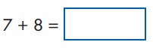 | Any U+U preferably as known fact  Noticing near doubles  Could link to ‘missing box’ presentation
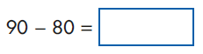 | Any multiple of 10- multiple of 10  Noticing link with U-U and therefore as known fact  Any multiple of 10+ multiple of 10  Noticing link with U+U ( as a fact etc)
Any TU-U
Partitioning second number as known number bonds to bridge through 10
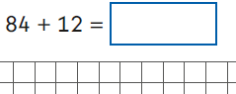 | Any TU+TU, adding a teen number  Adding 10 to any number  Bridging through ten where needed
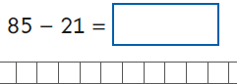 | Any TU- TU with low units digit for second number  Not crossing tens boundary
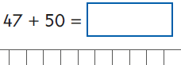 | Any TU + multiple of 10  Counting in 10s from any number, using PV understanding, knowing it’s ‘5 tens more’
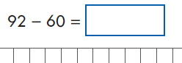 | Any TU - multiple of 10  Counting in 10s backwards from any number, using PV understanding  Knowing its ‘6 tens less’
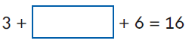 | Adding any 3 units numbers  Noticing number bonds to 10
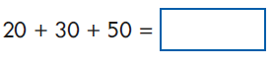 | Adding any 3 multiples of tens  Noticing link with adding 3 units, using PV understanding
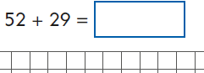 | Any TU+TU where second number could be rounded to nearest multiple of 10, then adjust with subtraction
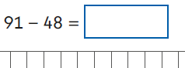 | Any TU-TU where second number could be rounded to nearest multiple of 10 then adjust with addition
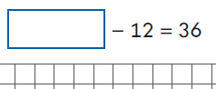 | Any TU+/-TU presented as missing box  Using inverse (bar model imagery)
Key Stage 1 Arithmetic Paper 2017: addition and subtraction

