KS1 Arithmetic P1 2017  Multiplication  and division | Knowledge/ strategy | Pupils who need further teaching to address gaps in understanding  Date:
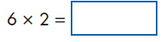 | Any UxU from 2x, 5x, 10x tables  Understand and use commutavity based on array model  Can read as 6 times 2 or ‘double 6’ etc  Recall of number fact
Understand use of ‘x3’ as ‘8 three times’
Can use array model to support solution
Understands links with 8+8+8 or 3+3+3+3+3+3+3+3
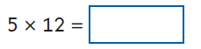 | Understands that counting in 5s can continue beyond 10th multiple  Number line or jottings to support
U÷U | Any fact from 2x, 5x,10 table  Able to ‘read’ symbol to interpret calculation  Use number line imagery  Recall of number facts- connect links with known tables facts / inverse
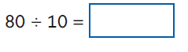 | Any multiple of 10 ÷10  Able to interpret this as’ how many tens in 80?’  Use of PV understanding linked to concrete experiences of representing TU with Dienes
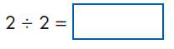 | Any U÷U where answer is 1  Need to be able to model this practically/ draw.
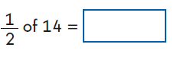 | Able to read and interpret as ‘Half of’ / ½ of U or TU  Use bar model imagery equal parts  Understand link with 2x tables facts and ‘doubles’
¼ of 8= | Able to read ‘quarter of’  Know to find a quarter, find a half first  Bar model imagery equal parts  Understand a quarter is half of a half
2/4 of 14= | Understand and use 2/4 = ½  ( bar model imagery)
¾ of 12= | Understand and use if I know ¼ then I know 2/4 and ¾  Bar model imagery  Also understand can take one quarter away to leave 3/4
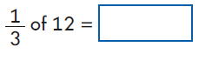 | Able to read ‘one third of’  Use bar model imagery equal parts
Key stage 1 Arithmetic Paper 2017: multiplication and division

