Teachers Notes: Max Box Problem

For the least able of all pupils the problem is essentially a practical one and can be introduced as such. At this level the problem is about constructing boxes and establishing their volumes. At the lowest level the volumes might be found by filling the boxes with cubes.

Most pupils should be able to work arithmetically from nets. The entry level for higher achieving students should move from the constructional, practical and arithmetical into something more symbolic. Pupils should be encouraged to examine the values of ‘x' that maximize

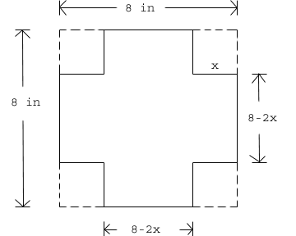
30cm
30cm

x

V = x(30 -2x)(30 -2x)

Pupils could use graphical calculators or spread sheets. Pupils could examine cubic graphs.

You should discuss the need for a logical approach, does a square always give a box of maximum volume. Pupils should be able to provide a symbolic general statement of equivalent to : ‘The maximum volume of a box made from a square occurs when the height is 1/6th of the length. They should test this.

Pupils, if finished early, could move on to rectangles where the length is twice the width.

