The Doctor’s Diner

- In a bid to save money and promote healthy eating Dr. Sykes has proposed the chips from the canteen are sold in open top boxes made from 30cm square of cardboard.
- Year 9 pupils would still like to get the maximum amount of chips for their money
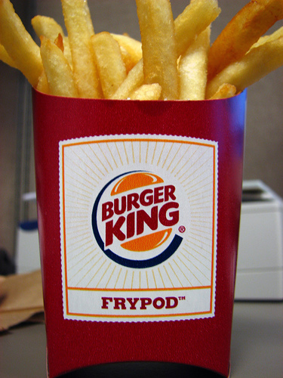


- Using a 30cm square of cardboard can you design a box to give maximum volume?
- What about other squares of cardboard?
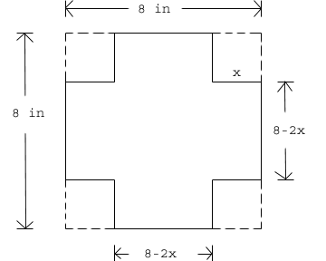
- What height gives you maximum volume? Can you come up with a general rule?
30cm
30cm

