The Strange Billiard Table

Introduction:

I have been asked to _________ how many times a ball ________ around a billiard table and which ________ it ends up in. I will be looking at lots of different ______ tables and recording my _______ by using ________ and ______. I will then look at my results and see if I can see any _______.

tables bounces diagrams investigate

corner results patterns sized

Working Out

Rectangles with a height of 1:
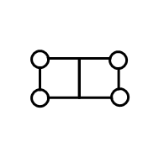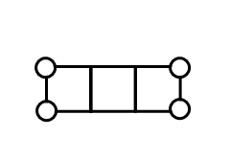
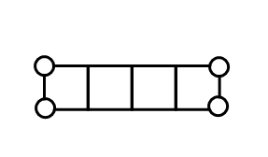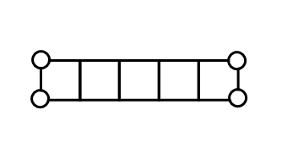

Rectangles with a height of 2: 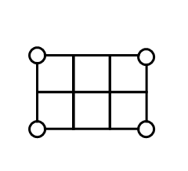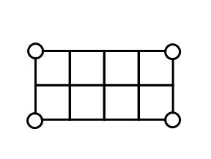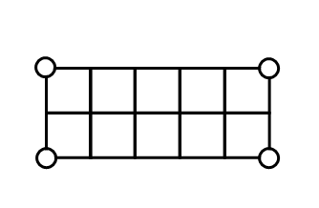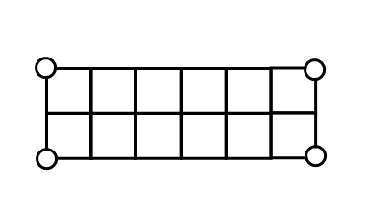

Rectangles with a height of 3: 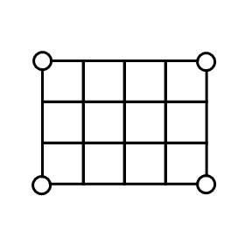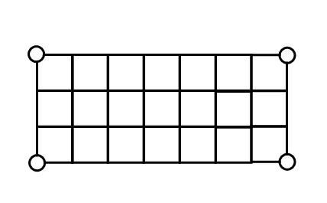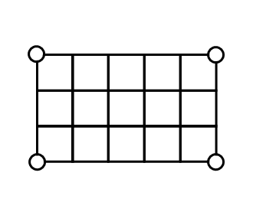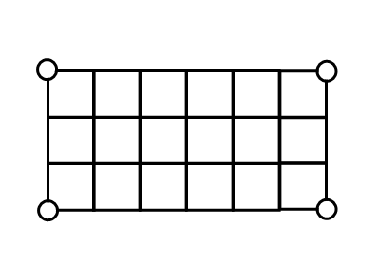
Squares: 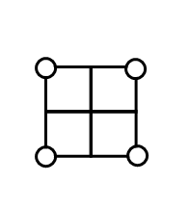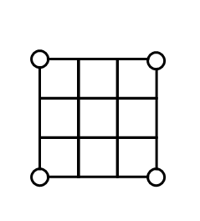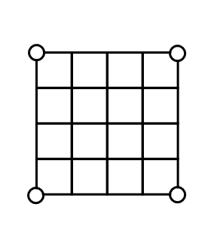
Results:

Here is a table of my results:

Length | Width | No. of Bounces | Finishing Pocket
1 | 2
1 | 3
1 | 4
1 | 5
2 | 3
2 | 4
2 | 5
2 | 6
3 | 4
3 | 5
3 | 6
3 | 7
2 | 2
3 | 3
4 | 4

Conclusion:

Rectangles with a height of 1:

I have found out that if you increase the width by ____ the number of _______ goes up by ___.
Other things I noticed ___________________________________________
___________________________________________________________________

Rectangles with a height of 2:

I have found out ______________________________________________________
______________________________________________________________________________________________________________________________________

Rectangles with a height of 3:

I have found out ______________________________________________________
______________________________________________________________________________________________________________________________________

Squares:

I have found out ______________________________________________________
______________________________________________________________________________________________________________________________________

