The Strange Billiard Table

The strange billiard table only has 4 pockets and the ball rebounds at exactly 90⁰. The table also mysteriously changes size!
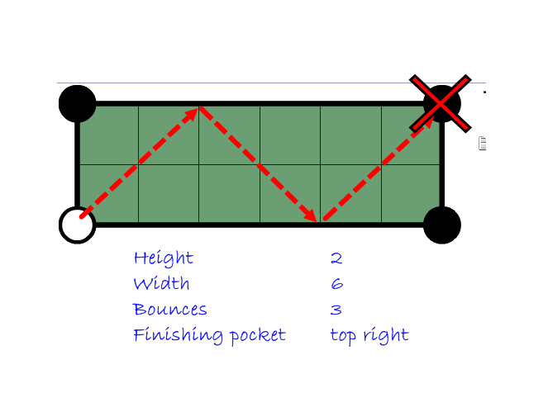
2
You need to investigate to see if there is a way to predict the number of bounces a ball makes before it is potted and which pocket it goes into.

The following website may assist you in your investigation

http://www.subtangent.com/maths/investigations.php (Loopy Snooker)

YOU MUST MAKE SURE THAT IN YOUR WRITE UP YOU DRAW OUT SOME EXAMPLES AND HAVE A TABLE OF RESULTS.

Hints and Tips

- BE LOGICAL
See what happens with all the tables with a height of 2 before moving on to heights of 3

- ALWAYS START IN THE SAME PLACE
To help you spot patterns

- USE A TABLE
Record your results as you go
Think carefully about how to lay this out

- EXPLAIN WHAT YOU ARE DOING AS YOU GO ALONG
Imagine the person reading it has no idea what is going on!
A good report always has an introduction and a conclusion

