How to use transformations in GeoGebra to design a graphic pattern, suitable for a fabric or background image.

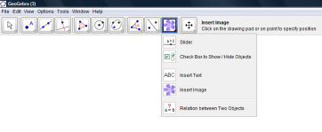
In GeoGebra select Insert Image

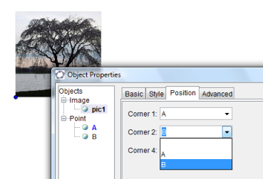
Click on screen and open an image file.
(You may want to use a crop tool to make this square before you start). Place a point (A) in the bottom left hand corner of your image. In the input bar at the bottom of the screen define point B which will be the right hand bottom corner of your image. B=A+(3,0) then press enter.
Right click on the image and select object properties, position tab. Select point A for corner 1 and B for corner 2. This resizes your image.

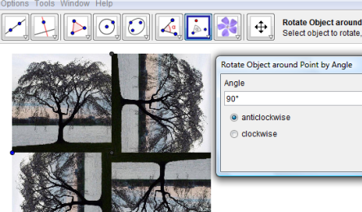
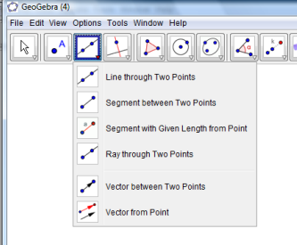
Select rotate object around point by angle from the transformation menu. Now select the image and then the centre of rotation (do not use the selection arrow) followed by the angle and direction.
The other transformations are found on the same menu.
For translations a vector can be created from the line menu.
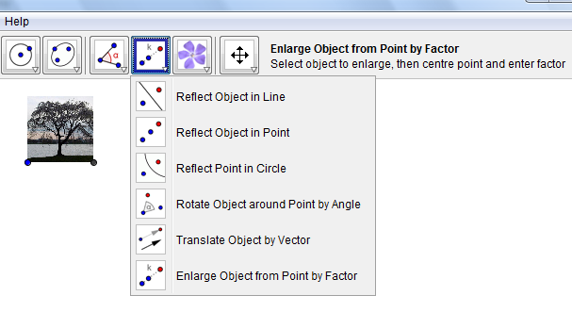
In each case, select the transformation then the image, then the centre or line or vector.

Design your own pattern then ask another student to explain how they think you created your design.

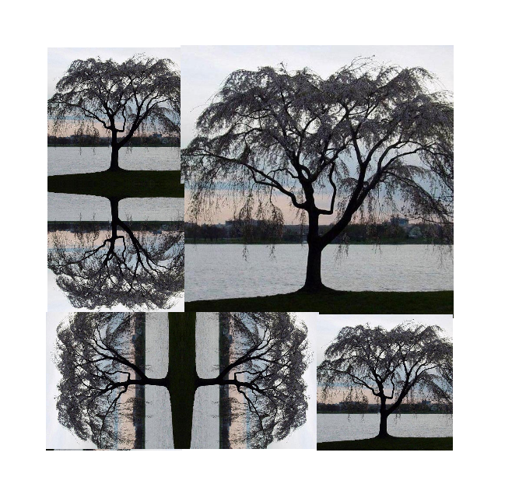
Challenge.....
Describe in detail how this pattern might have been formed.
Define each transformation in full, stating all the information needed to form an exact copy of this design.

