Transformations using Dynamic Geometry software: GeoGebra
Activity: Use geometric transformations to design a repeating pattern suitable for a fabric, wallpaper or background graphic.
This will improve your students understanding of mathematics because they will be motivated to explore dynamically the effects of altering the conditions relating to a range of transformations, such as the position and angle of a line of reflection symmetry or the position of the centre and the angle of turn of a rotation. The activity consolidates and extends students’ knowledge and understanding of transformations.
Outcomes: By using a photograph as the object, rather than a triangle or L shape, the students will become involved in a practical design task that has an interesting and visually pleasing outcome. They will think about how to define their transformations in order to achieve the visual effect they are seeking.
Follow-up/extension: Using GeoGebra, a free application that students can easily download from the internet at home, means that students can extend their exploration time outside of the classroom.
Specific Instructions:
- Students ideally work individually on the activity but clearly should share their successes and discuss their difficulties with each other.
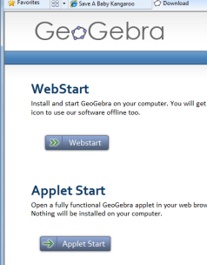
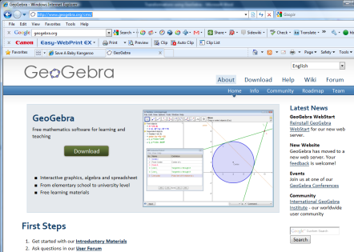
- The software is downloaded from http://www.geogebra.org/cms/ There is an option to install the software or to just use it as an applet.
- View – hide axes
- View – Algebra view toggles on and off the side screen which keeps a record of all objects on the main screen.
- GeoGebra uses the notation of lower case letters to label lines and upper case for points.
- Inputs are typed in at the bottom of the screen.
- Selecting objects for transformations is different to other dynamic geometry software packages but is explained in the students notes.
- At the start students select a photographic image which they import into Geogebra. Depending on the desired effect it may be worth cropping this to a square image before importing it.
- The first instructions on the students sheet resize the image making it 3 units wide.
- If printing is problematic either export it (File menu) as a graphics view or print screen and paste it into a Word document
Prior knowledge: An awareness of what is needed to define reflections, rotations, translations and enlargements
Key questions: How will you get the pattern to repeat? Can you move that image closer to/ further away from this one? How much overlap do you want in your rotations? How will you change this?

