Linear Graphing using Cameras

Activity 3: Speed Dating and Human Sculptures

This will improve your students’ understanding of mathematics because the pupils will need to apply their understanding of y=mx+c through a kinaesthetic activity. The following discussion based on the pictures taken not only will engage more visual pupils but also engages the pupils as they have a sense of ownership of the work being considered. Being able to look at the electronic record (photos) of their work will provide an intrinsically interesting resource which can be used to evaluate the understanding and misconceptions of groups of pupils.

Suggested preparation for teaching: Ensure that you either have a camera that can be connected easily to a laptop or a means of downloading so the photos can be displayed in the second part or a subsequent lesson. Copy the Speed Dating sheet onto card and cut up so that each pupil can have one. Be prepared to move the furniture in your room or book a larger space as the pupils will need room to move around and form their “sculptures”.

Outcomes: Pupils will have a greater understanding of the purpose of m and c in equations of the form y = mx + c and what effect varying them will have on the graph. Because this is both a kinaesthetic and an active activity, a greater proportion of the pupils will be effectively engaged.

Follow-up/extension: Note that the level of difficulty can be easily adapted to suit by creating easier or more complicated speed dating cards for the whole class or for specific individuals. As the lesson progresses the conditions set can be more complicated, eg to find someone with a perpendicular gradient to yours, make a group of 3 with 2 parallel lines and 2 with the same intercept etc. The same idea can be extended to demonstrating quadratics, cubics, or pairs of pupils can sculpt reciprocal graphs.
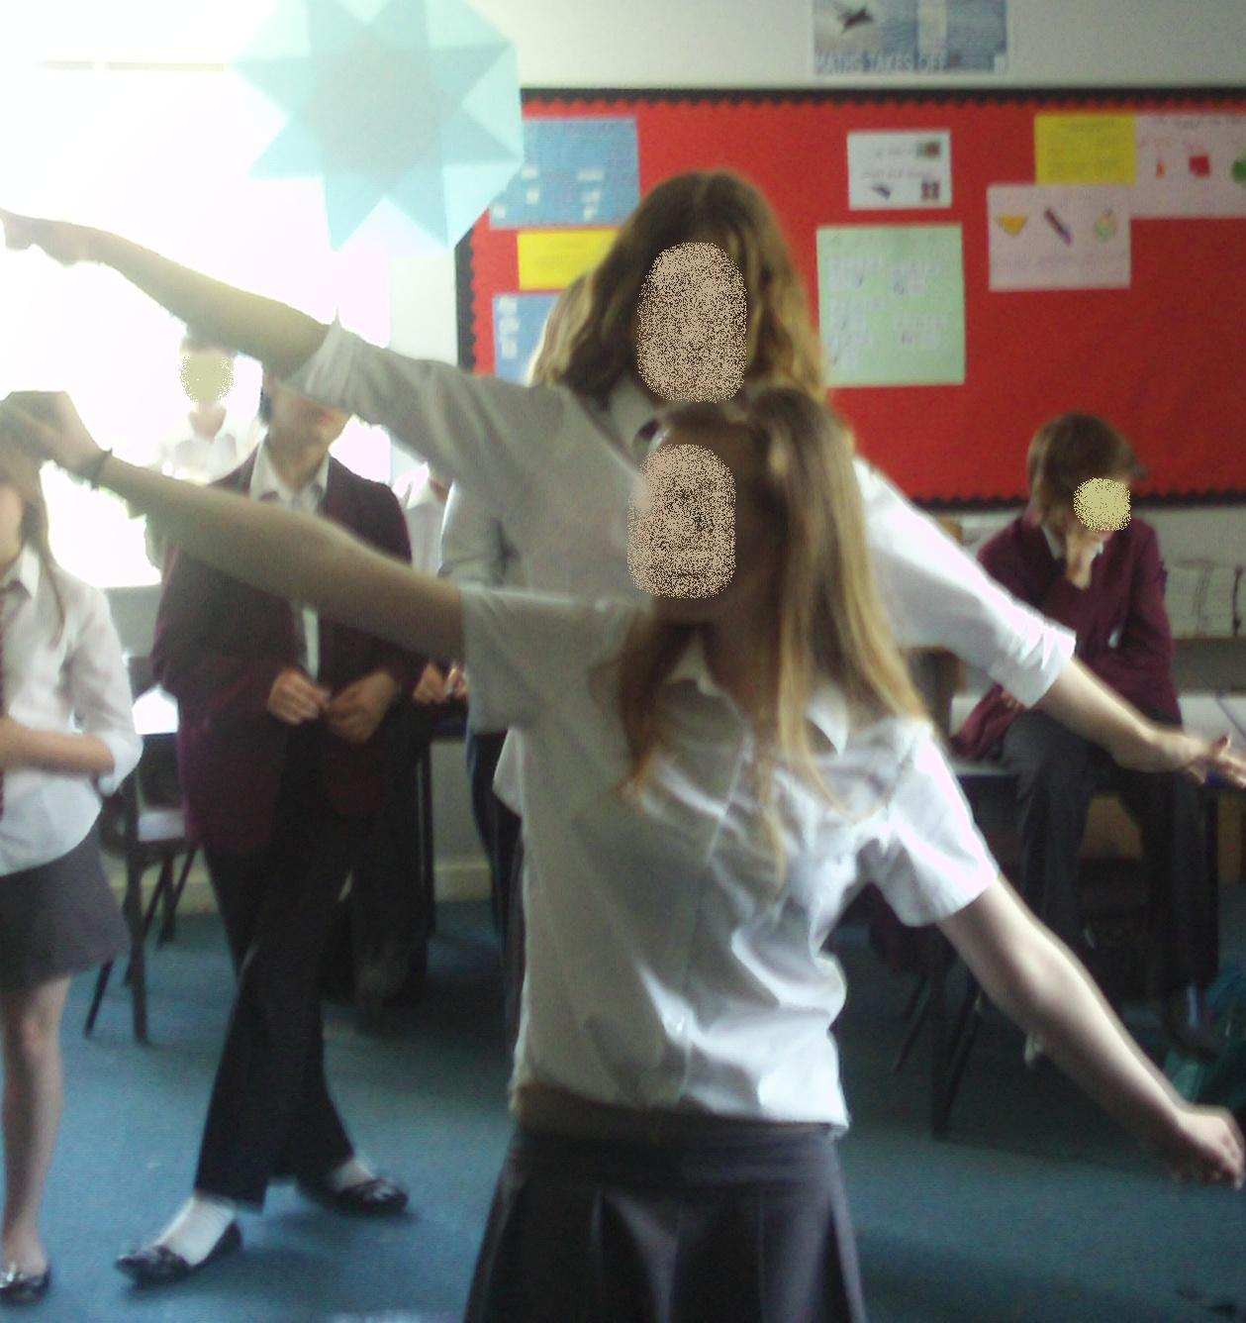
Specific instructions: Each pupil should be given a card with the equation of a line graph, asked to find another person with a particular condition (eg a parallel line) then asked to use their bodies to display these lines. The teacher can take pictures of these sculptures. This can then be repeated with another condition for speed dating.
Later in the lesson, or in the following lesson the pictures can be displayed and discussed by the class who have to give possible equations, explain by looking at the sculpture what the equations might have in common or given the equations explain what was wrong with the sculpture. An example of a sculpture is shown to the right. The pupils were trying to display y=-2x + 1 and y=-2x+3.

Prior knowledge : Some understanding of y=mx+c.

Key questions: Initially questions should help pupils to focus on the effect of varying m and c in the equation. Secondly, questions on identifying the effect of increasing or decreasing their chosen variable and how they might show this with their bodies. Some pupils might need to consider whether their picture is right for a person looking at them, or as they view themselves – the teacher might also need to consider whether this will confuse the pupils or whether they would be better to photograph the pupils from the front or behind them.

Questions can be based around one of the pupil’s actual equation or hypothetical eg “If ‘person A’ had the equation y = .... give me some examples of what the other equations in the photo might be.

Activity 3 – Speed Dating and Human Sculpture – These are a possible set of cards, one to be given to each pupil.

y = 2x + 3 | y = 3x + 3 | y = x + 3 | y = -2x + 3 | y = ½x + 3
y = 2x + 1 | y = 3x + 1 | y = x + 1 | y = -2x + 1 | y = ½x + 1
y = 2x | y = 3x | y = x | y = -2x | y = ½x
y = 2x - 2 | y = 3x - 2 | y = x -2 | y = -2x -2 | y = ½x -2
y = 2x - 4 | y = 3x - 4 | y = x - 4 | y = -2x - 4 | y = ½x - 4

