Graphical Calculator Help Sheet – Guide to Keys for Activities 1, 2 and 4

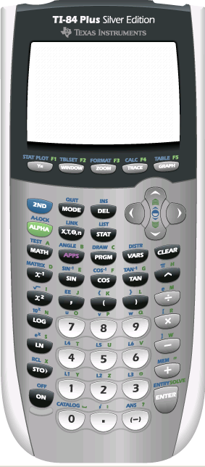
Subtract button
Negative button
Format button – press 2nd function button first – use to format the axes
Window button – use to set up axes
Y= button – use to input equations for graphs
X,T,θ,n button – use to put a variable in an equation
Graph button – use to view graphs of your equations
STAT button – use to get into the Lists area to put sequences in a table

