Enhancing Understanding (of Reflection) through the use of Video

This will improve your students’ understanding of mathematics because in the physical activity the pupils should be able to access some difficult tasks involving reflection, without the added confusion of a background grid. The use of video combined with such a physical activity will suit both visual and kinaesthetic learners but will also engage pupils in the lesson as they will have a sense of ownership of the work being considered. Being able to look at the electronic record (video) of their work will provide an intrinsically interesting resource which can be used as a base for discussion to evaluate the understanding and misconceptions of groups of pupils. This should lead to pupils consolidating or developing their own rules for how reflections work.

Suggested preparation for teaching: Ensure that you either have a video camera that can be connected to a laptop or a means of downloading so the video can be displayed in the second part or a subsequent lesson. Have shapes and ribbon or string. Also it is useful to have a GSP or similar dynamic file ready so that you can demonstrate to the pupils what they are trying to achieve.

Outcomes: Pupils will have a greater understanding that when shapes reflect the distance between the shapes and the mirror line should be measured perpendicular to the mirror line. This will help them to access questions involving obliquely placed mirror lines and those where the mirror runs through the object.

Follow-up/extension: Pupils might be able to find the placement of a mirror line by bisecting the distance between equivalent points, or by attempting to do this decide if a diagram given is actually a single reflection. Note that the use of video or still photos can be used in a number of ways, for example: human sculptures of line / quadratic graphs etc; a human cumulative frequency curve with human box plot, and to extend this they could dynamically change their positions as different data sets are given to them.

Specific instructions: Use GSP or a similar dynamic geometry package to demonstrate how the mirror line affects the position of a reflection. For example, what happens to the image when: the mirror line is oblique rather than horizontal or vertical; the mirror line runs through the shape; the mirror line is translated away or towards the object; the mirror line is rotated; the object is translated away or towards the mirror line; or the object is rotated. (The tasks you demonstrate and ask of the class or individual groups will depend on their ability. Some might only attempt certain tasks, some might produce a few examples when either the mirror or object is transformed, while more able groups might be asked to model that transformation dynamically). Then the pupils should be given pairs of congruent shapes (weaker groups could be given simpler or more symmetrical shapes) and a piece of ribbon or string and asked to practise reproducing some or all of these tasks. When a group is ready their presentation can be videoed. Later in the lesson, or in the following lesson, these videos can be shown and discussed by the class. This discussion should focus on equal perpendicular distances between the mirror line and object/image – recognising this is what should happen and in recognising incorrect reflections that this didn’t work. As an extension you could also discuss the relative speed or angle of movement of the image when the mirror line is transformed. Or use their understanding to find mirror lines or show that two shapes are not reflections of each other. See below for some screen shots from the attached videos.

Prior knowledge : None

Key questions: The initial focus should be on recognising the perpendicular measurement of distances but perhaps moving onto relative speeds/angles of change in dynamic situations, finding mirror lines etc as discussed above.
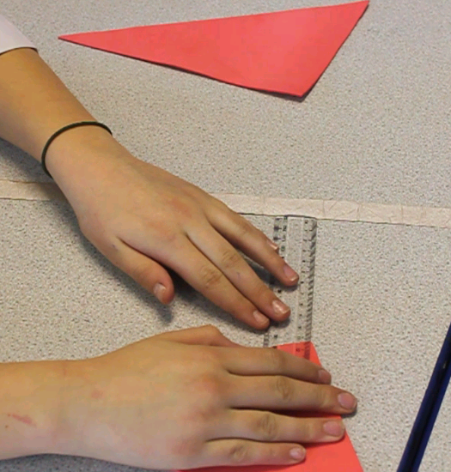
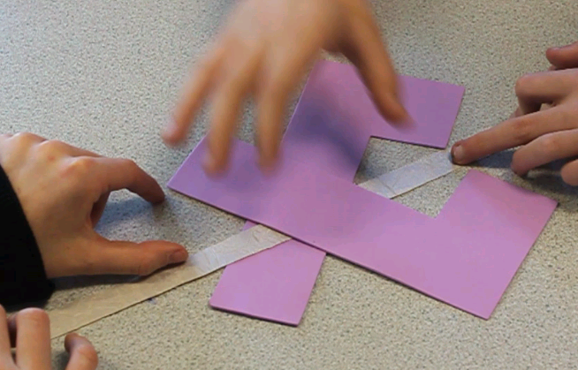
Screen shots from the attached videos

Using fingers or a ruler to measure distance – note that this is perpendicular to the mirror line.

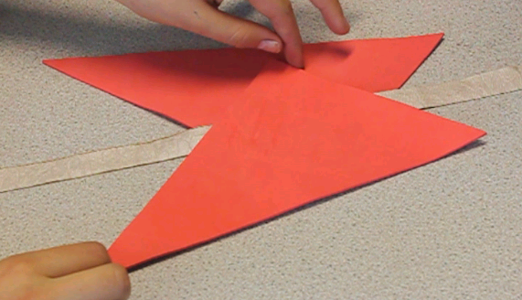

A reflection formed where the mirror line ran through the object. The way the pupils (on the video) discussed and decided on the final placement of this could be a useful trigger for a class discussion.

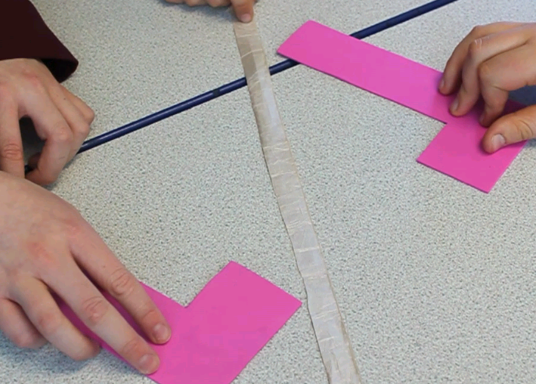
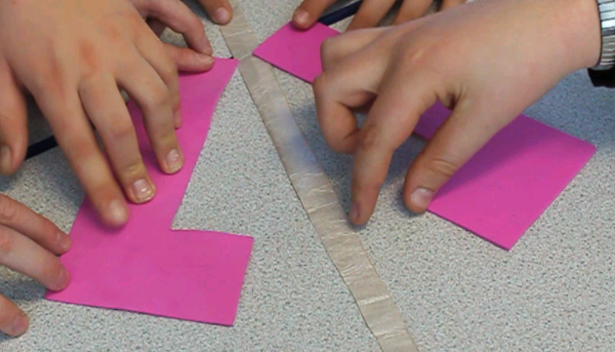
A mistake (that the pupils put right in the video) could prompt discussion in class about what was wrong and how it should be fixed.

