Using Google Sketchup to create your fish tank

- Open Google Sketchup

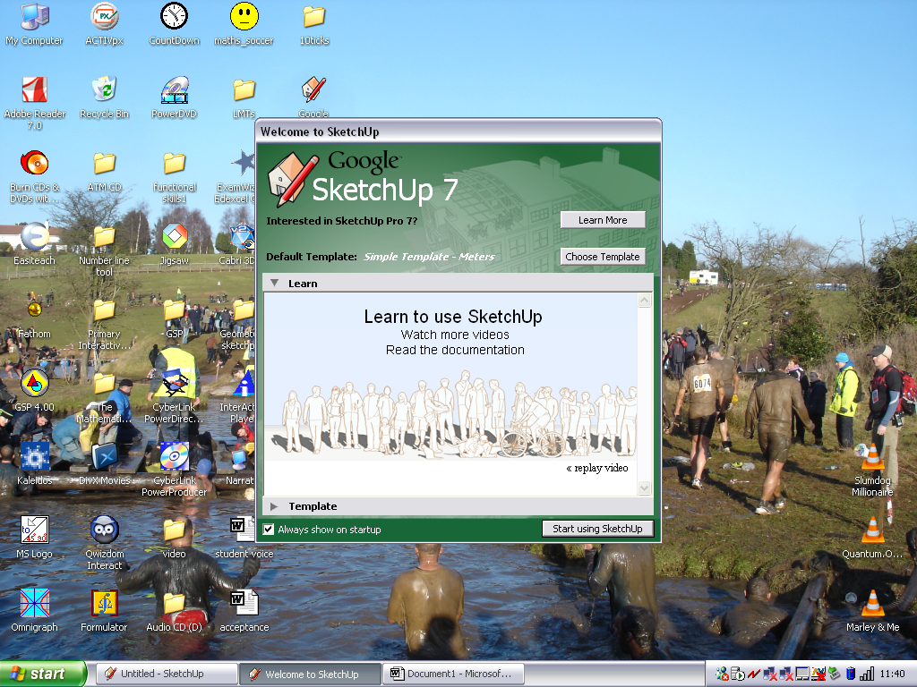

- Click on ‘Choose Template’, and select the second option

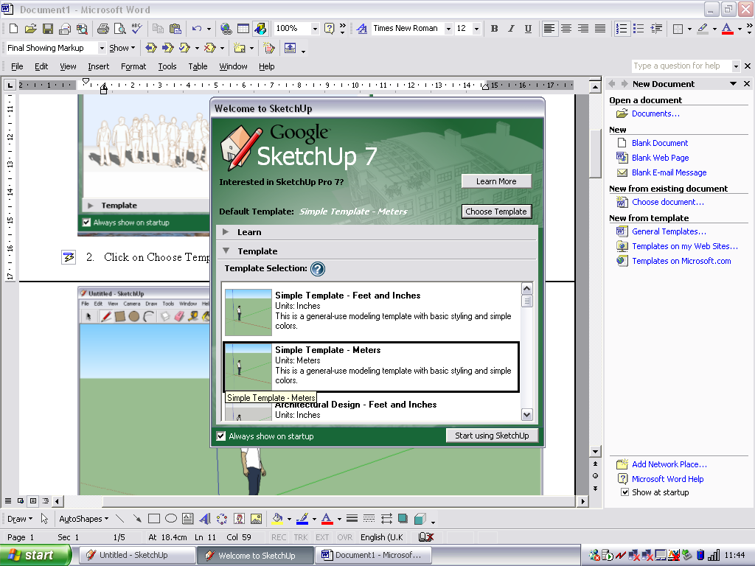

- Now select the pencil icon and draw what your fish tank will look like from the top. Notice in the bottom right hand corner the length of your line will be displayed. You need to be accurate so that we can calculate the volume and water surface area:

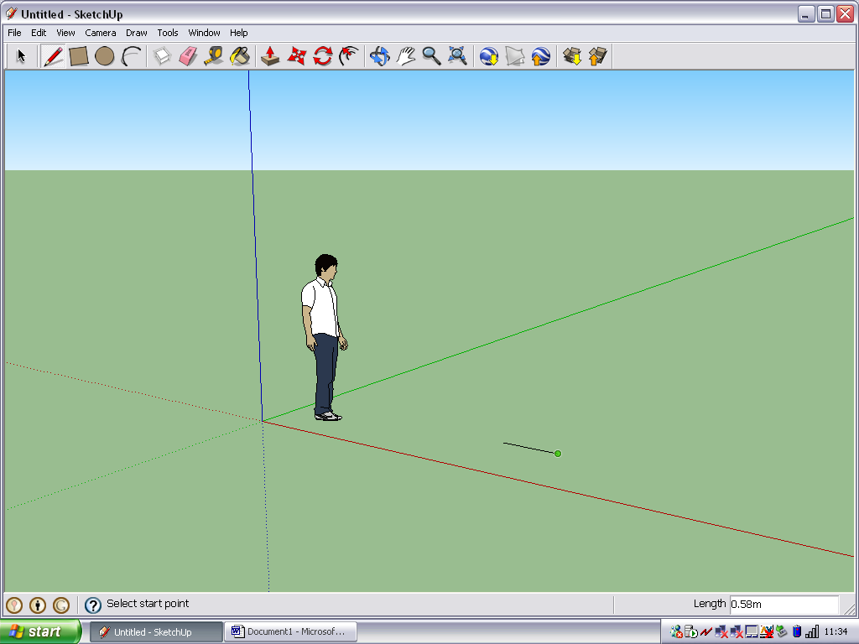

Also note that the length measurement is in metres. How can you change this for centimetres?

- Each time you draw a line make sure it connects with the last. A green circle will appear on the end of the line to show it is connected.
When you have joined back up to the start line the shape will turn grey inside to show it is complete.

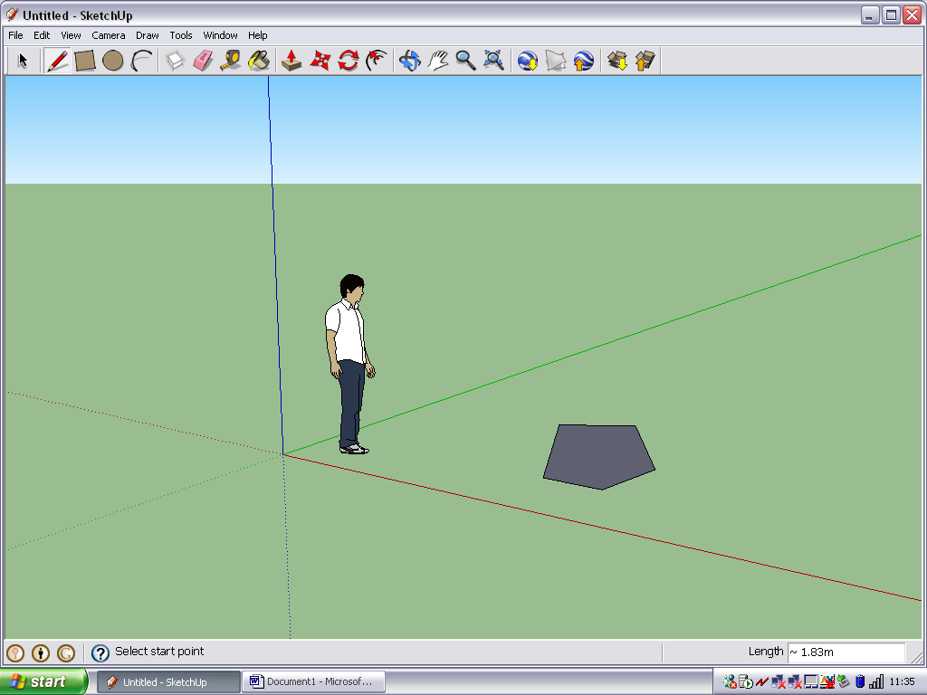

- Remember for any shape you create you must be able to find its area (you could try splitting it up into triangles and rectangles and measuring each of these before adding them up).

- If you now know the area of the top, you can work out how high the tank needs to be to get the correct volume. Use the ‘push/pull’ icon and click on the middle of the shape (it will have lots of little dots on it). Now drag it up to the height you want.

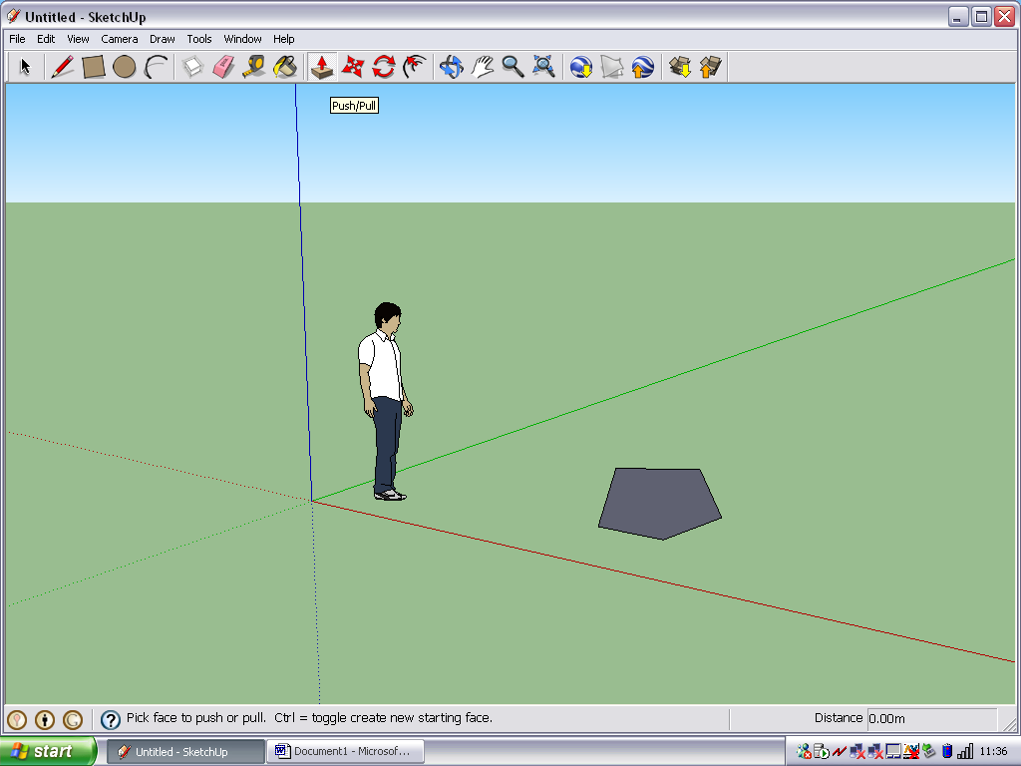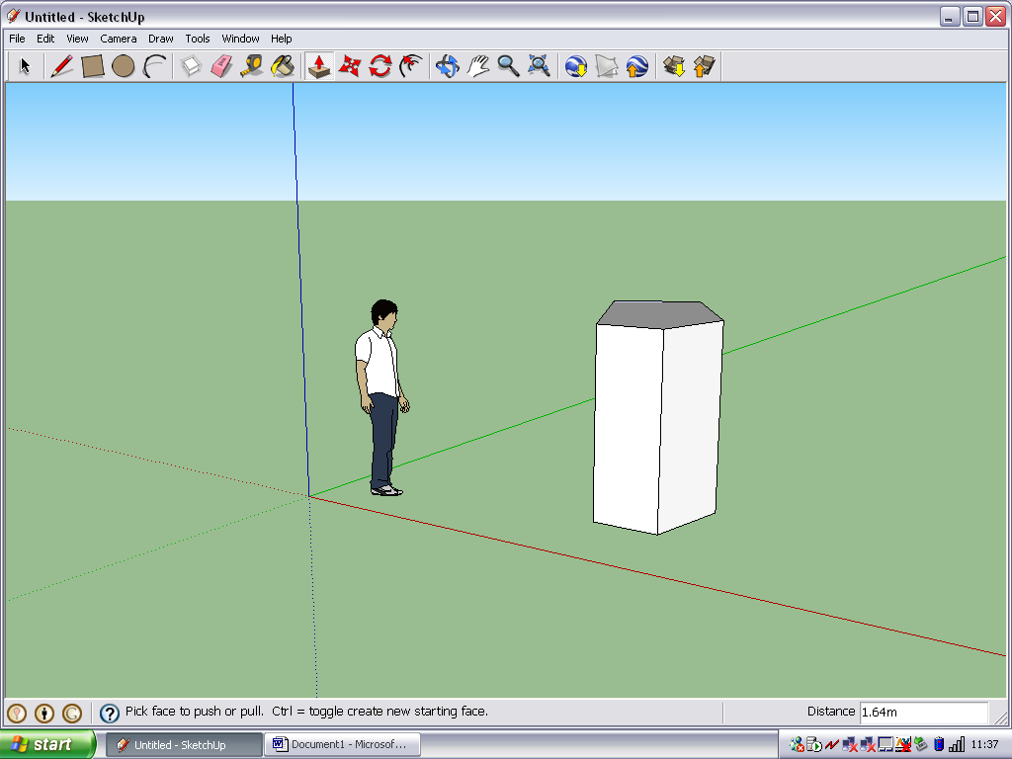

- If you now select the orbit tool you can move around the object and view it from different angles. Does it look about the right size? Did you think it would be bigger or smaller?

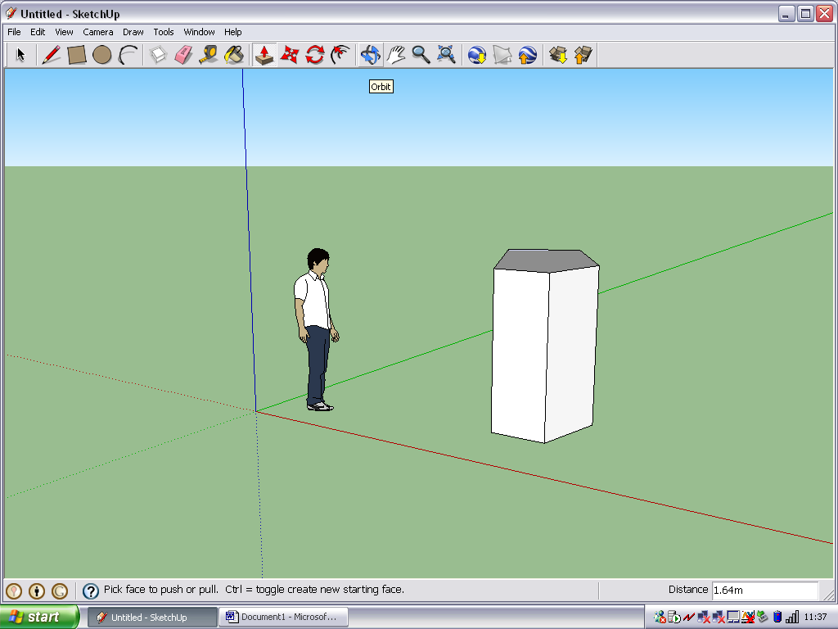

- If your fish tank is mathematically correct (it has the correct water surface area and the correct volume) why not try the following……….

  - Designing another fish tank with the same volume and water surface area.
  - Adding colour and designs to your fish tank. Maybe make it into actual glass with a frame and special effects. You can do this by using the ‘paint bucket’ tool.
  - Try importing some images from the Google 3D warehouse to actually put fish in the tank, or gravel, seaweed, etc. You can do this by using the ‘get models’ icon. 