Google Sketchup
User guide

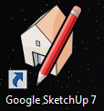

How to use Google Sketch up.
Google Sketch up is a very easy and simple tool to use. The first thing to learn is the tool bar:
The tools you have are...
- Select
- Pencil
- Square
- Circle
- Arc
- Make compound
- Eraser
- Tape measure
- Fill
- Push/Pull
- Move
- Rotate
- Offset
- Orbit
- Pan
- Zoom
- Zoom extents
These are the main tools that you will be using.

How to make a Cuboid
Select the square tool than make a square that should look something like this: 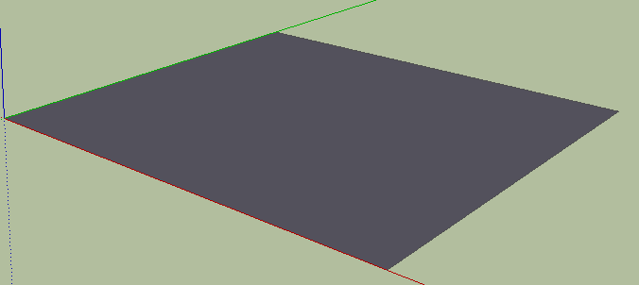
Once you have something that looks like this select the push pull tool then when the square turns white with lots of little blue dots click and hold, then drag up:
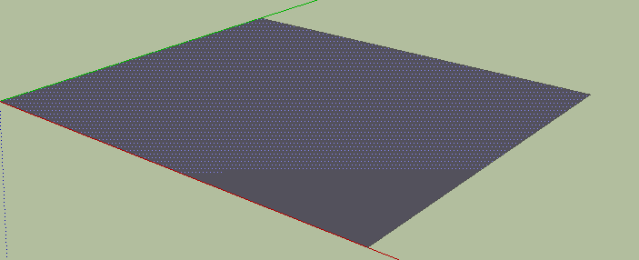
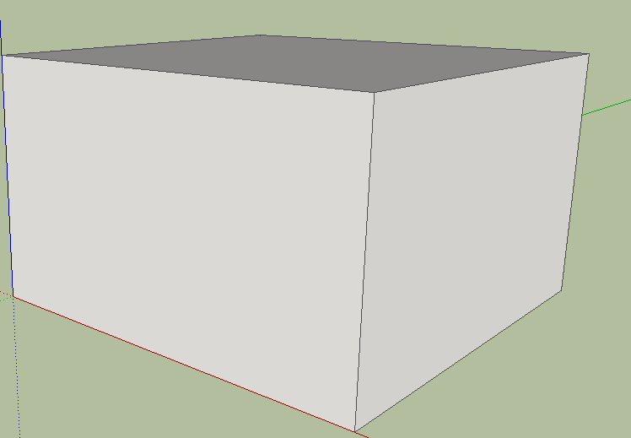
When you drag up it should look something like this.

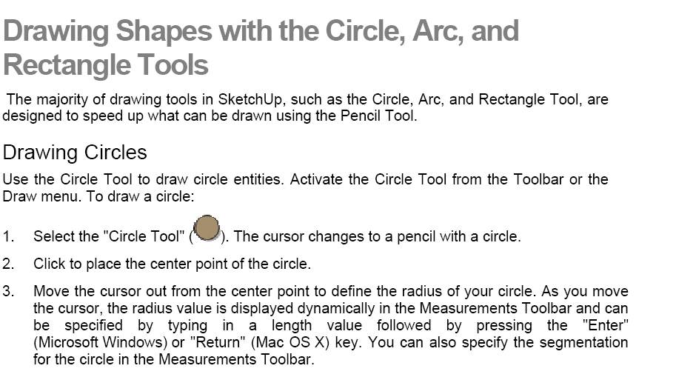
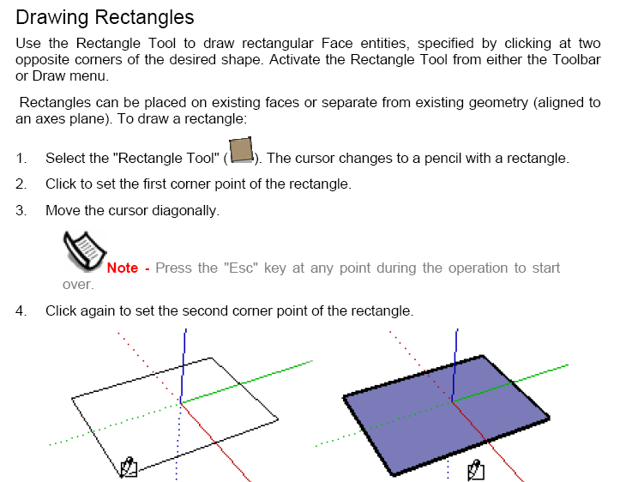

If you would like to make something accurate, look in the bottom right corner
, but you have to calculate area your self.

How to make a chair.

To make a chair first make a square:
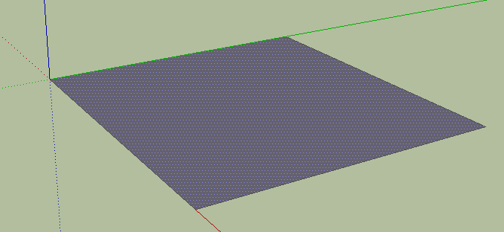
Then like we did to make a cube pull it up using the push/pull tool to make this:
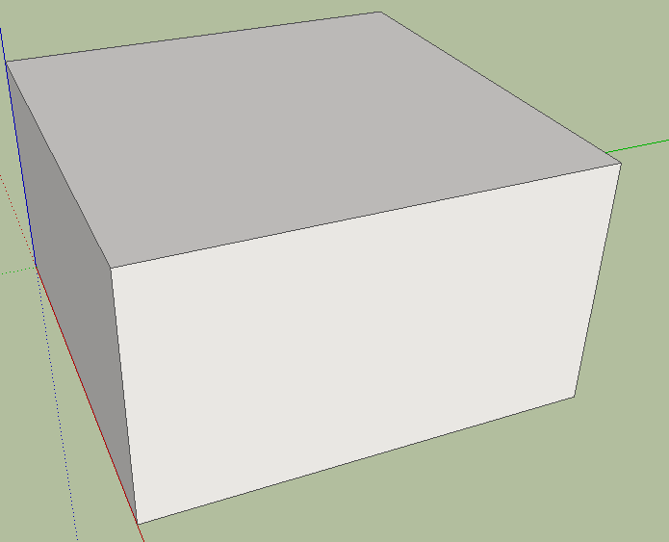

Then we are going to use the pencil tool to draw the lines to make the chairs basic structure:
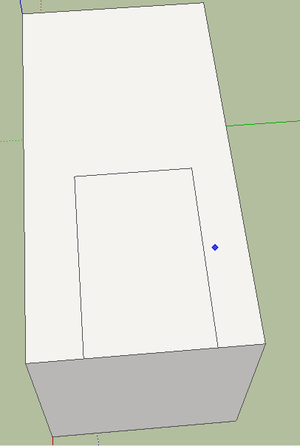
Now we are going to use the push tool to make two big legs:
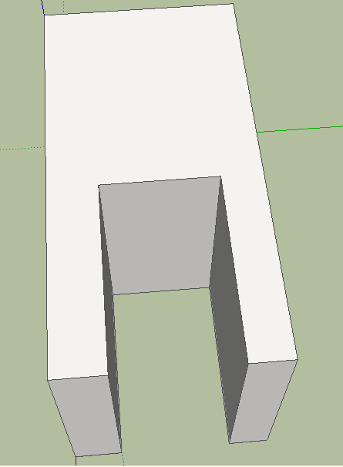

Now we will create the seat and the back of the chair at the same time using the pencil tool :
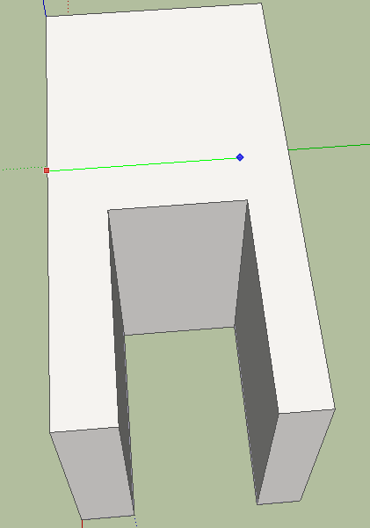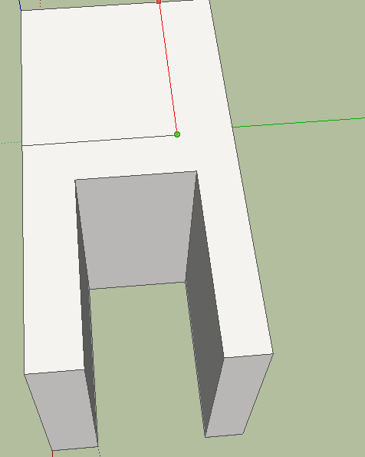
Now to form the seat and the back we need to push it down like we did with the legs:
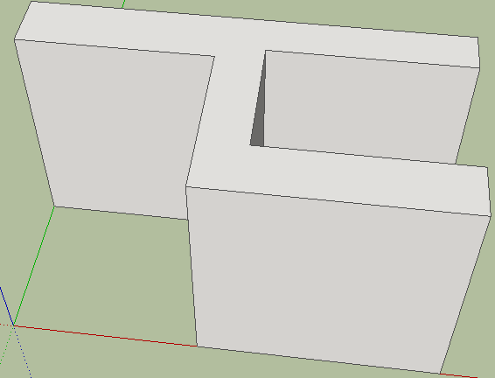

Now to make 2 legs in to 4 we must use the square tool and split it in half like so:
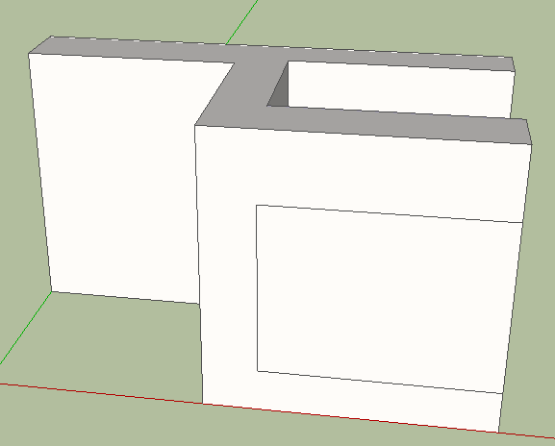
Then we need to do the same that we did with the seat and back we need to push it:
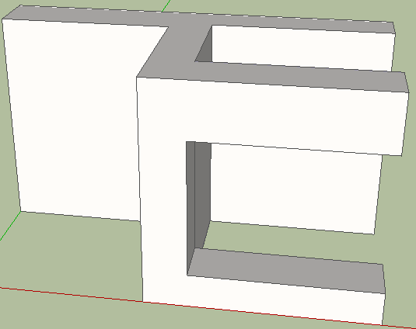
And then the same for the back:
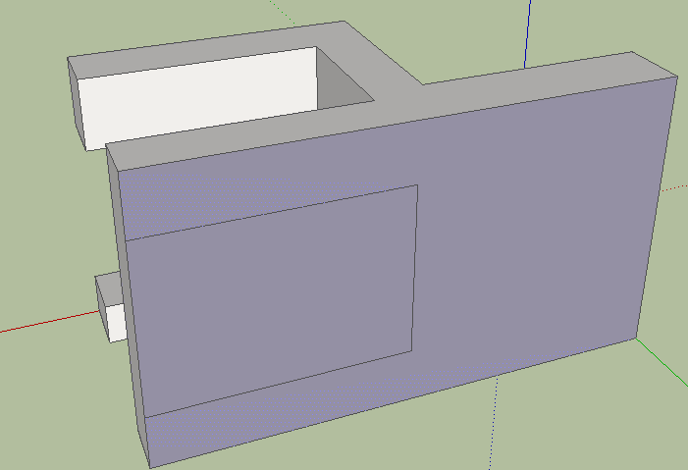
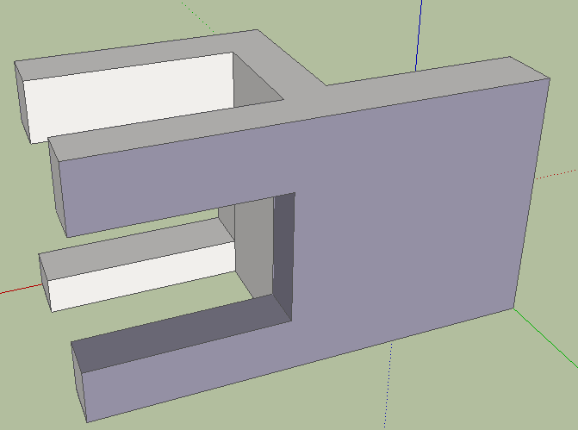
Now to form the top of the back we will use the arc tool, so, as we did before, we need to draw a line using the arc tool from 1 side to the other to then to the top of the back:
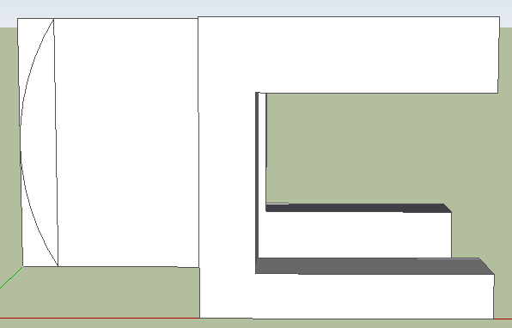

Then we will delete the over hang :
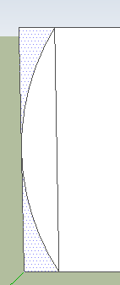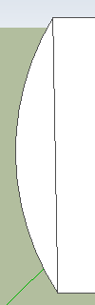

And now you will have a finished chair:
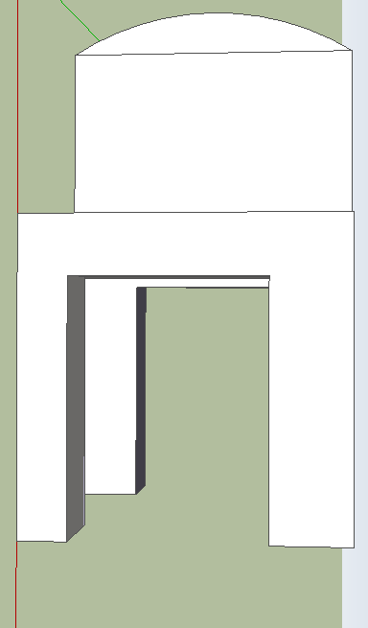

Google Sketchup and Google Earth

>Open Google Sketch Up
>Choose Template >Google Earth Modeling (Meters)
>Start Using Sketch Up

1. Import location from Google Earth to Sketch Up

- Find location in Google Earth
- Zoom position
- In Sketch Up, click ‘Get Current View’ button 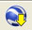 (top tool bar)
- Google Earth snapshot is imported
- Use ‘Orbit’ and ‘Pan’ buttons to change view of image (drag and rotate to view from above).

2. Create the building in Google Sketch Up

- Select ‘Axes’ tool 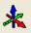 (left-hand tool bar)
- Click once in corner of building
- Align red axis to one side of building and click
- Align green axis (at right angle to red) and click
- Don’t worry about Blue axis
- Axes don’t need to be exact. Just roughly aligned to edges of building.
- Select ‘Line’ tool  and trace outline of building (hold ctrl and click on corners) – start at origin; click on each corner; when traced back round to start, the surface of the building is created.
- The surface is created
- Use ‘Orbit’ and ‘Pan’ buttons to change view of image (drag and rotate to view angled form side).
- Select ‘Push/Pull’ tool
- Pull up the building to the height you want (if you know the actual height you can type it in the ‘Distance’ box in the bottom right-hand corner)
3. Texture building with photos

- Take photos of building (all sides) and save them (your teacher might have done this for you)
- In Sketch Up: use ‘Select’ tool to select a face (wall) of building.
- In Sketch Up: File > Import
- Select appropriate image (select ’Use as texture’) click ‘open’
- Click image in lower left-hand corner of building model and drag to lower right-hand corner
- Rt click on image/building face > Texture > Position
- Drag photo to rough best fit position
- Rt click > uncheck ‘Fixed pins’
- Click and release to move (pick up) pins: position pins in corners of building image and then click on position to place pin.
- Click and hold to drag pins to corners of building model.
- Repeat on all corners
- When happy: Rt click > Done

- Repeat process with other pictures for back and sides of building

(Buildings with split levels)
- If building has split roof levels:
- Select ‘Line’ tool
- Draw lines to divide building
- Use ‘Push/Pull’ tool to achieve different split heights

4. Add roof image

- Go back to Google Earth
- File > Save Image (i.e. as roof.jpg)
- Use same process as before to add roof image to roof of building model

5. Preview model in Google Earth

- Click ‘Place Model’ button
- Model will be exported
- Can view as 3D image in Google Earth
6. Share model to Google 3D Warehouse (optional)

- Must have Google account and be signed in
- (https://google.com/accounts/NewAcount)
- In Sketch Up, click ‘Share Model’ button
- Follow steps to share

